 | Number Cards | 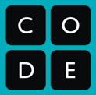

Each group will need one set of number cards.

