Mizzle the Mouse
Name:  Mizzle  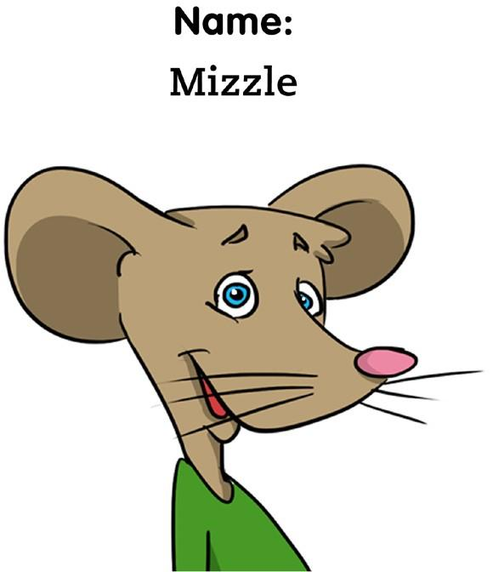 | Where you live:  Mouse Hole  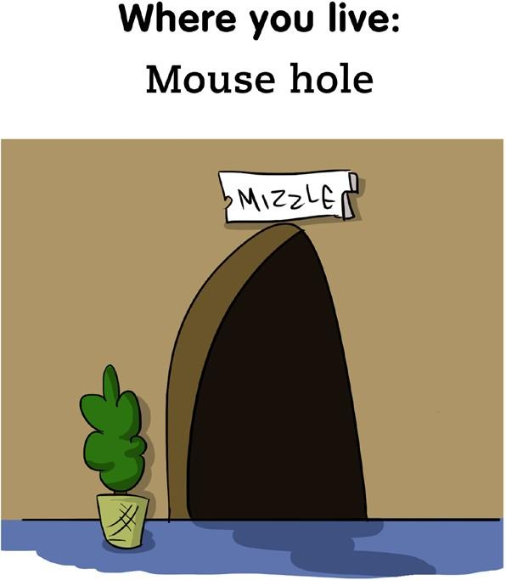
Pet’s Name:  Frank the Flea  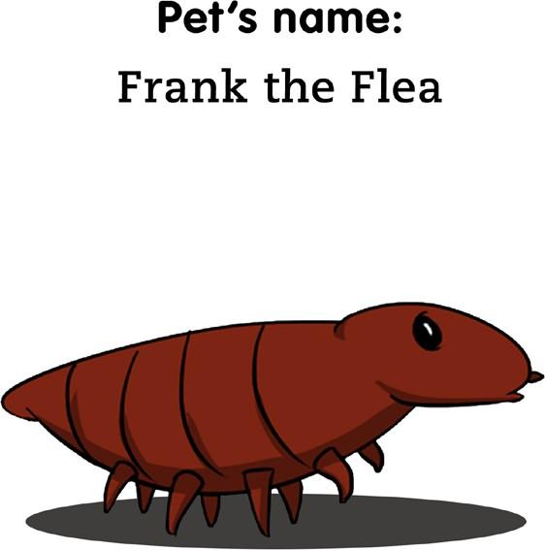 | Favorite Hobby:  Ice Skating  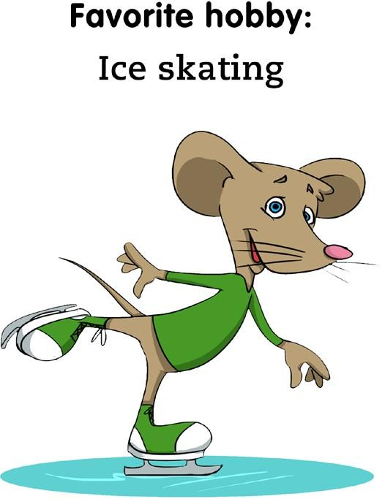
Favorite Food:  Cheese  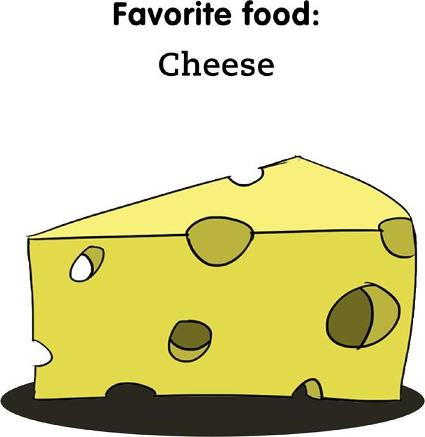 | My favorite photo:  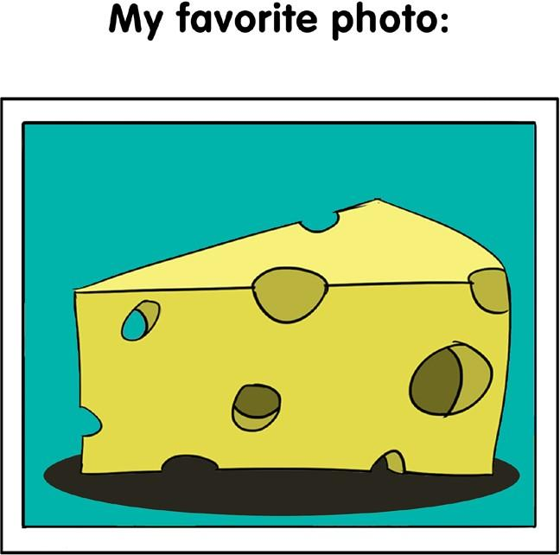

Electra the Elephant
Name:  My full name is Electra Ella Elephant  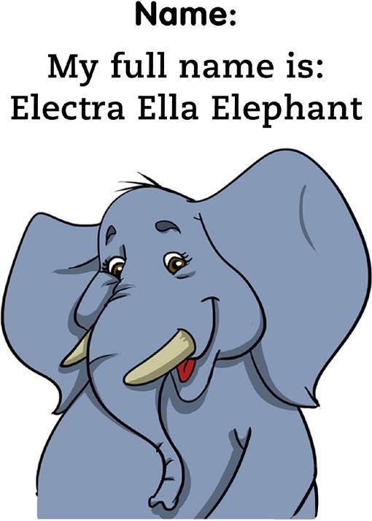 | Where you live:  123 Watering Hole Lane  Peanuts, Ohio  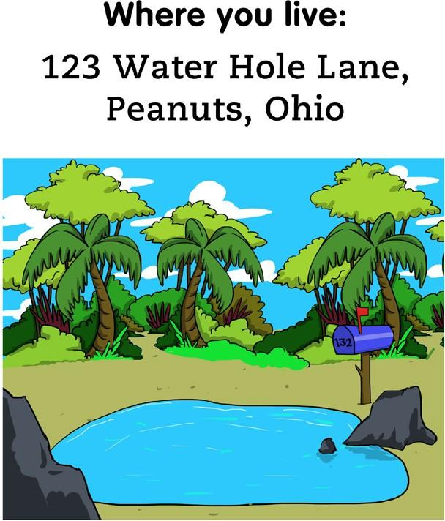
Birthday:  February 21, 2010  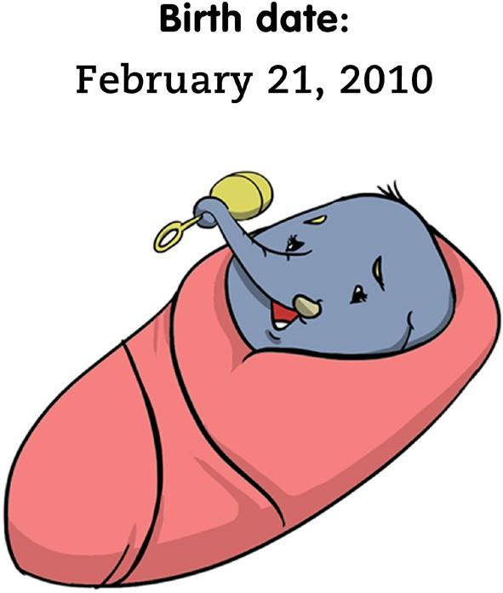 | Username: gray_toes  Password: bamboo  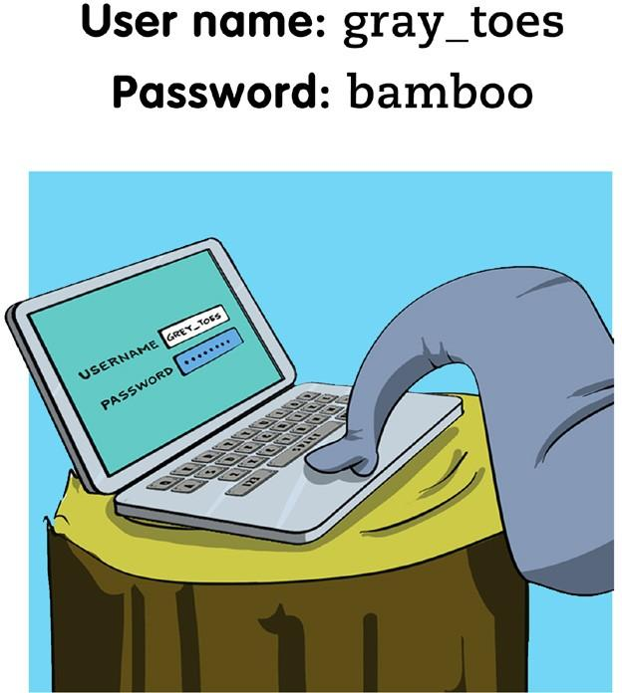
Secret:  My brother and I fight all the time  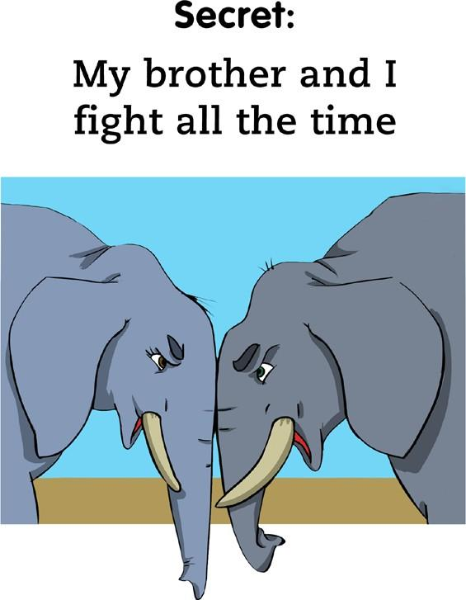 | My favorite photo:  