**🛑You do not need permission to download this file🛑  
Google Doc: To make a copy of this document: Go to File and select- “Make a copy”.   
Word Doc: To download a copy of this document- Go to File and select “Download as” choose .doc or .rtf. Save it on your computer and you can then complete your work. You may need to click “enable editing”.**

**4.06 We Will Not Fall!—Guided Notes**Directions: Your Guided Notes are a tool to use as you read your lesson pages in the course. These important notes will help you complete your lesson assessment, as well as prepare you for Discussion-Based Assessments, unit exams, and segment exams. You do not need to submit your Guided Notes for grading.  
  
**Key Vocabulary**

| **Word** | **Meaning (use context clues)** |
| --- | --- |
| Impressment |  |
| Seized |  |

**War of 1812**Why did Americans in the South and West demand war?

Why didn't Americans in the North and East want war?

When was war officially declared?

What marked the end of the war in 1814?

**Cause and Effect Chain**Fill in the boxes below to show the causes and effects of the War of 1812.  
Hint: Be sure to do the review activity on the last page of your lesson.  
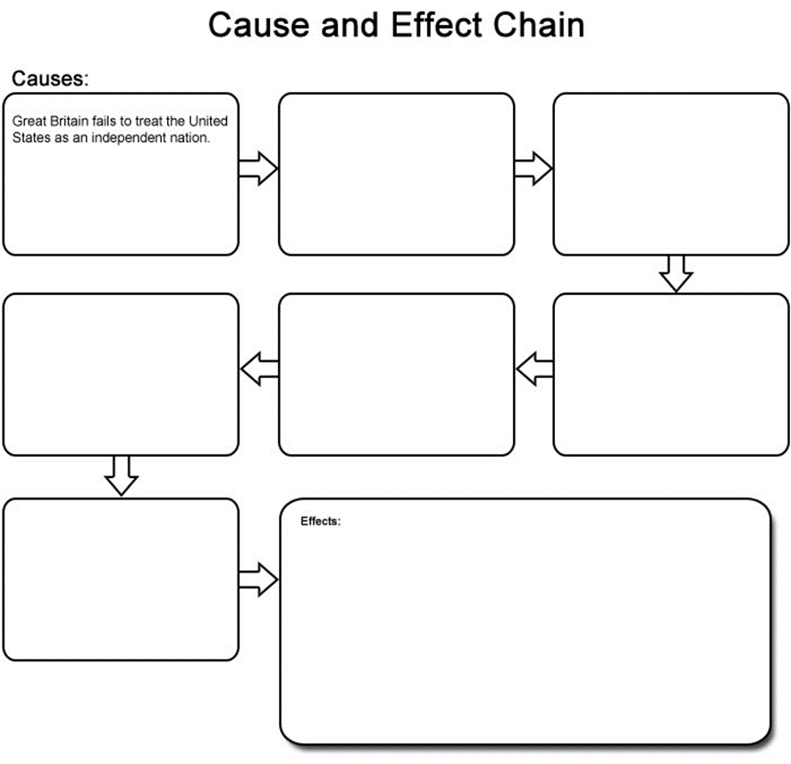

Unless Otherwise Noted All Content © 2022 Florida Virtual School. FlexPoint Education Cloud™ is a trademark of Florida Virtual School.