**The Iteration**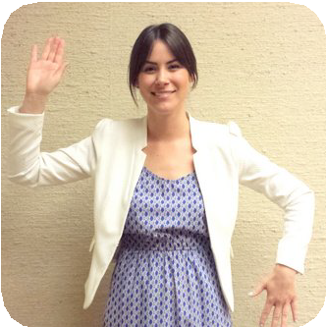

|  |  | **Clap** | **Clap** | **Clap** |  |
| --- | --- | --- | --- | --- | --- |
|  | **Behind Head** | **Waist** | **Behind Head** | **Waist** |
| Repeat this part **3** times! | **Clap** | **Clap** | **Clap** |  |
|  | **Left Up** | **Right Up** | **Left Up** | **Right Up** |
|  | **Clap** | **Clap** | **Clap** |  |
| Then do this! |  | **Belly Laugh** |  |  |  |