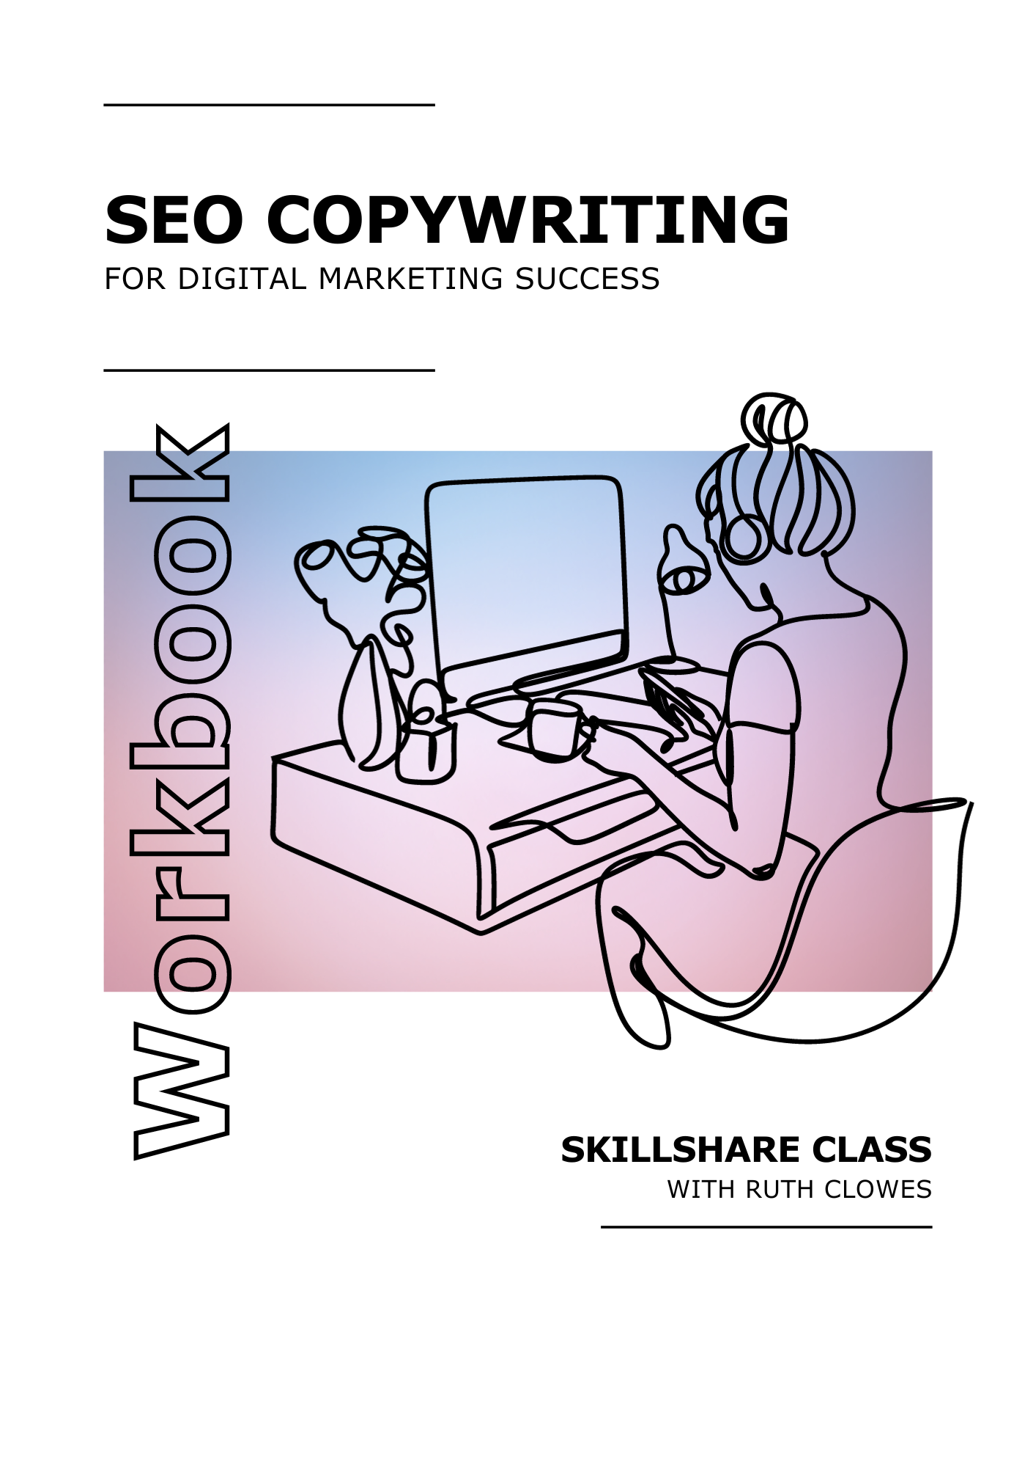

**Get ready to supercharge your SEO copywriting!**

Welcome to this workbook, your companion to my SEO Copywriting Skillshare class. It highlights key takeaways and exercises for real-time application. Download it or print it to complete each section by hand.

Your class project is to write a blog post using skills from the class. Follow along in the workbook, applying techniques to your project. Once complete, you'll have an SEO-friendly blog post and the resources for ongoing learning.

Thank you so much for choosing to learn from me. It’s a real privilege to guide you through this part of your professional journey.

**What’s Inside:**

SEO Copywriting Essentials 3

Keyword Research and Selection 4

Define Your Strategy 6

Structure Your Ideas 8

Write the First Draft 10

Add Effective Subheadings 12

Create a Clickworthy Title 13

Craft a Persuasive Call to Action 14

Enhance Readability 16

Develop Your Writing Style 17

Edit Your Work 18

Master Microcopy 19

Page Type Tactics 20

Maintain and Update Your Copy 21

Next Steps 23

Glossary 24

Quiz Answers 28

My Notes 29

# SEO Copywriting Essentials

**Key takeaways**

* **What is SEO copywriting?** It's the art of creating content that ranks well in search results and engages readers, combining strategic elements like keywords with more creative writing techniques.
* **SEO and user experience:** They work hand in hand. Modern search engines prioritise content that's both user-friendly and of high quality.
* **Avoid outdated tactics:** Focus on ethical strategies that deliver value to your audience, steering clear of tricks like keyword stuffing.
* **Golden rule of SEO copywriting:** Create content that your audience finds valuable and engaging.

-

**Exercise: Define your brand**

Paste or write your brand’s Mission Statement or About page copy below for easy reference as you progress through the class.

|  |
| --- |

-

**Recommended resource**

In my **15-Minute Brand Mission Statement** class, I show you how to write a strong mission statement for your brand in just 15 minutes using a simple formula. Having a clear mission statement can serve as a solid foundation for creating engaging and SEO-friendly blog posts, as it helps you connect with your readers and convey your brand's story and personality effectively.

Visit my Skillshare profile page to take the class: [skillshare.com/r/ruthclowes](https://www.skillshare.com/r/ruthclowes)

# Keyword Research and Selection

**Key takeaways**

* **Keyword basics:** Keywords are words or phrases people use in search engines. Effective SEO copywriting starts with understanding and selecting the right keywords.
* **Three-stage approach**: Conduct keyword research by focusing on your Brand (what you want to rank for), Audience (what your potential buyers are searching for), and Competition (what keyphrases you can realistically rank for).
* **Tools for research**: Use tools like Google Ads Keyword Planner and the Alphabet Soup technique with Google to understand your audience's search language.
* **Avoid language mismatch**: Ensure your brand's language aligns with the terms your audience uses in searches.
* **Competition analysis**: Analyse top-ranking pages for your potential keyphrases to identify opportunities and areas where you can offer unique value.

-

**Exercise: Carry out keyword research and selection**

**1. Brand stage keyphrases**

|  |
| --- |

**2. Audience stage keyphrases**

|  |
| --- |

**Focus Keyphrase**

|  |
| --- |

-

**Recommended resource**

The **Google Ads Keyword Planner** shows you how often people search for specific keywords and how much competition exists for those terms. This helps you choose the most effective keywords and keyphrases to use in your online advertising campaigns.

Use the keyword planner at: [ads.google.com/home/tools/keyword-planner](https://ads.google.com/home/tools/keyword-planner/)

# Define Your Strategy

**Key takeaways**

* **Four pillars of strategy:** Understand the WHO (audience), WHAT (message), WHY (purpose), and HOW (approach) before writing.
* **Audience definition:** Tailor your content to resonate with a specific audience.
* **Message clarity:** Set a consistent theme for your post that aligns with your Focus Keyphrase. This is the key idea you want your audience to take away.
* **Purpose identification:** Determine what action you want the reader to take after reading your post, whether it's making a purchase, signing up, or a feeling.
* **Unique approach:** Decide on a distinct 'flavour' or style for your content. Consider storytelling, data, debunking myths, or other tactics to make your content stand out.

-

**Exercise: Define your strategy**

Use the space below to define your audience, message, purpose and approach. On the next page is a list of potential approaches for inspiration.

**Audience**

|  |
| --- |

**Message**

|  |
| --- |

**Purpose**

|  |
| --- |

**Approach**

|  |
| --- |

-

**Recommended resource**

**Xtensio's User Persona Template** ([xtensio.com/user-persona-template](https://xtensio.com/user-persona-template)) helps you create detailed profiles of your target audience, including their needs and behaviour. Understanding your audience in this way makes it easier to write SEO copy that resonates with them and ranks well in search engines.

**Blog post approaches**

**Think about which approach best suits your audience, message and purpose. Consider blending multiple approaches to create a unique and compelling post.**

**Storytelling:** Craft your blog post around a compelling, relatable story. This helps humanise your brand and connects emotionally with your audience.

**Data-Driven:** Use statistics, charts, and research findings to support your message. This lends credibility to your post and can help to convince sceptics.

**Myth Debunking:** Address and debunk common myths or misconceptions related to your subject. This approach can intrigue readers and set the record straight.

**How-to Tutorial:** Provide a step-by-step guide or tutorial related to your focus keyphrase. This approach is educational and helps the reader to achieve something specific.

**Case Study:** Share a detailed analysis of a particular project or situation over time. This offers readers real-world examples and insights.

**Expert Interview**: Feature an interview with an industry expert or celebrity. This brings a fresh perspective to your blog and can also attract the expert's following.

**Listicle:** Organise your post as a list (e.g., “10 Best Eco-Friendly Cat Toys”). This format is highly scannable and popular among readers.

**Question and Answer:** Format your post as a series of questions and answers. This can help to address your readers’ specific queries clearly and directly.

**Timeline:** Present information in a chronological format. This can help to illustrate the history or progression of a topic.

**Comparison:** Compare and contrast two or more products, services, or ideas. This helps readers make informed decisions.

**Problem-Solution:** Clearly outline a problem and then provide a solution related to your focus keyphrase. This approach is straightforward and highly actionable for readers.

**Personal Experience/Reflection:** Share your own experiences and reflections related to the topic. This can make the post more relatable and authentic.

**Newsjacking:** Tie your blog post to a current event or trending topic. This can make your content timely and interesting to readers seeking recent information.

**Round-up:** Compile insights or advice from various experts or sources into one post. This offers readers a comprehensive view on a topic.

**Entertainment/Fun:** Write with the primary aim of entertaining the reader. Use humour, quizzes, or engaging stories to keep your readers entertained while also informing them.

# Structure Your Ideas

**Key takeaways**

* **Importance of structure:** A well-structured post improves readability, benefits SEO, and enhances audience engagement. Readers often scan subheadings and core sentences, so they should be engaging and informative.
* **Brainstorm ideas:** Start with a free-flowing brainstorm, jotting down everything you want to cover. Use tools like mind maps or Miro to visualise connections. Ensure your topics align with your strategy and consider recent trends or developments.
* **Organise topics and subtopics:** Group related ideas to form main topics and identify smaller points within these as subtopics. For instance, a topic might be the benefits of eco-friendly cat toys, with subtopics detailing environmental advantages and product range.
* **Sequence your topics:** Determine a logical flow for your content, considering the reader’s journey. The order could be chronological, sequential, or problem-solution based. Ensure smooth transitions between each topic and subtopic.

-

**Recommended resource**

**Miro** ([miro.com](https://miro.com/)) provides a digital board where you can jot down and organise your ideas visually. This makes it easier to brainstorm topics for a blog post and see how they connect with each other.

Alternatively, use the space below to brainstorm and organise your ideas.

|  |
| --- |

-

**Exercise: Write your blog outline**

Use the Blog Outline Template on the next page. There’s plenty of room to add more lines to the table if you need to.

**Blog Outline Template**

| **Topic** | **Subtopic** |
| --- | --- |
| Introduction |  |
| Topic 1 |  |
|  |  |
| Topic 2 |  |
|  |  |
| Topic 3 |  |
|  |  |
| Topic 4 |  |
|  |  |
| Topic 5 |  |
|  |  |
| Conclusion |  |

# Write the First Draft

**Key takeaways**

* **Starting point:** A first draft is like sculpting from clay; it begins rough. Your goal is to shape and refine it. Transfer your outline into your writing platform, like Wordpress, and title your blog with your Focus Keyphrase.
* **Core sentences:** These are the first sentences under each heading, vital for capturing attention. They should summarise the topic and subtopics and be compelling. Techniques include using shocking statistics, humour, questions, provocative statements, or directly addressing the reader. Incorporate your Focus Keyphrase where possible.
* **Crafting the body:** Write methodically through each topic and subtopic, supporting your message. Start paragraphs with a main idea, followed by elaboration. Ensure paragraphs tackle one idea and contain more than one sentence. Some sections, like tutorials, might work as lists.
* **Introduction:** Begin with a hook to capture attention, like a surprising fact or question. Provide context and state your main message. Shopify, for instance, uses a shocking story to engage readers in a post about insurance.
* **Conclusion:** Summarise key points, re-emphasise your message, and avoid introducing new information. Refer to your introduction for a sense of completion. Include your Focus Keyphrase naturally.
* **Staying focused:** If you struggle to concentrate, platforms like Noisli offer ambient sounds to create a distraction-free environment.
* **Next steps:** Complete your first draft using this approach. Convert your outline into a draft, focus on compelling core sentences, and ensure alignment of your introduction and conclusion with your message. Use the Self-Review Checklist in your Workbook for guidance.

-

**Exercise: Review your first draft**

Use the checklist on the next page to review your copy. To use the checklist, open your blog draft and go through each item. Tick off what you've done. If something's missing, go back and add it. Once everything's ticked, you're good to go.

The checklist helps you write better blogs quickly. It makes sure you don't miss important bits and keeps all your posts at the same high standard. It's also a good guide if you're new to blogging.

-

**Recommended resource**

**Noisli** ([noisli.com](https://www.noisli.com/)) lets you play background sounds like rain or coffee shop noise to drown out distractions. This can help you focus better when you're writing the first draft of a blog post.

**Self-Review Checklist**

**Initial setup**

* Have I transferred my outline into the app or platform where I will be doing my writing?
* Is the title of my blog post formulated, and does it include the focus keyphrase?

**Introduction**

* Does my introduction start with a compelling hook? (e.g., surprising fact, provocative question, powerful quote, intriguing statement)
* Have I provided a brief introduction to the topic and context?
* Have I clearly stated the purpose or thesis of the post using my main message?
* Is my focus keyphrase naturally incorporated into the introduction?

**Body structure and content**

* Have I turned the topics in my outline into headings in my draft?
* Have I turned the subtopics in my outline into body text in my draft?
* Does each section of my post start with a compelling core sentence?
* Does each paragraph tackle one main idea, and is it separated from others by white spaces?
* Have I avoided placing multiple subtopics into one paragraph?
* Have I included evidence or information to support my message under each topic and subtopic?
* Is my focus keyphrase naturally incorporated throughout the body of the post, especially in headings and core sentences?

**Visual planning**

* Have I considered what images I want to include in my post?
* Have I thought about how these images will complement the text and contribute to the post’s overall message?

**Conclusion**

* Does my conclusion summarise the key points made in the post?
* Have I restated my central message in the conclusion?
* Have I avoided introducing any new information in the conclusion?
* Is my focus keyphrase naturally incorporated into the conclusion?

**Overall flow**

* Does the post have a logical flow, moving from introduction to body to conclusion in a coherent and organised manner?
* Have I reviewed my draft for grammar, spelling, and punctuation errors?
* Have I formatted different sections appropriately, as per the content? (e.g., lists, step-by-step guides)

**Next steps**

* Am I ready to move on to the next step of adding effective subheadings?

# Add Effective Subheadings

**Key takeaways**

* **Keep it clear:** Your subheadings should be both descriptive and concise. Aim for 5-10 words, ensuring they accurately reflect the content that follows.
* **Engage your reader:** Start subheadings with action verbs to make them more inviting - "Discover the benefits" is more engaging than just "The benefits".
* **Balance with keywords:** Incorporate your Focus Keyphrase in subheadings to boost SEO. However, do it naturally, avoiding the trap of keyword stuffing.
* **Hierarchy matters:** Use a clear hierarchy for your subheadings. Your main title is H1, topic headings are H2, and if needed, use H3 for more detailed subtopics.

-

**Exercise: Experiment with different types of subheadings**

**Descriptive:** Clearly and concisely summarise the content that follows.

*Example: The Benefits of Eco-Friendly Cat Toys*

|  |
| --- |

**Action-oriented:** Start with action verbs and create a direct relationship with the reader.

*Example: Discover the Joy of Green Catnip Toys*

|  |
| --- |

**Intriguing:** Spark curiosity and entice the reader to continue reading.

*Example: The Secret Filling in Our Eco-Friendly Mouse Toy*

|  |
| --- |

**Problem-solving:** State the problem your content is solving as a statement or question.

*Example: Ready to Make Your Cat Care Routine More Sustainable*

|  |
| --- |

-

**Recommended resource**

The SEO experts at **Yoast** have written a brilliant article full of practical tips on how to use headings to guide the reader, improve SEO, and make your content more accessible. Read it here: [yoast.com/how-to-use-headings-on-your-site](https://yoast.com/how-to-use-headings-on-your-site/)

# Create a Clickworthy Title

**Key takeaways**

* **The power of titles:** Your blog post's title is the first impression, crucial for captivating readers and impressing search engines. It's best crafted after the content is complete to ensure alignment with the post's evolved focus.
* **Crafting techniques:** Aim for titles between 50-60 characters. Use action verbs, numbers, or invoke curiosity. For instance, "10 Reasons to Choose Eco-friendly Cat Toys" or "Discover the Secret Ingredient in Our Eco-Friendly Toy". Remember, numerals grab attention more than written numbers.
* **SEO and focus keyphrase:** Incorporate your Focus Keyphrase naturally into the title for SEO benefits. It should be a seamless fit since the keyphrase represents the core of your content.
* **URL considerations:** Customise your post's URL for clarity and SEO. For example, instead of "10-eco-friendly-toys-your-cat-will-love", use "eco-friendly-cat-toys". Avoid changing URLs post-publishing to prevent broken links.
* **Next steps:** Experiment with various title styles, ensuring alignment with your content and natural incorporation of your Focus Keyphrase. Record your attempts in your Workbook for reference.

-

**Exercise: Write some possible titles and choose your favourite**

Experiment with starting your title with an action verb, using numbers, or creating a sense of curiosity. Ensure that your Focus Keyphrase is naturally incorporated into your title and that your title aligns with the content of your blog post.

|  |
| --- |

-

**Recommended resources**

The **Headline Studio by CoSchedule** ([headlines.coschedule.com](https://headlines.coschedule.com/)) is a tool that scores the quality of your blog post titles and rates their potential for social shares, increased traffic, and SEO value. It helps you write better headlines that can attract more readers and improve your blog's search engine ranking.

In my **Writing Persuasive Headlines** Skillshare class, I show you how to write headlines that are both persuasive and clickable, using professional copywriting techniques. The skills you learn can help make your blog post titles more appealing, increasing clicks and engagement without resorting to clickbait. Find the class on my Skillshare profile page: [skillshare.com/r/ruthclowes](https://www.skillshare.com/r/ruthclowes)

# Craft a Persuasive Call to Action

**Key takeaways**

* **Purpose of CTAs:** CTAs guide readers from passive engagement to active participation. They're essential for SEO, reducing bounce rates, and increasing site engagement. Your Focus Keyphrase can be naturally incorporated, but it's also a place to get creative.
* **Placement:** While the end of a post is an obvious spot, consider interspersing CTAs throughout your content. This caters to readers at different engagement levels and addresses varied intentions. However, avoid overloading; ensure CTAs are relevant and non-disruptive.
* **Effective techniques:** Start with a strong action verb for clarity, like "Discover the eco-friendly difference!". Channel the reader's voice, e.g., "Yes, I want greener playtime!". Highlight benefits, such as "Claim your 20% discount today!” and use urgency triggers like "now" or "today".
* **Engage with questions and reassurance:** Questions, like "Looking for a sustainable cat toy?", engage readers psychologically. Reassurance, such as "30-day money-back guarantee", builds trust and alleviates online shopping concerns.

-

**Exercise: Experiment to find the CTA type that fits your post**

**Invitation to explore**

Invites curiosity and encourages readers to learn more about a topic, making them more likely to engage.

*Example: "Discover Sustainable Play"*

|  |
| --- |

**Discount offer**

Directly appeals to cost-saving interests, increasing the likelihood of first-time purchases.

*Example: "Get 20% Off Your First Eco-Toy Order"*

|  |
| --- |

**Exclusive membership**

Creates a sense of community and exclusivity, enticing readers to gain access to special offers.

*Example: "Join the Green Paw Club for Exclusive Deals"*

|  |
| --- |

**Free resource**

Offers valuable information at no cost, building trust and encouraging further interaction.

*Example: "Download Our Free Guide to Eco-Friendly Cat Care"*

|  |
| --- |

**Direct call to shop**

Provides a clear action for immediate purchase, making it easier for readers to decide.

*Example: "Shop Now for Toys Cats Love—and the Planet Appreciates"*

|  |
| --- |

**Educational content**

Encourages informed decision-making by offering educational content, increasing engagement.

*Example: "Learn Why Sustainability Matters for Your Cat"*

|  |
| --- |

**Gifting option**

Highlights a specific use-case or occasion, making the offer more relatable and appealing.

*Example: "Gift a Bundle of Joy: Eco-Friendly Toy Sets Available"*

|  |
| --- |

**Time-sensitive deal**

Creates urgency, prompting quicker decision-making and action.

*Example: "Limited Time Offer: Save on Our Best-Selling Eco Toys"*

|  |
| --- |

**Call for change**

Encourages readers to make a positive impact, increasing the likelihood of taking action.

*Example: "Take the Leap: Make Your Cat’s Playtime Greener Today"*

|  |
| --- |

**Reverse psychology**

Uses unexpected language to grab attention and make readers rethink their choices.

*Example: "No Thanks, I Prefer Plastic Toys"*

|  |
| --- |

-

**Recommended resource**

**HubSpot** have collected various examples and tips on how to create effective CTAs that guide visitors through the buying journey. It covers different types of CTAs and offers advice on writing compelling text to encourage action.

Read the article here: [blog.hubspot.com/marketing/call-to-action-examples](http://blog.hubspot.com/marketing/call-to-action-examples)

# Enhance Readability

**Key takeaways**

* **Simplifying language:** It’s about making complex ideas accessible.
* **Transition words:** These connective words, like 'and', 'but', and 'because', guide readers through your text, making it flow better.
* **Use simple language:** Opt for straightforward words over complex ones.
* **Shorten sentences:** Aim for sentences with 20 words or fewer.

-

**Exercise: Readability quiz**

Here is a series of sentences that can be improved using one or more of the techniques you’ve just learned. Check your improved versions against my suggestions at the back of the book.

Our eco-friendly cat toys are crafted utilising the utmost sustainable materials.

|  |
| --- |

Many customers have given positive reviews due to the undeniable satisfaction that our toys bring, as demonstrated by the glowing feedback and repeat purchases we observe.

|  |
| --- |

This month, some of our select, premium, eco-friendly cat toys are available for acquisition at a discounted rate.

|  |
| --- |

We encourage individuals who are conscious about the environment and the well-being of their feline companions to consider our products.

|  |
| --- |

This extensive guide elucidates the significance of choosing toys that are both enjoyable for your cat and have minimal negative impact on our planet.

|  |
| --- |

-

**Recommended resource**

The **Hemingway App** ([hemingwayapp.com](https://hemingwayapp.com/)) helps make your writing clearer by highlighting long, complex sentences and common errors. It offers suggestions for simpler words, identifies weak phrases, and marks sentences in passive voice.

# Develop Your Writing Style

**Key takeaways**

* **The power of unique style:** A distinctive style not only engages readers but also boosts SEO by keeping readers on your page longer and encouraging content sharing.
* **Finding your style:** In your Workbook, there's a list of writing styles. Choose two or three that resonate with you. This choice can guide your tone and approach.
* **Write like you talk:** Draft an email to a friend about a topic you love. This exercise helps you capture a conversational tone, making your writing more relatable.
* **Storytelling:** Share personal anecdotes or experiences in your content. These stories make your writing memorable and help build a connection with readers.
* **Imitate to innovate:** Start by imitating styles you admire. Over time, blend these elements with your voice.

-

**Exercise: Define your style**

Here is a list of twenty different writing styles that you can consider when developing your own style. Highlight or circle the ones that resonate with you and that you want to pursue. There’s space at the bottom of the table for you to add your own ideas.

| Humorous | Friendly | Professional | Reflective |
| --- | --- | --- | --- |
| Formal | Informal | Conversational | Provocative |
| Authoritative | Persuasive | Inspirational | Sarcastic |
| Descriptive | Analytical | Explanatory | Empathetic |
| Storytelling | Casual | Enthusiastic | Sincere |
|  |  |  |  |
|  |  |  |  |

-

**Recommended resources**

The **Writer Igniter by DIY MFA** ([diymfa.com/writer-igniter](https://diymfa.com/writer-igniter/)) is a prompt generator that gives you a random character, situation, prop, and setting to write about. It helps you practice different writing styles and scenarios, making it a useful tool for developing your own unique writing style.

In my **Tone of Voice** Skillshare class, I share how to maintain a consistent brand voice while adapting your tone for different audiences and platforms. You'll learn practical techniques for writing with clarity and warmth, making your marketing communications more effective and helping you develop your own writing style.

Visit my Skillshare profile page to take the class: [skillshare.com/r/ruthclowes](https://www.skillshare.com/r/ruthclowes)

# Edit Your Work

**Key takeaways**

* **Why edit?** Editing ensures clarity, professionalism, and boosts SEO. Think of it as clearing a path for a smooth reader journey.
* **Distance and structure:** After writing, take a break. Ensure your post has a clear start, middle, and end. Use the active voice for directness.
* **Trimming:** Remove redundant words and ensure sentences are concise. Manually check spelling, especially brand names.
* **Avoid clichés and check grammar:** Use tools like Cliché Finder and be mindful of common grammar pitfalls.

-

**Exercise: Practice using the active voice**

Here are six sentences written in the passive voice. Rewrite them in the active voice. The answers are at the back of the Workbook.

The eco-friendly toys were loved by all the cats.

|  |
| --- |

Sustainable cat food is sold at the Green Cat shop.

|  |
| --- |

Biodegradable litter boxes are being promoted this month.

|  |
| --- |

The organic catnip was grown without the use of pesticides.

|  |
| --- |

Customer inquiries are handled with utmost care by our team.

|  |
| --- |

-

**Recommended resource**

The **Cliché Finder** tool ([clichefinder.net](https://www.clichefinder.net/)) scans your blog post to find and highlight clichés—words or phrases that are overused. Removing these clichés can make your writing more original and improve its SEO performance.

# Master Microcopy

**Key Takeaways**

* **Meta descriptions:** These brief summaries under URLs in search results entice readers. Craft them to be succinct and intriguing, integrating keywords naturally.
* **Anchor text:** Instead of generic phrases like 'click here', use descriptive text like 'our range of sustainable cat toys' to guide readers and boost SEO.
* **Image captions and alt text:** Captions provide context, while alt text describes the image for accessibility and SEO. Write engaging captions and descriptive alt text.

-

**Exercise: Microcopy quiz**

Which type of microcopy is shown in each of the images below? Answers are at the back.

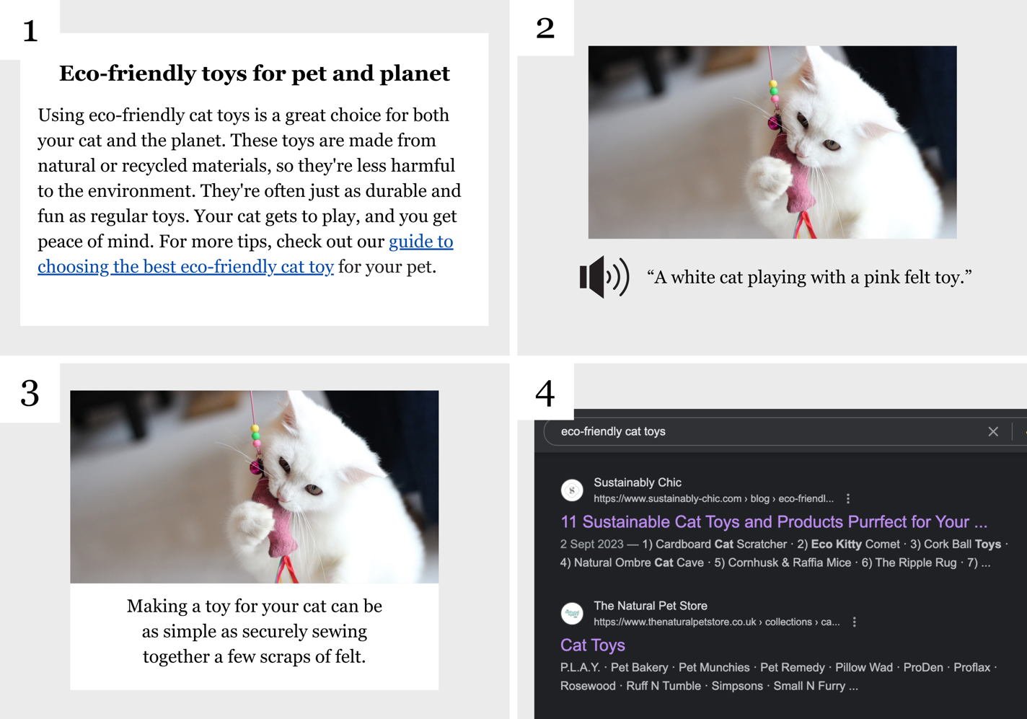

-

**Recommended resource**

**Portent's SERP Preview Tool** ([portent.com/serp-preview-tool](https://www.portent.com/serp-preview-tool/)) lets you see how the title and meta description of your blog post will appear in Google search results. This helps you tweak them to be more appealing and SEO-friendly.

# Page Type Tactics

**Key takeaways**

* Many of the techniques we’ve covered in this class are universal and can be applied to any web copy. But some types of pages call for you to **flex your approach** or prioritise certain techniques because each page on your website has its own unique purpose and audience.

-

**Exercise: Craft your page headlines**

**Craft compelling headlines** for different types of web pages on your site. Practice tailoring your approach to different pages while thinking about the user experience and SEO.

**About page:** *(e.g.**Meet the Team Behind Your Cat's Green Lifestyle)*

|  |
| --- |

**Product page:** *(e.g.**Organic Catnip: The Safe and Natural Choice for Your Feline Friend)*

|  |
| --- |

**Landing page:** *(e.g.**Transform Your Cat's Life with Our Eco-Friendly Essentials)*

|  |
| --- |

**Category page:** *(e.g.**Browse Our Range of Sustainable Cat Toys)*

|  |
| --- |

**FAQ page:** *(e.g.**Your Questions Answered: Making Eco-Friendly Choices for Your Cat)*

|  |
| --- |

**Contact page:** *(e.g.**Get in Touch: We're Here to Help You Go Green with Your Cat)*

|  |
| --- |

-

**Recommended resource**

**Google's Markup Helper** helps you add structured data to your blog post or web page. Structured data makes it easier for search engines to understand your content, increasing the chance of your page appearing as a rich result in Google search.

Find it here: <http://google.com/webmasters/markup-helper>

# Maintain and Update Your Copy

**Key Takeaways**

* **Why update?** Web copy is dynamic. With changing algorithms, trends, and business goals, regular updates ensure relevance and SEO favourability.
* **Audit timing:** Conduct content audits twice a year. For fast-paced industries, consider more frequent checks. Tools like Trello can help schedule these audits.
* Content Checks: Update facts and statistics. Ensure links work and CTAs align with current business goals. Adjust older content to reflect your evolving tone of voice.
* **SEO impact:** If older content still drives traffic, it's valuable and worth updating. For less popular posts, focus on creating fresh content.
* **Transparency:** When updating, add a note indicating changes and the new date. This builds trust with readers and can boost SEO.
* **Example:** Healthline provides update histories at the end of their posts, reinforcing trustworthiness.

-

**Exercise: Schedule your web page’s audit**

Create a schedule for maintaining and updating your web copy. Use the Web Page Audit Checklist on the next page to audit each web page.

-

**Recommended resource**

You can use **Trello** ([trello.com](http://trello.com/)) to create a board specifically for your blog maintenance and updates. Create lists for different stages like "Ideas," "In Progress," "Ready for Update," and "Completed." Add cards for each blog post that needs updating or maintenance and move them through the lists as you work on them. Attach deadlines, checklists, and notes to each card to keep track of what needs to be done and when.

**Web Page Audit Checklist**

**Verify facts and statistics**

* Confirm the accuracy of facts, figures, and statistics used on the page.

**Review internal linking strategy**

* Check for opportunities to add more relevant internal links.
* Ensure all existing internal links are working and point to the correct pages.

**Fix broken links**

* Use tools like Google's Search Console to identify and fix any broken links on the page.

**Update CTAs (Calls to Action)**

* Confirm that CTAs lead to the correct pages.
* Ensure CTAs align with current business goals and offers.

**Re-evaluate and adjust tone of voice**

* Review and adjust the language so it aligns with your evolving brand voice.

**SEO considerations**

* Look for updates from search engines and adjust your copy to reflect any changes in SEO best practices.
* If substantial changes are made, add a note indicating the content has been updated, with the new date.

**Analyse page performance**

* Review traffic data for the page. If traffic has dropped, consider a more significant refresh.

**Review and update meta descriptions and titles**

* Ensure that meta descriptions and titles are current, relevant, and effectively optimised for target keywords.

**Content relevance and freshness**

* Ensure the content remains relevant to your audience and up-to-date, based on current trends or industry changes.

**Check for mobile responsiveness**

* Ensure the page looks and functions well on mobile devices.

**Review user comments and feedback**

* Look at comments and feedback to see if any updates or clarifications are needed in the content.

**Update images and media**

* Check if images, videos, or other media are still relevant and working properly.

**Check social media shares and mentions**

* Review how often the post has been shared or mentioned on social media and consider updating shareable content.

**Review legal compliance**

* Make sure the content adheres to legal requirements, such as copyright laws.

**Audit page load speed**

* Check if the page loads quickly enough, especially with any new media added.

**Check for outdated offers or promotions**

* Remove or update any outdated special offers or promotions mentioned in the post.

**Review competitor content**

* Check what competitors are doing and see if your post still stands out.

**Update author bio**

* If there have been changes to the author's credentials or role, update the author bio accordingly.

# Next Steps

**Thank you for taking part in this class and congratulations on all your hard work!**

Together, we've dived into the world of SEO copywriting and surfaced with a better understanding of what makes great online content.

To view my full collection of Skillshare copywriting classes, visit my profile page ([skillshare.com/r/ruthclowes](https://www.skillshare.com/r/ruthclowes)). Don't forget to hit 'Follow' to receive updates whenever I launch a new class.

Again, thank you for joining me in this journey. It's been a pleasure to share my knowledge with you. Enjoy the rest of your day, and here's to your success in SEO copywriting!

# Glossary

**SEO Copywriting Essentials**

**SEO (Search Engine Optimisation)**: The practice of optimising a website to rank higher in search engine results.

**Copywriting**: The art of writing content that persuades readers to take a specific action, such as clicking on a website or buying a product.

**SEO copywriting**: A specialised form of copywriting that focuses on creating content that ranks well in search engines while also engaging and persuading readers.

**User experience**: The overall experience a user has while interacting with a website or application, including how easy or pleasing it is to use.

**Keyword stuffing**: The outdated and frowned-upon practice of excessively using keywords in content to manipulate rankings.

**Meta data**: Information about a web page that is included in the HTML but not visible to users. Includes meta descriptions and meta tags.

**Algorithm**: A set of rules that search engines use to rank web pages in their results.

**Mission statement**: A brief description of a company's fundamental objectives and values. Mentioned as important background information for SEO copywriting.

**Keyword Research and Selection**

**Keyword**: A word or phrase that people type into search engines to find information.

**Keyword research**: The process of identifying words or phrases that people use in search engines, aiming to rank your content for these terms.

**Focus keyphrase**: The primary keyword or phrase you aim to rank for in a specific post or page.

**Alphabet soup**: A technique using Google's search bar to find common search terms related to your main topic, starting with each letter of the alphabet.

**Unique Selling Points (USPs)**: Features or qualities that make your brand stand out from the competition.

**Niche**: A specialised segment of the market for a particular kind of product or service.

**Language mismatch**: The error of not using the same language or terms that your audience uses in searches.

**Define Your Strategy**

**Audience**: The target readers for your blog post or web page.

**Message**: The main idea or information you aim to convey to your audience.

**Purpose**: The desired outcome or action you want from readers after they've read your post.

**Approach**: The unique style or method you'll use to deliver your message.

**User persona**: A detailed profile of your ideal reader.

**Marketing plan**: A comprehensive document outlining your marketing efforts, including objectives, strategies, and tactics.

**Problem-solution approach**: A method of presenting a problem and then offering a solution, often your product or service.

**Listicle**: An article presented in the form of a numbered or bulleted list.

**Case study**: A detailed analysis of a particular subject, often used to provide evidence or support.

**Testimonial**: A statement testifying to the benefits of a product or service, usually from a satisfied customer.

**Structure Your Ideas**

**Structure**: The arrangement of ideas and information in your post to boost readability and SEO.

**Audience engagement**: The level of interest and interaction your audience has with your content.

**Scanning**: The act of quickly looking over text to get a general idea of the content.

**Subheadings**: Smaller headings used to break up content into sections.

**Core sentences**: The first sentences under each subheading, often containing the main ideas of each section.

**Logical transitions**: The use of words or phrases to guide the reader through the text and link ideas together.

**Reasonable surfer**: A model used by search engines to predict which links on a page are most likely to be clicked.

**Semantic closeness**: A measure of how closely related different parts of a text are, used by search engines to understand content.

**Write the First Draft**

**Introduction**: The opening section of your blog post, designed to hook the reader and provide an overview of the content.

**Conclusion**: The final section of your blog post, summarising the key points and re-emphasising the central message.

**Hook**: A compelling sentence or question in the introduction designed to capture attention.

**Paragraph structure**: The organisation of sentences within a paragraph to express and elaborate on a single main idea.

**White space**: Empty areas on a page that separate paragraphs and other elements, improving readability.

**Numbered list**: A list where each item is preceded by a number, often used for steps in a tutorial or process.

**Wordpress**: A popular platform for creating and publishing blog posts and websites.

**Focus mode**: A feature in some writing apps that minimises distractions to help you concentrate on writing.

**Stylistic effect**: Deliberate choices in writing style, such as sentence length or structure, to achieve a particular impact.

**Add Effective Subheadings**

**Subheadings**: Secondary titles within your blog post that break up the content and guide the reader through the text.

**Placeholder subheadings**: Temporary subheadings used during the planning stage, which may be refined later.

**Descriptive subheadings**: Subheadings that accurately reflect the content that follows, aiding in readability and SEO.

**Action verbs**: Words that signify an action, often used at the beginning of subheadings to engage the reader.

**Intriguing subheadings**: Subheadings designed to pique the reader's curiosity and encourage further reading.

**Problem-solving subheadings**: Subheadings that indicate the content will provide a solution to a specific problem.

**Hierarchy of subheadings**: The organisation of subheadings in a descending order of importance, usually marked by HTML tags like H1, H2, and H3.

**Create a Clickworthy Title**

**Title**: The main heading of your blog post, crucial for capturing reader attention and SEO.

**Character limit**: The optimal length for a title, usually between 50-60 characters, to ensure it displays fully in search engine results.

**Teaser titles**: Titles designed to invoke curiosity and suspense.

**Testimonial titles**: Titles that incorporate a personal experience or case study.

**Power words**: Words that evoke strong emotional responses to make titles more enticing.

**URL**: The web address where your blog post can be found, important for SEO.

**Bounce rates**: The percentage of visitors who navigate away from your site after viewing only one page, used as an SEO metric.

**Backlinks**: Incoming links to your webpage from another website, important for SEO.

**Craft a Persuasive Call to Action**

**CTA (Call to Action)**: A prompt within your content that encourages the reader to take a specific action, such as signing up for a newsletter or making a purchase.

**Split-testing**: A method of comparing two versions of a webpage or app against each other to determine which one performs better.

**Hubspot**: A developer and marketer of software products for inbound marketing, sales, and customer service. Known for educational content on digital marketing.

**Reassurance**: Providing a sense of security and trustworthiness, often used in CTAs to alleviate fears or concerns.

**Psychological triggers**: Elements like urgency or questions that engage the reader at a psychological level, making the CTA more effective.

**Enhance Readability**

**Readability**: The ease with which a reader can understand written text. High readability means the content is easy to read and understand.

**Transition words**: Words like 'and', 'but', 'so', and 'because' that help guide the reader through the text and make it flow better.

**Hemingway**: An online tool that helps improve the readability of your text by highlighting long sentences, complicated words, and passive voice.

**Simple alternatives**: Easier or more straightforward words that can replace more complicated or formal words to improve readability.

**Develop Your Writing Style**

**Conversational tone**: A writing style that mimics the way people naturally speak, making the content feel more relatable and engaging.

**Free writing**: A technique where you write continuously for a set period without worrying about grammar or structure, often used to unlock creativity.

**Writing prompt generator**: A tool that provides a starting point to inspire creative writing.

**Personal anecdotes**: Short, personal stories or experiences used to illustrate a point, add interest, or engage the reader.

**Imitate to innovate**: The practice of learning from other writers by mimicking their style before developing your own.

**Trusted group**: A circle of people whose opinions you value, often used for gathering feedback on your writing.

**Edit Your Work**

**Editing**: The process of revising and correcting a written document to improve its clarity, coherence, and overall quality.

**Active voice**: A sentence structure where the subject performs the action.

**Passive voice**: A sentence structure where the subject receives the action.

**Spellchecker**: A software tool that identifies and corrects spelling errors in a text.

**Fact-check**: The process of verifying the accuracy of information.

**Grammar and punctuation**: The set of structural rules governing the composition of sentences, phrases, and words in a language.

**Feedback**: Comments or suggestions about a product, service, or piece of work, aimed at improving its quality.

**Master Microcopy**

**Microcopy**: Small bits of text on a website that guide actions and improve experience.

**Meta descriptions**: Short summaries that appear under the URL in search results, providing a sneak peek into the content of a web page.

**SERP (Search Engine Results Page)**: The page shown by a search engine in response to a query.

**Click-through rates**: The ratio of users who click on a specific link to the number of total users who view the page.

**Anchor text**: The clickable text in a hyperlink that describes the content linked to.

**Image captions**: Short descriptions placed under images.

**Alt text (alternative text)**: Text that describes the content and function of an image.

**Accessibility**: The design of products, devices, services, or environments to be usable by as many people as possible, including those with disabilities.

**Page Type Tactics**

**Social proof**: Evidence, like customer testimonials or reviews, that others have had a positive experience with a product or service.

**Scannable format**: A layout that allows readers to quickly identify key points, often using headings, bullet points, and short paragraphs.

**Conversion**: The action you want a visitor to take on a landing page, such as making a purchase or filling out a form.

**Page authority**: A metric that predicts how well a specific page will rank on search engine result pages (SERP).

**Schema markup**: A code that you put on your website to help search engines provide more informative results for users.

**Local SEO**: SEO strategies focused on improving visibility in local search results.

**Maintain and Update Your Copy**

**Audit**: A thorough review of your web content to ensure it's accurate, current, and aligned with your business goals.

**Trello**: A task management tool that can be used to schedule content audits and updates.

**Google's Search Console**: A tool provided by Google to help you monitor, maintain, and troubleshoot your site's presence in Google Search results.

**Ethical transparency**: The practice of being honest about changes made to published content.

**Evergreen content**: Content that remains relevant and useful over a long period of time.

# Quiz Answers

**Readability**

**Original:** Our eco-friendly cat toys are crafted utilising the utmost sustainable materials.

**Improved:** Our eco-friendly cat toys are made using sustainable, organic materials.

**Original:** Many customers have given positive reviews due to the undeniable satisfaction that our toys bring, as demonstrated by the glowing feedback and repeat purchases we observe.

**Improved:** Many customers have given positive reviews because our toys bring them joy. In fact, we often see repeat purchases.

**Original:** This month, some of our select, premium, eco-friendly cat toys are available for acquisition at a discounted rate.

**Improved:** This month, you can buy some of our best eco-friendly cat toys on sale.

**Original:** We encourage individuals who are conscious about the environment and the well-being of their feline companions to consider our products.

**Improved:** If you care about the environment and your cat's health, consider our products.

**Original:** This extensive guide elucidates the significance of choosing toys that are both enjoyable for your cat and have minimal negative impact on our planet.

**Improved:** This guide explains why choosing fun and eco-friendly toys for your cat is important.

-

**Active voice**

**Passive:** The eco-friendly toys were loved by all the cats.

**Active:** All the cats loved the eco-friendly toys.

**Passive:** Sustainable cat food is sold at the Green Cat shop.

**Active:** The Green Cat shop sells sustainable cat food.

**Passive:** Biodegradable litter boxes are being promoted this month.

**Active:** We are promoting biodegradable litter boxes this month.

**Passive:** The organic catnip was grown without the use of pesticides.

**Active:** We grew the organic catnip without using pesticides.

**Passive:** Customer inquiries are handled with utmost care by our team.

**Active:** Our team handles customer inquiries with utmost care.

-

**Microcopy**

**1** = Anchor text

**2** = Alt text

**3** = Image caption

**4** = Meta description

# My Notes

|  |
| --- |