ASSESSMENT
Powerful Passwords

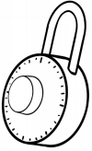
- Some websites make you type in a username and a __________ if you want to visit their site.

  - password

  - crossword

  - puzzle

- True or False: Sam Slate’s password is sammyslate.
This is a great password because it has a lot of letters.

  - True

  - False

- Circle DO or DON’T next to each of the statements below.

DO DON’T share your password with your friends.

DO DON’T make passwords eight or more characters long.

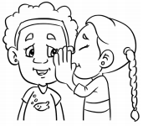
DO DON’T use your street address in your password.

