

Resume example
Hello Valued Applicant,
Creating a standout resume has never been easier! Our resumes feature clean, modern designs tailored to make a lasting impression. Crafted by certified resume writers and optimized for ATS compatibility, they’re built to help you succeed in today’s competitive job market.

Here’s how we can help you:
Build Your Resume – Our simple tool makes creating a standout resume quick and stress-free.
Browse Resume Templates – Choose from modern, eye-catching designs tailored to impress.
Explore Resume Examples – Get inspired by samples made for every industry and role.
Write the Perfect Cover Letter – Complete your application with a compelling cover letter that wins interviews.
Job Search – Visit our blog for expert tips and strategies to help you land your dream job.
Take the guesswork out of job applications and start creating your future today. We’ll make sure you’re ready to seize every opportunity with confidence!
Your next chapter starts here – let’s get started.

Warm regards,
The Resume Example Team

How to Write a Business Manager Resume

1. Start with a Strong Resume Summary
- Your summary should highlight your expertise, leadership experience, and key achievements in 2–3 sentences.
- Use numbers and measurable results to showcase impact.

2. Tailor Your Resume for Each Job
- Customize your resume by including keywords from the job description.
- Align your experience with the role’s key responsibilities.

3. Emphasize Leadership and Business Strategy
- Show how you have led teams, improved efficiency, and contributed to business growth.
- Use action-oriented bullet points to describe your work experience.

4. Use Quantifiable Achievements
- Instead of generic descriptions, include numbers:
  - "Increased sales by 25% in one year."
  - "Reduced operational costs by 30%."

5. Optimize for Applicant Tracking Systems (ATS)
- Use standard section headings (e.g., "Work Experience," "Skills," "Education").
- Avoid images, charts, and complex formatting that ATS may not read.

6. Keep it Concise and Professional
- Stick to a one- to two-page resume.
- Use a professional font (Arial, Calibri, Times New Roman) in size 10-12.

7. Include Relevant Certifications and Skills
- Certifications like PMP, Six Sigma, and leadership training add credibility.
- Highlight technical skills relevant to business management.

Business Manager Resume Example

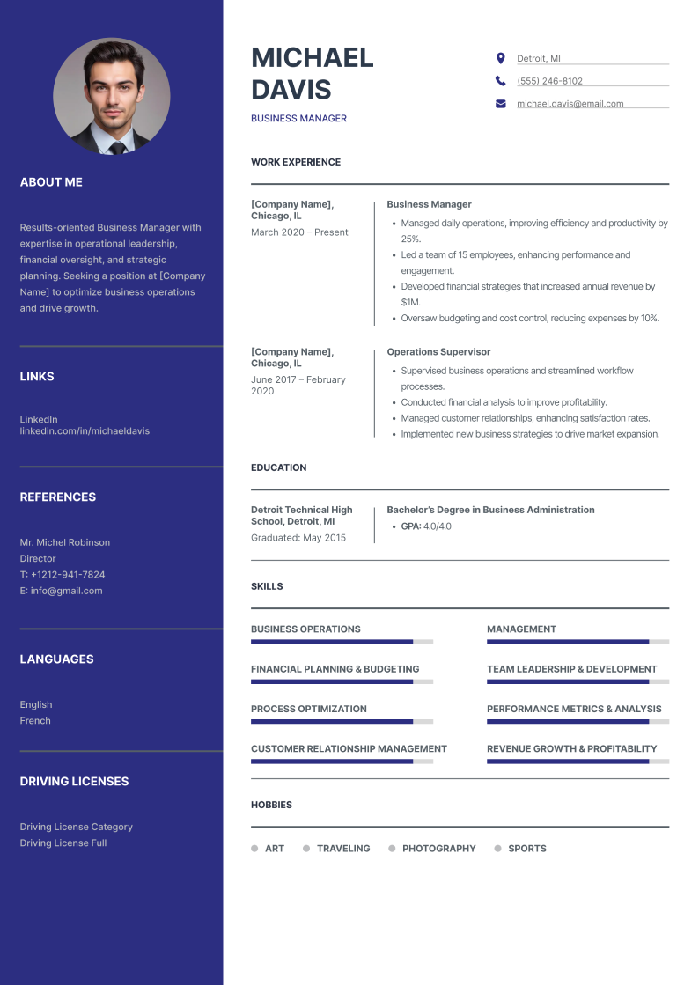

Business Manager Resume Checklist

Check your business manager resume if it has all the critical elements:

✅ Header with Name, Job Title, and Contact Information
✅ Strong Resume Summary with Measurable Achievements
✅ Work Experience Listed in Reverse Chronological Order
✅ Quantifiable Accomplishments in Bullet Points
✅ Industry-specific keywords for ATS Optimization
✅ Relevant Education and Certifications
✅ Skills Section Featuring Hard and Soft Skills
✅ Professional Formatting with Consistent Fonts and Spacing
✅ Proofread for Grammar, Clarity, and Readability

If you're unsure about writing your resume or want to save time, we're here to help.
Use our resume builder to create a professional, ATS-friendly resume in minutes—boosting your chances of landing an interview and securing your dream job.

Good Luck!

