The Title Should be Clear, Brief and Informative
(CAMBRIA 14, Capitalize Each Word, BOLD, CENTER)

First Author¹*, Second Author², Third Author³
¹University, Country
²University, Country
³University, Country

* Corresponding author:
Author, University, COUNTRY. @email

Article Info |  | Abstract
Article history:  (Cambria 9) |  | ABSTRACT (The word length is not more than 250 words)  Background of study:  Aims and scope of paper:  Methods:  Result:  Conclusion:
  Received | : | Month XX, 20XX
  Revised | : | Month XX, 20XX
  Accepted | : | Month XX, 20XX
Keywords:

First keyword;
Second keyword;
Third keyword;
Fourth keyword;
Fifth keyword.
(Cambria 9, consist of 3-5 words or phrases, alphabetic)

To cite this article: Author. (20XX). Title. KONEKTIVITAS: Jurnal Pengabdian kepada Masyarakat, X(X), XX-XX
This article is licensed under a Creative Commons Attribution-ShareAlike 4.0 International License © 20XX by author/s

INTRODUCTION
Background of the study:
Literature review:
Gap analysis:
Rationale of the study:
Purpose or Hypotheses of the study:

METHOD
Research Design :
Participant :
Population and the methods of sampling Instrumentation (sample of questions, scoring method, and psychometric properties (validity and reliability)) :
Instrument :
Procedures and if relevant, the time frame :
Analysis plan (describe statistical test and the comparisons mode: ordinary statistical methods should be used without comment; advanced or unusual methods may require a literature citation):
Scope and/or limitations of the methodology you used :
Manuscript can use the method for observational studies, SRQR for qualitative studies, PRISMA for reviews, CARE for case reports, CONSORT for clinical trials
(Recommendations)

RESULTS AND DISCUSSION
Results :
Discussion :
Implications :
Contribution of Community Service :
Limitations :
Suggestions :

CONCLUSION
Provide a statement that what is expected, as stated in the "Introduction" chapter can ultimately result in "Results and Discussion" chapter, so there is compatibility. Moreover, it can also be added to the prospect of the development of research results and application prospects of further studies into the next (based on result and discussion).
ACKNOWLEDGMENT
The acknowledgement is a form of appreciation for the contribution of an institution or an individual who is not considered as the writer for example an institution or an individual who provides the research funding (funding support) of this publication.
AUTHOR CONTRIBUTION STATEMENT
The Author Contributions Statement can be up to several sentences long and should briefly describe the tasks of individual authors. Please list only 2 initials for each author, without full stops, but separated by commas (e.g. JC, JS). In the case of two authors with the same initials, please use their middle initial to differentiate between them (e.g. REW, RSW). The Author Contributions Statement should be included at the end of the manuscript before the References.
AI DISCLOSURE STATEMENT
The author used [TOOL/SERVICE NAME] during the preparation of this work for [REASON]. After using the tool/service, the author thoroughly reviewed and edited the content as needed and takes full responsibility for the content of the publication.
The authors declare that this research was prepared, researched, written, and edited without the aid of artificial intelligence (AI) techniques.
REFERENCES
The following are the reference writing guidelines of Online Learning in Educational Research. The references should be written to justify alignment and alphabetically. We suggest you use Mendeley management reference with APA style for your references. The guideline for example below:

Journal Article:
Lin, C.-Y., Shen, W.-J., Lu, F. J. H., Hsieh, Y.-C., Fang, B.-B., & Chen, B. (2025). Predicting physical activity in adults with physical disabilities: Adaptation of physical activity behavioral models. Adapted Physical Activity Quarterly, 42(3), 123–135. https://doi.org/10.1123/apaq.2025-0028

Book:
Creswell, J. W., & Plano Clark, V. L. (2018). Designing and conducting mixed methods research (3rd ed.). SAGE Publications.

Articles Compilation book (edited book):
Burhaein, E., Tarigan, B., Budiana, D., Hendrayana, Y., & Phytanza, D. T. (2022). Profile changes in adaptive physical education learning during the COVID-19 pandemic. In Innovation in education and social sciences (Chapter 3). Taylor & Francis. https://doi.org/10.1201/9781003265061-3

Published Undergraduate Thesis / Dissertation / Thesis
Lewellen, J. A. (2025). Assessing the feasibility of the Virtual Reality Training protocol (Doctoral dissertation). West Virginia University. https://researchrepository.wvu.edu/etd/12802/

Unpublished Undergraduate Thesis / Dissertation / Thesis
Burhaein, E. (2018). Pengembangan Instrumen Friendship Activity Observational Test dan Adjective Observational Test untuk Anak Tunagrahita dalam Unified Sports (Unpublished undergraduate thesis). Program Pascasarjana, Universitas Negeri Yogyakarta.

Internet Sources:
World Health Organization. (2025, Januari 23). Physical activity. https://www.who.int/news-room/fact-sheets/detail/physical-activity

Regulation:
Mendikdasmen. (2025). Permendikdasmen nomor 13 tahun 2025 tentang Tentang Kurikulum pada Pendidikan Anak Usia Dini, Jenjang Pendidikan Dasar, dan Jenjang Pendidikan Menengah. Jakarta: Kemendikdasmen.

Table 1. The sample of table format (Center, Cambria, 11)
No | Description | Explanation
 | Description 1 | Explanation
 | Description 2 | Explanation
 | Description 3 | Explanation
 | Description 4 | Explanation
 | Description 5 | Explanation

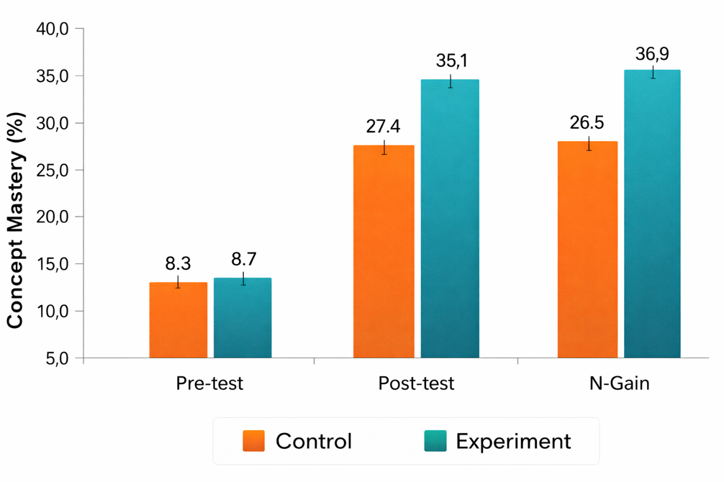
Figure 1. The example of an image of the spectrum absorption coefficients of organic semiconductor materials

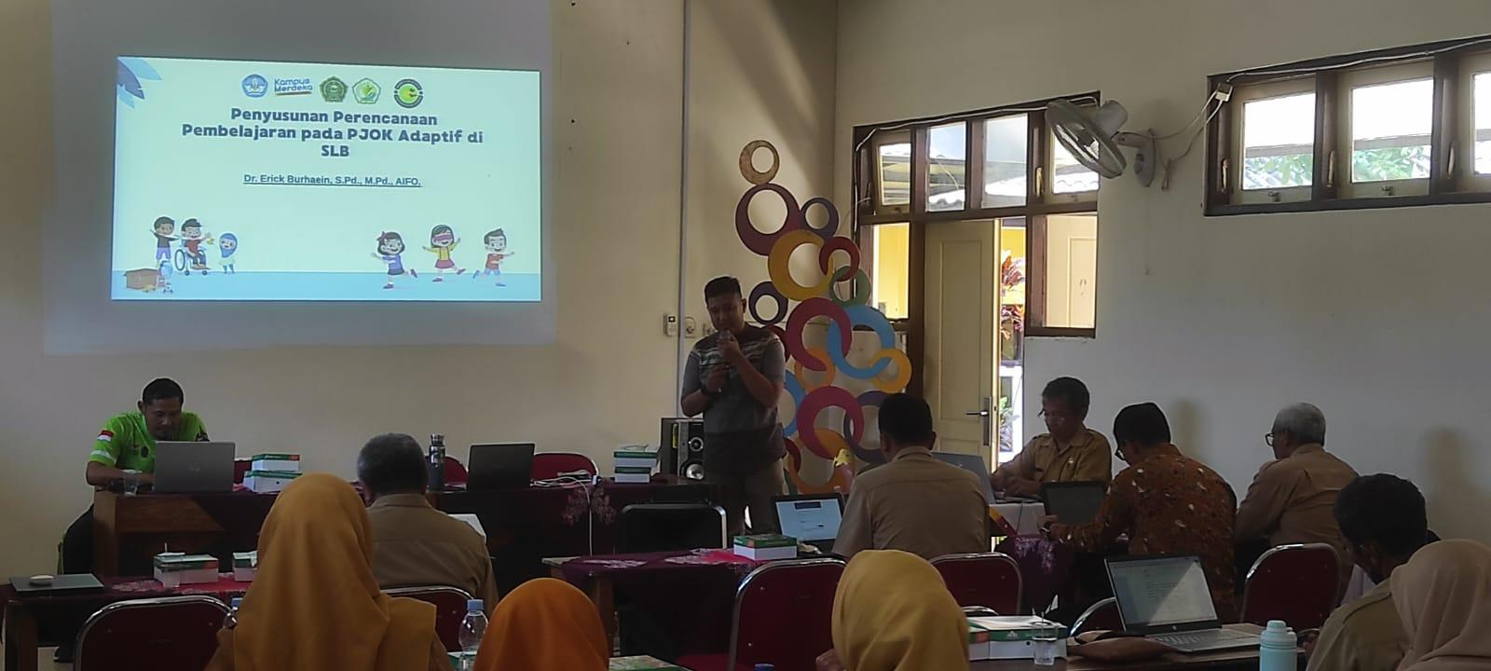
Figure 2. The example of an image of seminar

