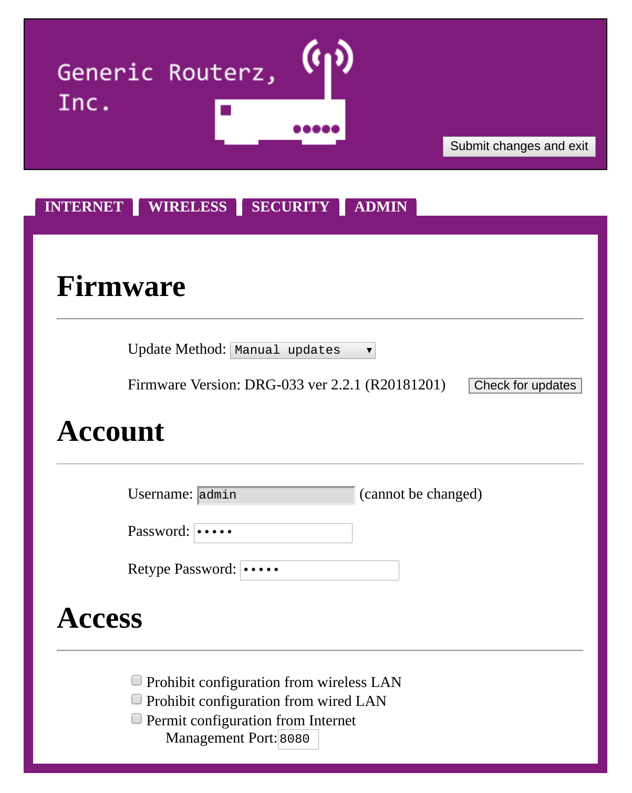
Configuring a Router

BACKGROUND
Routers are a staple of the internet infrastructure. Almost every business relies on one or more routers all day, every day. Oftentimes, these routers are commercial grade and tucked away in a networking closet. They are usually for hardwired LAN connections (though at some point on the network, the routers will offer a wireless signal to employees and customers).
Home users are very familiar with wireless routers; they are the lifeblood of internet connection.
The evolution of the wireless router has been palpable; not too long ago, home routers were not shipped with a password, so anyone could hop on any network they encountered.
Modern routers, however, are given a bit more security at the factory. However, there are always issues with wireless router security (default passwords, open ports, etc.).

DESCRIPTION
This lab will walk you through a few different things you can do to help secure your home router. It is only a simulation! Nothing you do in this exercise will affect your network, your real router, or your computer.

REQUIREMENTS
This exercise assumes you have access to a computer that has internet access. No part of this exercise will affect your actual router; it’s just a simulated environment online.

Router Configuration: Instructions
For this assignment, you will be going to a website that looks like a router configuration page, but isn’t (so if you screw something up, it won’t affect the network you are on).
Your job is to poke around through the different tabs and make the following changes.
The simulation can be found here: www.daveghidiu.com/security/router.html
- Log in to the router. The username is admin and the password is also admin.
- Change the router name. The default name doesn’t mean much to most people. Change it to something more meaningful. Name it after yourself (be sure to use your first and last name, as this is how you will get a grade attached to your work!).
- Change the DNS servers. The default DNS servers are run by the ISP, and that’s no good! Use the following, reputable two servers:
  - 1.1.1.1
  - 9.9.9.9
- Update the firmware! The router may already be updated, but you’ll have to check to make sure. You should also change the update mechanism to automatic.
- Change the password! Right now, the default password of ‘admin’ is not secure! Change it to something more secure. But for the scope of this assignment, do not use any of your personal passwords! Make up a new one. You will not be assessed on the strength of the password - you’ll only be assessed if you change it from the default. But on your router at home, use a real solid password.
- Change both SSID names. This router has two different networks (a 2.4 and a 5.0). Change both names to something meaningful. The SSID is what your friends will see when they log on to your WiFi.
- Change both SSID passwords. Again, don’t use any password that is your personal one.
- Disable UPnP.
- Make sure that the router is configured such that it cannot be accessed from the internet.

