SUMMATIVE TEST NO. 1
Objectives | CODE | Percentage | No. of Items | Item Placement
describe and draw intersecting, parallel and perpendicular lines using ruler and set square. | (M4GE-IIIa-12.2) | 50% | 10 | 1-10
describes and illustrates different kinds of angles | (M4GE-IIIb-14) | 25% | 5 | 11-15
describes the attributes/properties of triangles and quadrilaterals using concrete objects or models | (M4GE- IIIb-15). | 25% | 5 | 16=20
Total |  | 100 | 20 | 1 – 20
GRADE IV – MATH
SKAI KRU

SUMMATIVE TEST NO.1
GRADE IV – MATH
SKAI KRU

Name :____________________________________________________ Grade and Section:_________

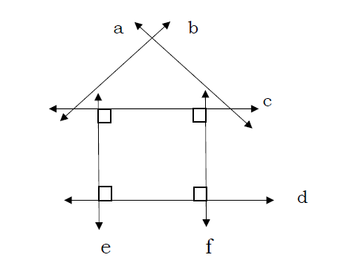
I. A. Observe the figure below and answer the questions that follow. Write the letter of the correct answer in your answer sheet.

_____1. Line a and line b meet at a point, what are these lines?
A. intersecting lines C. line segment
B. parallel lines D. perpendicular lines
_____2. Line e and line f did not meet at any point, what are these lines?
A. intersecting lines C. line segment
B. parallel lines D. perpendicular lines
_____3. Line d and line f intersect and form a square corner or right angle, what are these lines?
A. connecting lines C. intersecting lines
B. parallel lines D. perpendicular lines
_____4. How many pair of parallel lines are in the figure?
A. 2 B. 3 C. 4 D. 5
_____5. How many pair of perpendicular lines are shown in the figure?
A. 2 B. 3 C. 4 D. 5

B. Given the figure in the box, determine whether the lines are intersecting, parallel or perpendicular. Write A for intersecting lines, B for parallel lines and C for perpendicular lines.
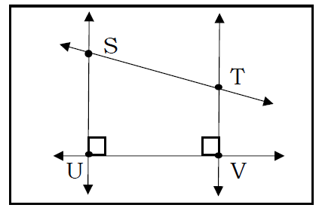
6. line SU and line UV is ________
7. line UV and line TV is ________
8. line ST and line TV is ________
9. line SU and line TV is ________
10. line ST and line SU is ________

II. A. Write the letter of the correct answer on a sheet of paper.
_____11. Which of the angles below measures more than 90° but less than 180°?
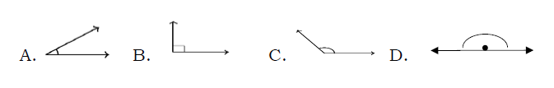

_____12. Which of the following tells about obtuse angle?
A. It measures exactly 90°
B. It measures less than 90°
C. It measures exactly 180°.
D. It measures more than 90°but less than 180°
_____13. Which could be the measurement of an acute angle?
A. 35° B. 90° C. 180° D. 360°
_____14. What kind of angle is formed by the corner of a square table?
A. acute angle B. obtuse angle C. right angle D. straight angle
_____15. What kind of angle is shown by an opened book whose measure is greater than 90°?
A. acute angle B. obtuse angle C. right angle D. straight angle
_____16. Which property allows you to name a quadrilateral?
A. five sided figure C. three sided figure
B. four sided figure D. two sided figure
_____17.Which of the following is not a polygon?
- A. quadrilateral B. pentagon C. semi-circle D. pentagon
_____18.How many sides does a triangle have?
- A. three B. four C. five D. six
_____19.What is the sum of the interior angle in a triangle?
- A. 90° B. 180° C. 220° D. 360°
_____20.What is a polygon?
A closed figure made up of crossed line segments
- B. A closed figure made up of straight line segments
- C. An open figure made up of crossed line segments
- D. An open figure made up of straight line segments

SUMMATIVE TEST 1 ANSWER KEY:
II.
11. C
12. D
13. A
14. C
15. B
16. B
17. C
18. A
19. B
20. B

I.
1. A
2. B
3. D
4. A
5. C
6. C
7. C
8. A
9. B
10. B

