**Hunting for Rocks from Outer Space**

by Pat Murphy

Do you want your very own rock from outer space? If you have a strong magnet, you can hunt for space rocks wherever you live.

Every day, rocks from outer space rain down all over the Earth. When these space rocks are falling, they are called meteors. After they hit the ground, they get a new name. A fallen meteor is a meteorite.

Hundreds of thousands of meteorites fall to Earth every day. You don’t see these falling rocks because they are tiny. Most meteorites are smaller than a grain of rice. In fact, most of them are about the size of a speck of dust. These are called micrometeorites. “Micro” means very small, so a micrometeorite is a very small meteorite.

A magnet makes it easy to search for these itty-bitty space rocks. Most micrometeorites are made of iron. That means they will stick to your magnet.

A great spot to look for micrometeorites is in a rain gutter on the edge of a roof. Micrometeorites fall on the roof, and rain washes them into the gutter.

But climbing up to the roof to look in the rain gutter could be dangerous. Instead of looking in the gutter, you can look in the water that pours out of that gutter. To make a trap for meteorites, paint your magnet white. Then leave the magnet where water from the rain gutter will flow over it. After a rainstorm, look for small black specks on your white magnet. Those specks are micrometeorites that the rain washed into your magnetic trap.

Some meteorite hunters go to distant places in search of space rocks. They search in the world’s deserts because dark meteorites show up well against pale desert sand. But meteors fall all over the Earth. So you don’t have to go far to find a space rock to call your own.

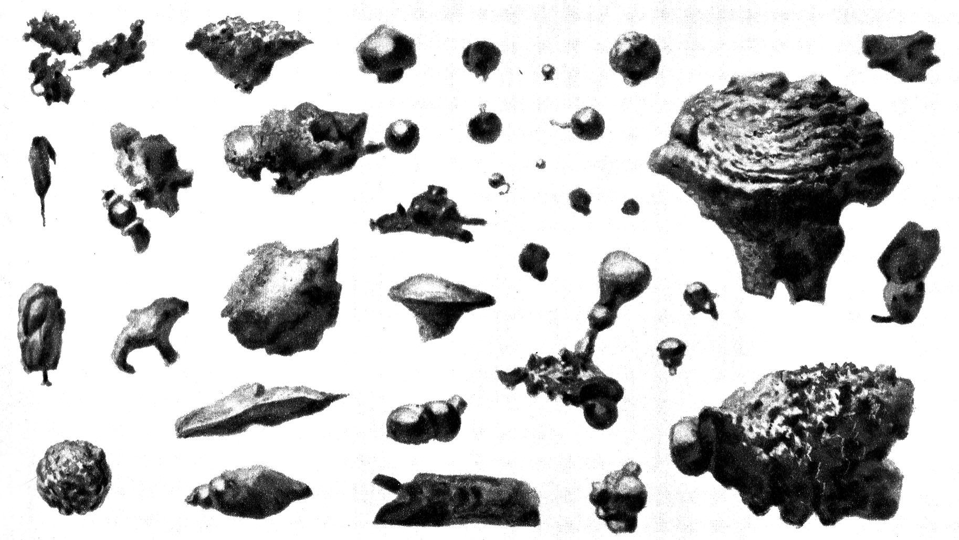

**Caption: This picture shows many micrometeorites. These were collected by a French astronomer named** [**Lucien Rudaux**](http://io9.com/lucien-rudaux)**.**