**🛑You do not need permission to download this file🛑  
Google Doc: To make a copy of this document: Go to File and select- “Make a copy”.   
Word Doc: To download a copy of this document- Go to File and select “Download as” choose .doc or .rtf. Save it on your computer and you can then complete your work. You may need to click “enable editing”.**

**4.03 American Voices—Guided Notes**Directions: Your Guided Notes are a tool to use as you read your lesson pages in the course. These important notes will help you complete your lesson assessment, as well as prepare you for Discussion-Based Assessments, unit exams, and segment exams. You do not need to submit your Guided Notes for grading.

**Key Vocabulary**

| **Word** | **Meaning (use context clues)** |
| --- | --- |
| U.S. Census |  |
| Reliable |  |

**Venn Diagram**

Use this Venn diagram to record information from the lesson about these groups of people. Note shared experiences in the center circle. The other circles are for you to note information unique to each group. An example has been provided for you.  
  
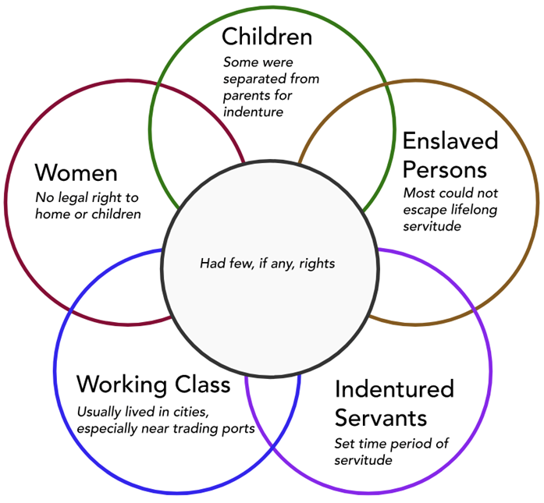

**Questions and Answers**How can examining others’ perspectives help us learn more about history?

What sources can we use to learn more about the experiences of Americans in history?

List five important Florida history events in the years 1763–1818.

1.

2.

3.

4.

5.

Unless Otherwise Noted All Content © 2022 Florida Virtual School. FlexPoint Education Cloud™ is a trademark of Florida Virtual School.