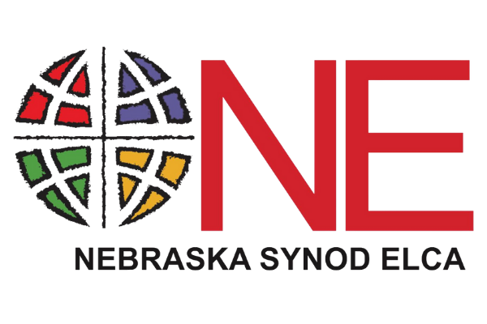
2026 Nebraska Synod ‘One Another’ Grant Application

While all projects will be considered for funding through this opportunity, it is encouraged to consider activities that focus on improving the nutritional value of foods offered through your pantry. In the United States, between August 2021 – August 2023, the prevalence of adult obesity was 40.3% (CDC). Obesity is a risk factor to the development of other chronic conditions such as high blood pressure, heart disease, Type 2 Diabetes, stroke, and some cancers. Consider what others have done to improve the nutritional value of the food that is offered at their pantry and then consider if there is something that can be done to encourage healthier food practices in your community: Garden donations, On-site healthy cooking demonstrations and recipe tastings, or Grocery store tours with teaching on how to make healthy food choices. For more ideas and resources, check out the ELCA World Hunger’s Feeding Ministries Guide, or click here: County Health Rankings and Roadmaps or here: Create Healthy Choices Pantry Toolkit.

Congregation or Synod Ministry:
Primary Contact (Name, Phone, Email):
Address:
Phone:
Email:

Please list all organizations (including community groups, ecumenical partners, and other congregations and synod ministries) involved in this project:
__________________________________________________________________________________________________________________________________________________________________________________________________________________

Please tell us about your food or hunger ministry (no more than 300 words).

___________________________________________________________________________________________________________________________________________________________________________________________________________________________________________________________________________________________________________________________

We anticipate grants to be $1000.00. How do you anticipate using these funds in your community? (no more than 300 words)

___________________________________________________________________________________________________________________________________________________________________________________________________________________________________________________________________________________________________________________________

Will you be promoting healthy food options in your community? Yes or No
If yes, how will these funds be used for that purpose? (no more than 300 words)

___________________________________________________________________________________________________________________________________________________________________________________________________________________________________________________________________________________________________________________________

Have you ever applied for an ELCA World Hunger grant in the past?
[ ] Yes [ ]No

Have you ever applied for a One Another grant in the past?
[ ] Yes [ ]No

Please send all typed or handwritten requests by July 26, 2026 to:

Nebraska Synod, ELCA
ATTN: One Another Grant
6757 Newport Ave., #200
Omaha, NE 68152
gretchen@nebraskasynod.org

If you have questions about One Another grants or wish to have someone come speak about ELCA World Hunger, please contact the Nebraska Synod office at (404)583-4591 or by email at gretchen@nebraskasynod.org. If you have questions regarding this application, please contact Gretchen at gretchen@nebraskasynod.org or 404-583-4591.

Applications received after July 26, 2026 will not be considered!

