ASSESSMENT
TEACHER VERSION
Private and Personal Information

- If a website asks you for your __________________ online, you should talk to a parent or family member.

  - favorite color
  - date of birth
  - screen name

- An identity thief probably would not be interested in your personal information, such as ___________________.

  - your full name
  - your street address
  - your favorite movie

- Clara received two emails. Which email should she NOT respond to? Circle your answer.

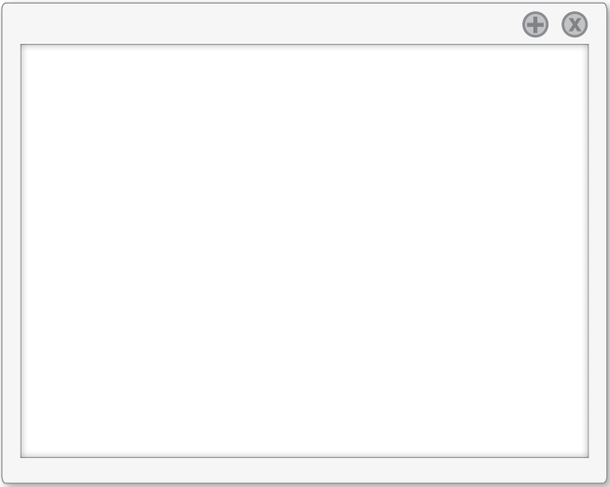

Dear Clara,

We found a problem with your email account. Please send us your full name and address so we can fix it.

Sincerely,
The SmartMail.com Team

Hi Clara!

What do you want for your birthday this year? Your Uncle and I are excited to see you!

Love,
Aunt Patty

