Name(s)_______________________________________________ Period ______ Date ___________________

|  | **Activity Guide - Prototype Brainstorming** |  |
| --- | --- | --- |

## UI Elements:

The following is a table of some of the UI elements that are available in App Lab. For each element, discuss with as a team what you think it does and how you might use it in your app. Write it down in the Intended Use column.

| **UI Element** | **Intended Use** |
| --- | --- |
|  |  |
|  |  |
|  |  |
|  |  |
|  |  |
|  |  |
|  |  |
|  |  |
|  |  |

## Example “What’s for Lunch?” wireframe:

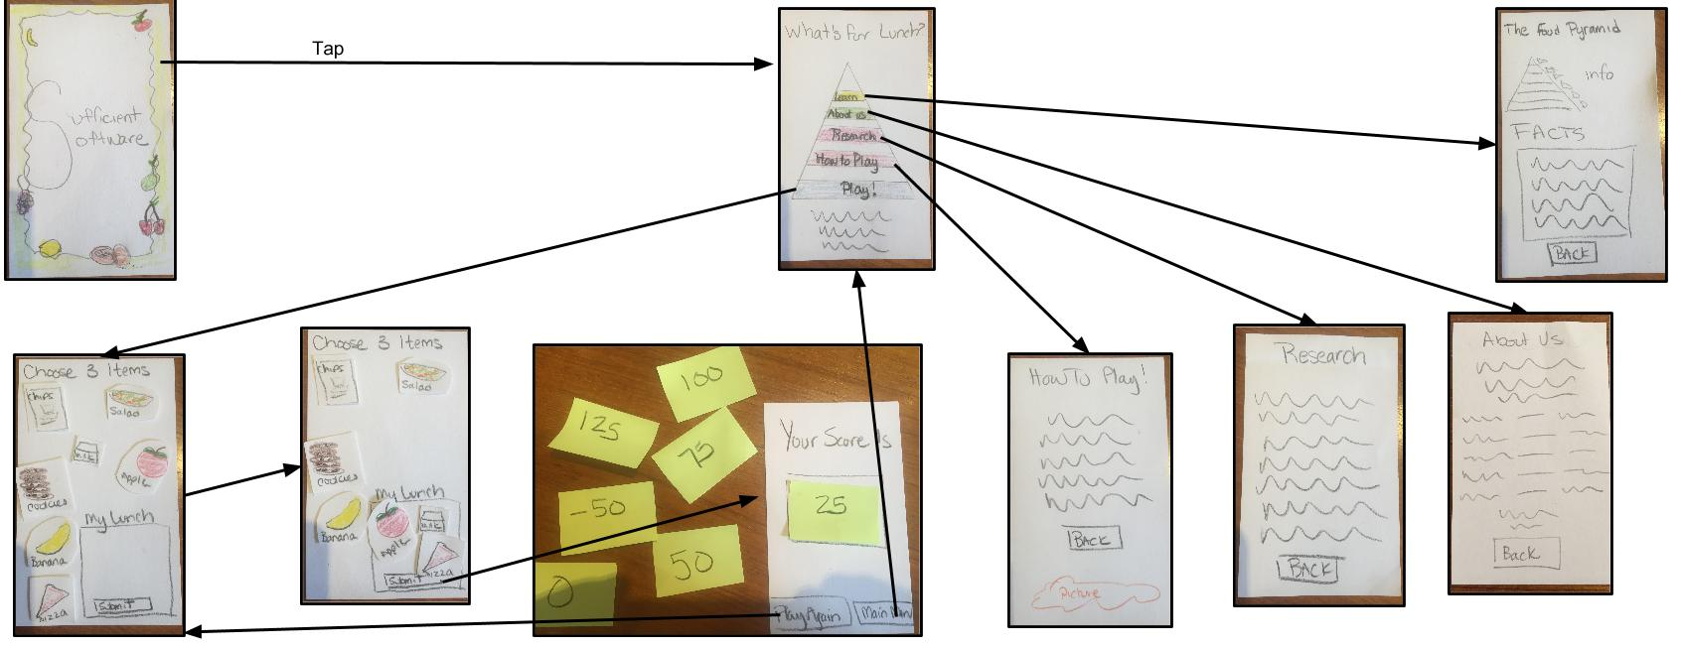

## Suggested Screens:

Reminder: There must be at least one screen per student in the team.

| **App Type** | **Example** | **Suggested Screens** |
| --- | --- | --- |
| Decision Making | Can I recycle this? | * Home/about us * Questions / answers * Answer page |
| List Management | Homework reminder | * Home/about us * List of items * Add item * Remove item * See all items that have been done |
| Quiz | Spanish Helper | * Home/about us * Questions / answers (sequential) * Tracking results * Compare results with others |
| Crowdsourcing | Which recycling bins are full? | * List of locations * For each location you can do something - Reporting, checking in * Personal Summary page * Global summary page did everyone do |

## 

## 

## Our App’s Screens

Based on the app you plan to develop, and the suggested screens on the first page of this guide, identify all of the screens that you’ll need to design. For each screen, write a brief description and include a list of all of the other screens that it will need to link to.

| **Screen** | **Description** | **Links to** |
| --- | --- | --- |
|  |  |  |
|  |  |  |
|  |  |  |
|  |  |  |
|  |  |  |
|  |  |  |
|  |  |  |
|  |  |  |
|  |  |  |
|  |  |  |

## 