AUTHORIZATION TO RELEASE INFORMATION
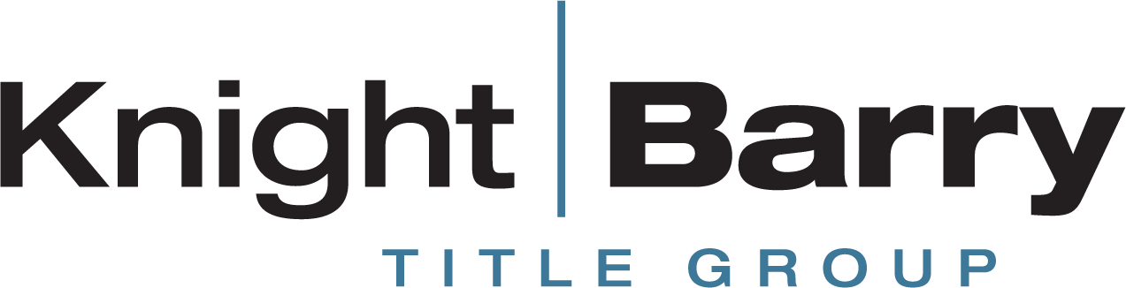

The undersigned is/are the owner(s) of the property (the "Property") located at __________________________________________ (street address).

The undersigned hereby authorize(s) Knight Barry Title, Inc., Knight Barry Title Services LLC, Knight Barry Title Advantage LLC, Knight Barry Title United LLC, Knight Barry Title Solutions Inc. and/or their duly authorized agents, to obtain: (i) any mortgage, judgment or lien relating to the Property, including but not limited to payoff amounts and escrow information, and (ii) any prior title policy(ies) for the Property from any title insurers or agents.

Signature: ____________________________
Print Name: __________________________
Date: ________________________________
Forwarding Address: ___________________
____________________________________
_____________________________________
Phone No.____________________________

Signature: ____________________________
Print Name: __________________________
Date: ________________________________
Forwarding Address: ___________________
____________________________________
_____________________________________
Phone No.____________________________

1st Mortgage Holder:___________________________________________________________
Loan Number:_________________________________________________________________
Customer Service Phone Number:________________________________________________

2nd Mortgage Holder:__________________________________________________________
Loan Number:_________________________________________________________________
Customer Service Phone Number:________________________________________________

