**SUMMATIVE TEST NO. 2**

|  |  |  |  |  |
| --- | --- | --- | --- | --- |
| **Objectives** | **CODE** | **Percentage** | **No. of Items** | **Item Placement** |
| use words that are related to self, family, school, and community | (**EN1V-IIIa-e-5**). | **50%** | **5** | **1-5** |
| predict possible ending of a story read; | (**EN1LC-IIIa-j-1.1**) | **50%** | **5** | **6-10** |
| **Total** |  | **100** | **10** | **1 – 10** |

**GRADE I – ENGLISH**

**SKAI KRU**

**SUMMATIVE TEST NO.2**

**GRADE I – ENGLISH**

**SKAI KRU**

Name :_____________________________________ Grade and Section:_________

I. Choose the letter of the correct answer. Write your answer on a separate sheet of paper.

1. What word is related to school?

a. father b. police c. teacher

2. What word is related to family?

a. canteen b. market c. sister

3. What word is related to the community?

a. brother b. doctor c. pencil

4. Books, pencil, and paper are words connected to __________.

a. family b. school c. self

5. Father is related to ________________.

a. family b. school c. self

II. Predict what will happen next to the following situations. Write the letter of the correct answer on the space provided before the number.

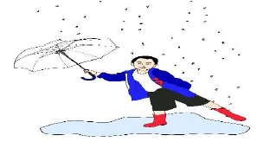____6. Kian played in the rain the whole day.

a. Kian will get sick.

b. Kian will be happy.

c. Kian will stay under the rain.

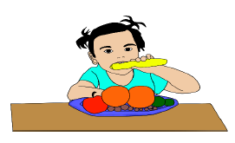_____7. Rizza eats nutritious foods. She exercises regularly.

a. She will get sick.

b. She will be a supermodel.

c. She will be healthy.

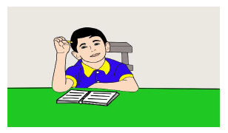____8. Jolo got home from school. He got his pencil and notebook and sat on the table.

a. He will do his homework.

b. He will do a trick on the table.

c. He will eat some cookies.

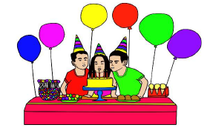_____9. Mother cooked some delicious foods. There are many balloons and cake, too.

a. The children were noisy.

b. There was a birthday party.

c. The family was hungry.

___10. Mrs. Mendoza gave her class a poem to recite. Cassy memorized the poem at home.

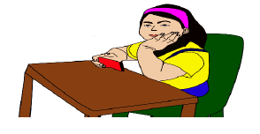 a. She can recite the poem well.

b. She can’t recite the poem.

c. She will be absent.

***SUMMATIVE TEST 2 ANSWER KEY:***

I.

1. C

2. C

3. B

4. B

5. A

II.

6. A

7. C

8. A

9. B

10. A

**SUMMATIVE TEST NO. 3**

|  |  |  |  |  |
| --- | --- | --- | --- | --- |
| **Objectives** | **CODE** | **Percentage** | **No. of Items** | **Item Placement** |
| Identify cause and effect/or effect of events | (**EN1LC-IIIa-j 1.1**) | **50%** | **5** | **1-5** |
| Identify the problem and solution | (**EN1LC-IIIa-j 1.1**) | **50%** | **5** | **6-10** |
| **Total** |  | **100** | **10** | **1 – 10** |

**GRADE I – ENGLISH**

**SKAI KRU**

**SUMMATIVE TEST NO.3**

**GRADE I – ENGLISH**

**SKAI KRU**

Name :_____________________________________ Grade and Section:_________

I. Encircle the correct answer. Read the underlined sentence and identify if it is cause or effect.

1. Aga throw a banana peel in the floor, so Claire slipped when she stepped on the banana peel. (Cause, Effect)

2. Ella is healthy because she is eating fruits and vegetables. (Cause, Effect)

3. Carmi got a perfect score in the test because she reviews her lessons. (Cause, Effect)

4. Abby had a cake because it’s her birthday. (Cause, Effect)

5. It was pouring rain, so the volleyball game was cancelled. (Cause, Effect)

II. Encircle the correct answer. Read the underlined sentence and identify if it is PROBLEM or SOLUTION.

1. A tire goes flat, so put air in it. (problem, solution)

2. The boy ate because he is hungry. (problem, solution)

3. The girl uses her umbrella because it is raining outside. (problem, solution)

4. She was soaking wet, so she changed her clothes immediately. (problem, solution)

5. I did not make my assignment, so my teacher gave me a failing grade. (problem, solution)

***SUMMATIVE TEST 3 ANSWER KEY:***

I.

1. CAUSE

2. EFFECT

3. CAUSE

4. CAUSE

5. EFFECT

II.

6. SOLUTION

7. PROBLEM

8. SOLUTION

9. SOLUTION

10. PROBLEM

**SUMMATIVE TEST NO. 4**

|  |  |  |  |  |
| --- | --- | --- | --- | --- |
| **Objectives** | **CODE** | **Percentage** | **No. of Items** | **Item Placement** |
| Use / Respond appropriately to polite expressions | (**EN1OL-IIIa-e-1.5**); | **50%** | **5** | **1-5** |
| talk about one’s personal experiences | (**EN10L-IIIb-c-1.3.3**) | **50%** | **5** | **6-10** |
| **Total** |  | **100** | **10** | **1 – 10** |

**GRADE I – ENGLISH**

**SKAI KRU**

**SUMMATIVE TEST NO.4**

**GRADE I – ENGLISH**

**SKAI KRU**

Name :_____________________________________ Grade and Section:_________

I. Write the letter of the correct answer on a sheet of paper.

1. Your brother gave you a gift on your birthday. What do you say?

a. Good Afternoon!

b. Good Evening!

c. Thank you!

2. After eating breakfast, your school service arrives, and you leave for school. What do you say to your parents?

a. Bye mom and dad see you later!

b. Good night mom and dad!

c. Good evening mom and dad!

3. You accidentally stepped on your sister’s foot. What will you say?

a. I’m sorry!

b. Good evening!

c. Good Afternoon!

4. You are about to sleep at night, what do you say to your family?

a. Goodbye!

b. Goodnight!

c. So long!

5. You see your grandfather carrying heavy loads of pail. What will you say if you want to offer help?

a. Good Evening!

b. May I help you, Lolo?

c. Goodnight!

II. Draw a heart inside the box if the picture shows your experience in your Kindergarten class and a triangle if it is not. Write your answer in your answer sheet.

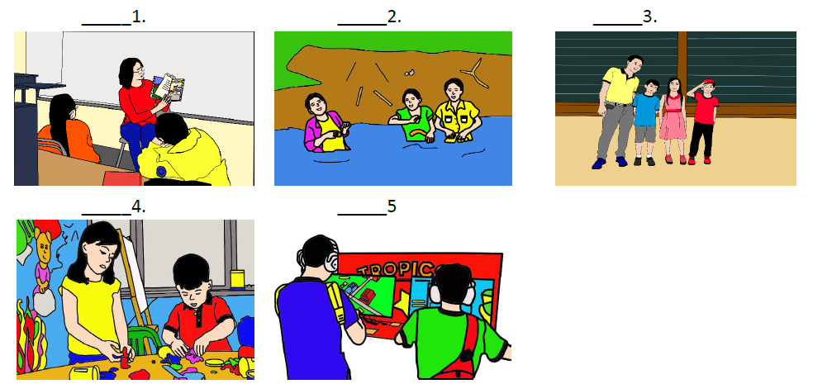

***SUMMATIVE TEST 4 ANSWER KEY:***

I.

1. C

2. A

3. A

4. B

5. B

II.

6. HEART

7. TRIANGLE

8. HEART

9. HEART

10. TRIANGLE