Name(s)_______________________________________________ Period ______ Date ___________________

|  | **Project Guide - Smart Bike Prototype** |  |
| --- | --- | --- |

## Overview

Designing a computing device that combines hardware and software requires a good deal of preparation. Starting with a clear plan can help you stay organized and identify issues ahead of time. A lot of the work you do here will make it much easier to keep track of what you need to do once you begin creating your device, both the physical and software components.

## Device Goal and Design

Start by thinking about what problem your device is going to solve. How will the user interact with it? How does it communicate information back to the user? What shape will it take?

## Sketch and Describe Your Device

Describe your device and roughly sketch out the main elements. Don’t worry about making it pretty.

The smart bike controller is a computer that can be attached to the handlebars of any bike to turn a regular bike into a “smart” bike. It has controls to activate turn signals on the ends of the handlebars, a horn that can play a customizable tone or song, and automatic headlights that turn on when it gets dark. We might also include a speedometer and a safety sensor that detects when a car is too close.

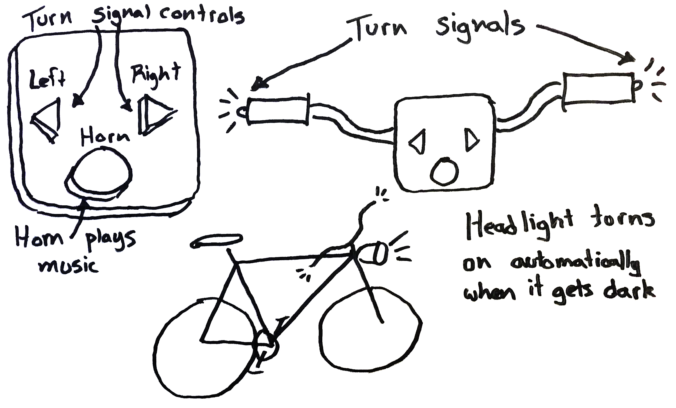

## Inputs

What inputs will your prototype need to function? What will they be used for?

| **Input type** | **What it is used For** |
| --- | --- |
| Buttons (at least 3) | Activating turn signals and horn |
| Light sensor | Turning on headlight automatically |
|  |  |
|  |  |
|  |  |

## Outputs

What outputs will your prototype need? What will they communicate to the user?

| **Output Type** | **What does it communicate?** |
| --- | --- |
| Handlebar LEDs | Blinking when the rider intends to turn. May also be used as an alert when cars get too close. |
| Buzzer | Acts as a horn. Could also be used as an alert when cars get too close. |
| Headlight | Bright LEDs to improve vision and visibility in the dark. |
|  |  |
|  |  |

## 

## 

## Processing

How will you use the inputs to decide what the outputs should be? Break the program up into the major steps you’ll need for it to work. The different behaviors you described in your events should help you decide what these steps should be.

| **Function name** | **Parameters**  (Inputs to the function) | **How It Changes During the Program**  (What’s the starting value, when will it change?) |
| --- | --- | --- |
|  |  |  |
|  |  |  |
|  |  |  |
|  |  |  |
|  |  |  |

## Additional Notes

Use this area to take any extra notes that you might need to complete the program. This could include any variables that you might need, hardware setup for the board, or resources that you’ll need to find (like images, sounds, etc), or ideas for more features that you want to explore.