  MONKEY | MONKEY | MONKEY | MONKEY | MONKEY | MONKEY
  HIPPO | HIPPO | HIPPO | HIPPO | HIPPO | HIPPO
  RABBIT | RABBIT | RABBIT | RABBIT | RABBIT | RABBIT
  GIRAFFE | GIRAFFE | GIRAFFE | GIRAFFE | GIRAFFE | GIRAFFE
  PIG | PIG | PIG | PIG | PIG | PIG
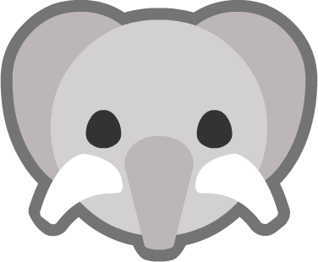  ELEPHANT | ELEPHANT | ELEPHANT | ELEPHANT | ELEPHANT | ELEPHANT

