Collecting Data from the Past Worksheet
For this assessment, you’ll be looking at two different graphs. Both graphs show data on carbon dioxide levels and how that data correlates with temperature. You will notice the timelines for these graphs are very different; one is very old and the other is much more current, Post-Industrial Revolution.

The carbon dioxide value provided is “ppm” – parts per million. This data shows how many carbon dioxide particles are in a million particles of air. For example, a carbon dioxide concentration of 550 ppm means that for every million air particles, 550 of them are carbon dioxide molecules. Carbon dioxide is a greenhouse gas and contributes to trapping of heat in the Earth’s atmosphere. Changes in carbon dioxide help us to understand climate changes.

The Earth’s temperature data is provided to show whether temperatures were higher or lower than average. We calculate the baseline temperature by averaging 30 or more years of temperature data. Remember, climate is long-term weather conditions, including temperature, while weather is the day-to-day conditions. If there is a positive temperature, this shows the weather was warmer than average, and a negative temperature shows a cooler than average year. By studying long-term temperature fluctuations, we are able to make more accurate long-term temperature predictions.
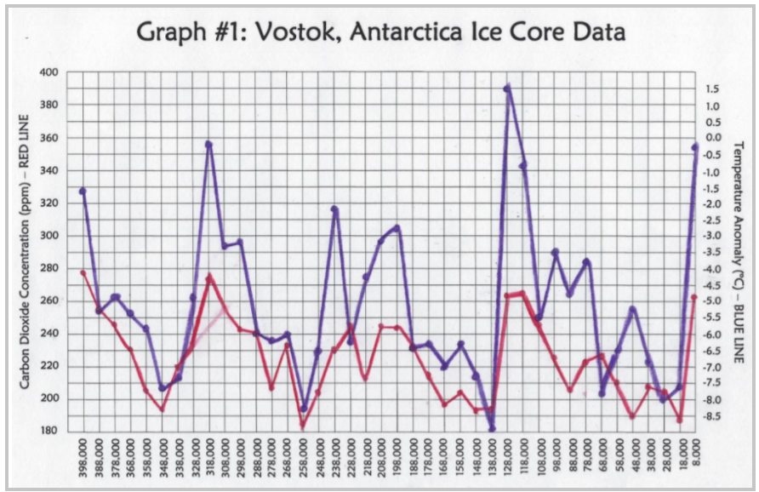 | 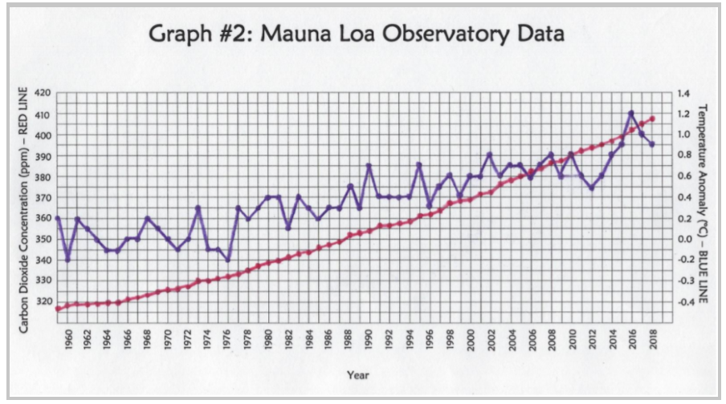

Using the graphs above, please answer the following:
1. Look at Graph #1. Notice that there are peaks (high points) and trough (low points)? Do troughs represent glacial periods or interglacial periods? How do you know?
2. Modern humans evolved about 200,000 years ago. Look at Graph #1 to answer the following:
a. Describe the carbon dioxide level at that time.
b. Describe how the carbon dioxide level changed in the 200,000 years after humans evolved.
3. Which graph represents a time period after the Industrial Revolution?
4. Carbon dioxide has been added to the atmosphere in large amounts since the Industrial Revolution.
a. Is this fact evident by looking at the two graphs? Use information from each graph in your answer.
b. Compare and contrast the carbon dioxide portion of the graph for Graph #1 and Graph #2.
c. Approximately how much higher is the highest atmospheric concentration of carbon dioxide from the Mauna Loa data than the maximum levels seen in the ice core record?
5. Each graph represents a different period in time.
a. Describe the difference between the time periods covered by the two graphs.
b. How much of the Vostok Ice Core time period would the time period of the Mauna Loa data take up? You don’t have to provide a specific value—make a generalization.
6. If there was no human effect on climate, how would you expect the climate to change over the next several thousand years?

