

B3Networks CPaaS
Product Specification for Phone System Solution

Table of Contents
Product Summary 4
Product Features 5
Generic Features 7
Features on the Device 7
Product License Requirements 9
CPaaS Phone System SKU List Requirements 9
Functional Spec 10
Incoming Workflow 10
Outgoing Workflow 10
Use Cases for Various Industries 11
Hospital & Clinic 11
Banking Institution 11

Document Control Versioning

Document History
Date | Version | Applicable BMOs | Author | Comments
16 Sept 2022 | Version 1.0 | All | Ray | Creation
5 Oct 2022 | Version 1.1 | All | Mahnoor | Amendment
20 Oct 2022 | Version 1.2 | All | Mahnoor | Amendment
20 Dec 2022 | Version 1.3 | All | Muneeb | Addition

Product Summary

The CPaaS Phone System is an advanced cloud-based telephony system that runs entirely on the internet.

VOIP technology converts your voice into a digital signal, allowing you to make calls over the internet. That means you spend less money on hardware and maintenance.

It also gives you the flexibility to take calls from both your desk phone and your computer or mobile device. Hence, you can utilize all the features of the office phone system wherever you are. With cloud telephony, you will never miss your important calls again.

Generic Features
(Describe the generic features of CPaaS portal)
Feature | Description
Organization link | Connect two or more organizations so that they can communicate using extension keys
VIP mode | Able to hide the VIP users on the sharing Call Directory list
Licenses management | Allow admin to manage the licenses allocation in an organization
User profile view | Allow admin to check the current profile set on certain user
Organization announcement | Allow admin to set announcement, this announcement will be able to view by users on the portal
Release communication | History of the releases on the portal, also served as a communication mechanism between the telco and the clients
NOTE: These functions are applicable to All Countries.

Features on the Devices
(Phone System features that work on the supported devices)
Feature | Description | Web Phone | Desktop App | IP  Phone | Mobile App
Make and receive calls | Able to make outgoing and receive incoming calls from the registered devices | ✅ | ✅ | ✅ | ✅
Internal call | Able to make internal calls from Extension to Extension | ✅ | ✅ | ✅ | ✅
Call transfer | Able to perform call transfer to an extension number or external number using blind or attended transfer | ✅ | ✅ | ✅ | ✅
Call hold/retrieve | Able to put the call on hold/retrieve | ✅ | ✅ | ✅ | ✅
Call return (Last Number Redial) | Able to redial the last number | ✅ | ✅ | ✅ | ✅
Speed dial | Allow users to press predefined fast key to dial the full range number | ✅ | ✅ | ✅ | ✅
Call passcode | Users have to press their passcode when they call a specific destination | ✅ | ✅ | ✅ | ✅
Call pickup | Perform a call pickup on another extension using the establish user define key | ✅ | ✅ | ✅ | ✅
Call waiting | Allow a user to be notify that there is another incoming call when the user is still on the line , and the ability to hold current call and retrieve the new calls | ✅ | ✅ | ✅ | ✅
Call park | Park the call to a slot, and allow other users to go into the slot to retrieve the call | ✅ | ✅ | ✅ | ✅
3-way calling | Connect to one more party during the call to establish a 3-way conference call | ✅ | ✅ | ❌ | ✅
Call delegate | Secretaries can pick up calls of the Boss | ✅ | ✅ | ✅ | ✅
Hot desking | Users can use the same device in one station and log in to their own accounts | ✅ | ✅ | ❌ | ✅
Call history | Able to check call history on the device | ✅ | ✅ | ✅ | ✅
Play/Download call recording/voicemail | Able to play/download call recording/voicemail from the call history | ✅ | ✅ | ❌ | ✅
Add contacts | Able to add/delete Contacts on the Desktop App | ❌ | ✅ | ❌ | ❌
Caller ID management | Able to select the caller ID (Assigned / Private) from the app | ✅ | ✅ | ❌ | ✅
Submit diagnostic reports/Logs for debugging | Allow users to submit the diagnostic reports from their apps when there is a technical issue happening | ❌ | ✅ | ❌ | ✅
Auto-provisioning for supported IP Phones (allows for easy, plug-n-play deployment) | The phone will be provisioned automatically with the settings preset on the portal. The auto provision only allows the certified phones to be auto-provisioned | ❌ | ❌ | ✅ | ❌
Team chat (purchased license) | Allow users to communicate with other users within the organization | ✅ | ✅ | ❌ | ✅
Busy lamp field | A light on an IP Phone that tells you whether another extension connected within the organization is busy or not | ❌ | ❌ | ✅ | ❌
NOTE: These features are applicable to All Countries.

Phone System
(Describe the CPaaS Phone System features)
Feature | Description
Extension key | - User's Phone Extension Number  - Each user can have only one extension number
Multiple DIDs per user | Allow more than one DID to be set for a single user
Supports calls to International Numbers, Toll-Free, Landline, and Golden Numbers | Able to make outgoing calls to different types of numbers
Holidays settings | Set public holidays so that inbound call will react based on the setting of public holidays
Bulk provisioning | Allow bulk provisioning of user to an organization
Call group (Hunt group) | Able to route a call to a group of user using Ring All, Sequential , Round Robin and longest idle
Missed Call for Call Group | Configure Inbound Missed Call Settings for Call Group with options like Play Message, Record Voicemail or Hangup actions.
Customizable outbound rules | Ability to set dial plans, countries whitelist, and organization link
Dial plans | Dial plan, allow certain number input by user to be translated
Country whitelist with passcode required | Country whitelist will allow certain countries to be called
Inbound call rules | Provide inbound number filtering mechanism
Busy lamp field | Create groups of users on the portal to enable IP phones to set up busy lamp fields more quickly
Inbound call setting | Determine the action of the call upon meeting the status set by the user
Text-to-speech missed call message and voicemail notification to email | Able to insert the text which will be converted to voice message prior to trigger of call messages and voicemail
Call forwarding | Allow call forward to extension number or DID number
Inbound call filter | Provide filtering mechanism for incoming calls
Personal music on hold | lay customized music on hold, when customer is holding on the call
Personal working hours | Set personal working hours so that inbound call will react based on the setting for non-working hours
Inbound missed call | Allow user to select action if they when they reject the call or unanswered
Singapore DNC (purchased license) | Make calls with auto-filtering or on-demand Singapore DNC number checking
Call recording (purchased license) | - Auto record all calls to users  - 1-year unlimited call recording storage on the Cloud  - Play & Download Call Recording Files
Call history | Comprehensive call history with call details and voicemail/call recording file
Caller ID management | Able to select the caller ID (Assigned / Private) from the portal
Speed dial | Allow the set of speel dial to a number, and using that number a fast key to dial the full range number
Call delegate | Able to delegate a call from Boss / Secretary with Ring all / Sequential mode
Support Away mode | Allow the user to set themselves to DND, and action on the call for DND is also self defined by user
App integration | Integrable with MS Teams
Dashboard | Visual Reporting tool that uses powerful analytics features to help users monitor their organization's calls data, such as key metrics, call type.
NOTES:
- These functions are applicable to All Countries.
- These features above are configured on the supported Web Portal (recommended web browser: Google Chrome with the newest version).

Product License Requirements

CPaaS Phone System SKU List Requirements
SKU Name | SKU Type | Unit of measure
Phone System
Phone System | Base License | per seat per month
IP Phone | Addon License | per line per month
Mobile App (iOS/Android) | Addon License | per line per month
Desktop App (Windows/Mac) | Addon License | per line per month
*Number (for extension) | Addon License | per extension per month
*Call Recording (up to 1 year unlimited call recording storage) | Addon License | per extension per month
*Unlimited Call Recording Storage  (up to 7 year unlimited call recording storage)  - This is an Add-on license to the basic Call Recording license above - | Addon License | per extension per month
*DNC (applicable for Singapore) | Addon License | per extension per month
*Team Chat | Addon License | per extension per month
*Microsoft Teams Direct Routing | Addon License | per extension per month
*Microsoft Teams Direct Routing Resource Account | Addon License | per extension per month
*CTI | Addon License | per extension per month
(*): optional

Functional Spec

Incoming Workflow

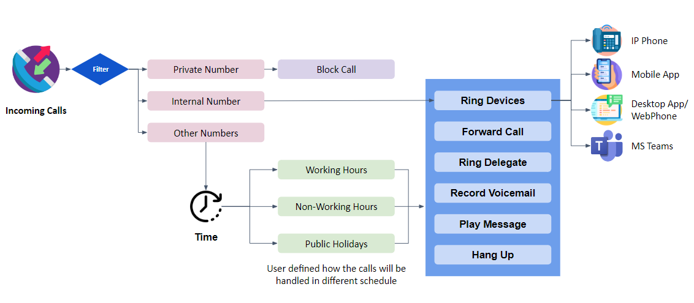

Outgoing Workflow

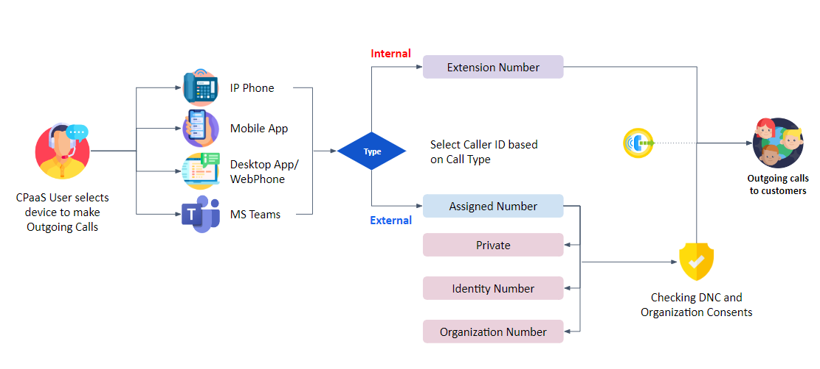

Use Cases for Various Industries
CPaaS Phone System Solution can meet your communication requirements with flexible and scalable solutions across all industries.

Hospital & Clinic
Doctors’ offices rely on auto-attendants to funnel callers to the right department (e.g., office staff for appointment booking and nurses for medical inquiries).
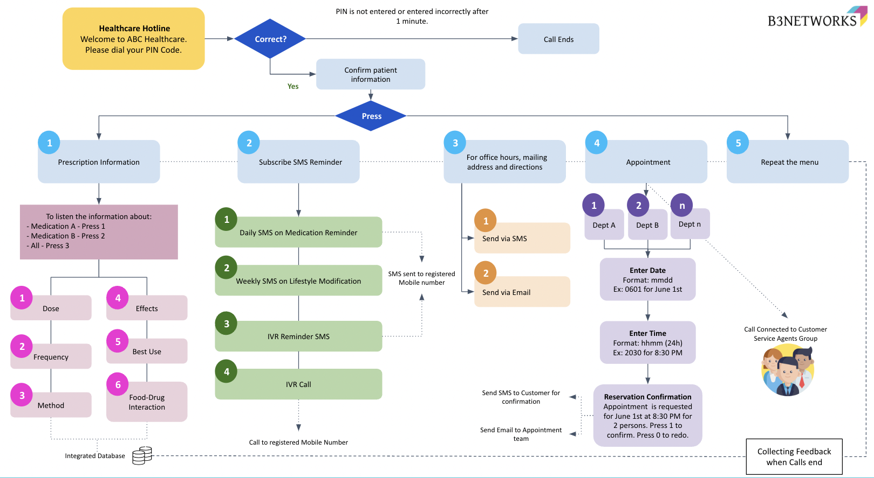

Banking Institution
CPaaS is a powerful and efficient solution that can help banks to seamlessly communicate and manage the high volume of calls everyday that are for common sales enquiries, customer service, collections, support etc to list a few..
