 | Activity Guide - Simulation: How Routers Learn | 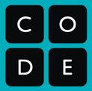

You are the router!
In this activity, you and your classmates will act as routers. You will be directly connected to three other routers (three classmates) with whom you can exchange information about the best ways to route packets, and over time you will learn which is the best way to all the other possible destinations.

Your goal: For every possible destination, you are trying to find out which neighboring router is the best one to forward a packet to to reach that destination. You do this by talking with your neighboring routers and exchanging the best information you’ve got so far.

Example (diagram at right): Imagine that you are router X, and are directly connected to routers Q, S, and W. You will use a routing table diagram to keep track of paths to other nodes that go through your neighbors.
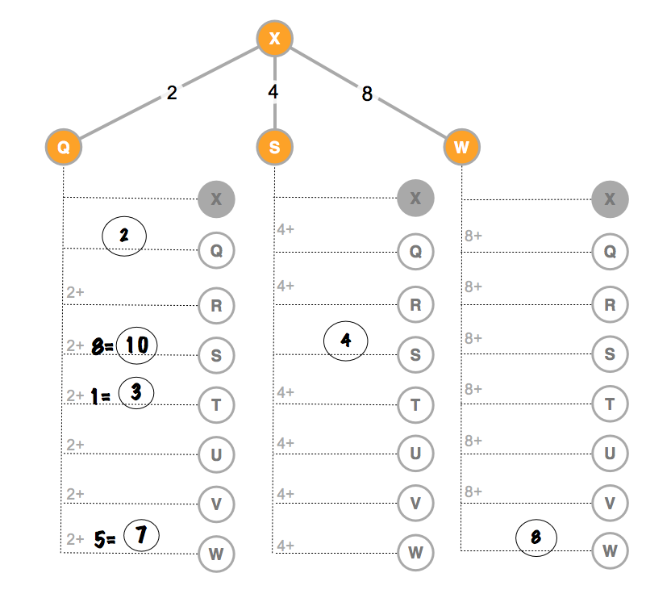
The example assumes you have done a round of information exchange with router Q and you have filled in everything you found out from Q about paths to other nodes. From the table you can tell:
- You do not yet know about any path to R.
- You know two paths to S, but the best one is the direct connection with a cost of 4.
- You found that Q can get to T with cost 1, so it’s a cost of 3 for you to get to T through Q.
- There is a path to W through Q that costs less than your direct connection to W. (Whoa!)

NOTE: All the other routers are learning all the time too, which means the next time you talk to Q, she might have a path to R. She might also have an even better path to S. This means the numbers you calculate are just the best you know at that point in time.

When you exchange info with a neighbor | Examples
Neighbors exchange best-known paths to each possible destination. | You: “Hey, router Q, what is your best path to R? ...what about S?...and T?” etc.
When you are asked what is the best path you have, look across all the paths you currently know about to a destination and report the one with least cost. | You: “My best path to S right now has a cost of 4...I don’t have a path to G yet...my best path to H has a cost of 7” etc.
Update your table:  For each response you get from a neighbor, update your routing table diagram: add the cost it takes you to get to the neighbor + the neighbor’s cost to the destination. | Neighbor says: “I don’t have a path to R, yet.”  (no action required)  Neighbor says: “My best path to W has a cost of 5” (update your table to show 5 + cost-to-neighbor)

Activity Guide - How Routers Learn

You are router: A
How to Exchange Information with a Neighbor
- Neighbors exchange best-known paths so far. Ask your neighbor what is the least cost path she knows about to each of the possible destinations.
- When you are asked what is the best path, look across all the paths you currently know about to a destination and report the one with least cost.
- Update your table: For each response you get from a neighbor, update your routing table diagram: add the cost it takes you to get to the neighbor + the neighbor’s cost to the destination.

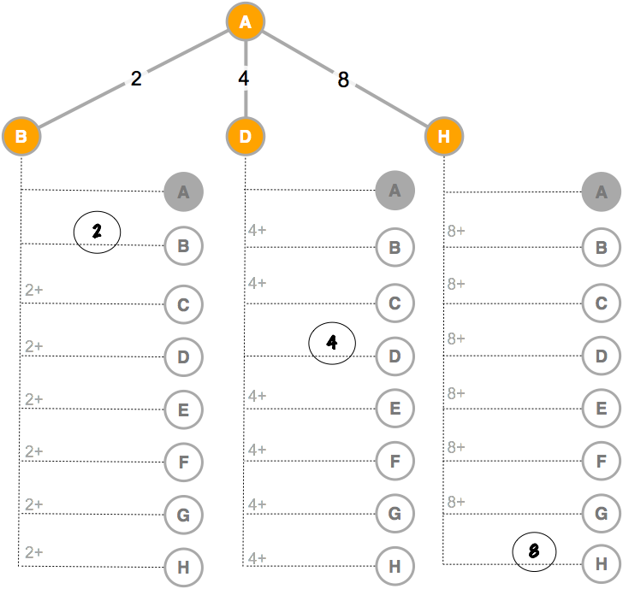

Activity Guide - How Routers Learn

You are the router!
In this activity, you and your classmates will act as routers. You will be directly connected to three other routers (three classmates) with whom you can exchange information about the best ways to route packets, and over time you will learn which is the best way to all the other possible destinations.

Your goal: For every possible destination, you are trying to find out which neighboring router is the best one to forward a packet to to reach that destination. You do this by talking with your neighboring routers and exchanging the best information you’ve got so far.

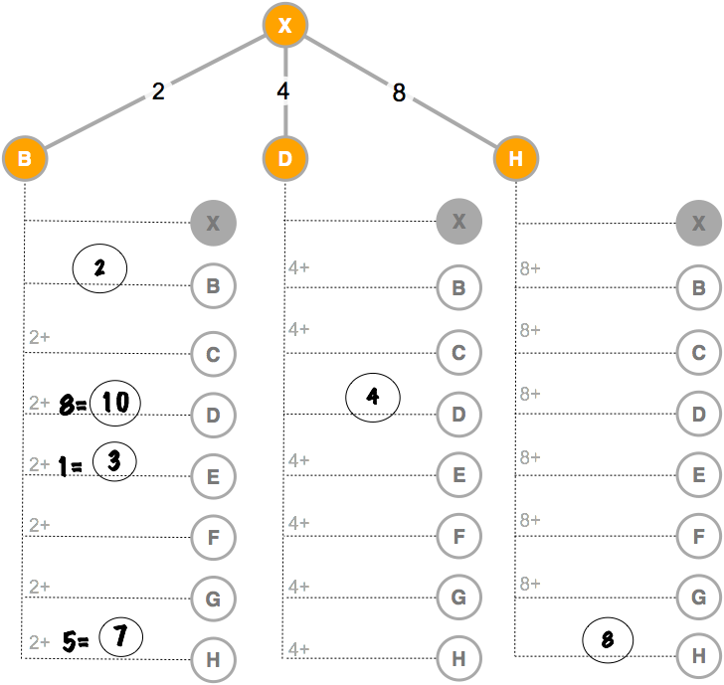
Example (diagram at right): Imagine that you are router X, and are directly connected to routers B, D, and H. You will use a routing table diagram to keep track of paths to other nodes that go through your neighbors.

The example assumes you have done a round of information exchange with router B and you have filled in everything you found out from B about paths to other nodes. From the table you can tell:
- You do not yet know about any path to C.
- You know two paths to D, but the best one is the direct connection with a cost of 4.
- You found that B can get to E with cost 1, so it’s a cost of 3 for you to get to E through B.
- There is a path to H through B that costs less than your direct connection to H. (Whoa!)

NOTE: All the other routers are learning all the time too, which means the next time you talk to B, she might have a path to C. She might also have a new, even better path to D. This means the numbers you calculate are just the best you know at that point in time.

When you exchange info with a neighbor | Examples
Neighbors exchange best-known paths to each possible destination | You: “Hey, router B, what is your best path to C? ...what about D?...and E?” etc.
When you are asked what is the best path you have, look across all the paths you currently know about to a destination and report the one with least cost. | You: “My best path to D right now has a cost of 4...I don’t have a path to G yet...my best path to H has a cost of 7” etc.
Update your table  For each response you get from a neighbor, update your routing table diagram: add the cost it takes you to get to the neighbor + the neighbor’s cost to the destination. | Neighbor says: “I don’t have a path to C, yet.”  (no action required)  Neighbor says: “My best path to H has a cost of 5” (update your table to show 5 + cost-to-neighbor)

Activity Guide - How Routers Learn

You are router: B
How to Exchange Information with a Neighbor
- Neighbors exchange best-known paths so far. Ask your neighbor what is the least cost path she knows about to each of the possible destinations.
- When you are asked what is the best path, look across all the paths you currently know about to a destination and report the one with least cost.
- Update your table: For each response you get from a neighbor, update your routing table diagram: add the cost it takes you to get to the neighbor + the neighbor’s cost to the destination.

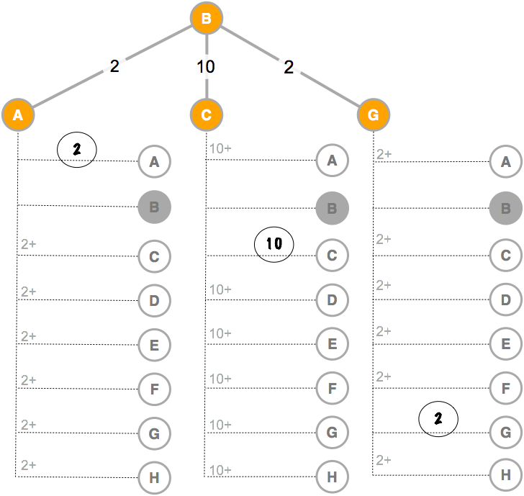

Activity Guide - How Routers Learn

You are the router!
In this activity, you and your classmates will act as routers. You will be directly connected to three other routers (three classmates) with whom you can exchange information about the best ways to route packets, and over time you will learn which is the best way to all the other possible destinations.

Your goal: For every possible destination, you are trying to find out which neighboring router is the best one to forward a packet to to reach that destination. You do this by talking with your neighboring routers and exchanging the best information you’ve got so far.

Example (diagram at right): Imagine that you are router X, and are directly connected to routers B, D, and H. You will use a routing table diagram to keep track of paths to other nodes that go through your neighbors.

The example assumes you have done a round of information exchange with router B and you have filled in everything you found out from B about paths to other nodes. From the table you can tell:
- You do not yet know about any path to C.
- You know two paths to D, but the best one is the direct connection with a cost of 4.
- You found that B can get to E with cost 1, so it’s a cost of 3 for you to get to E through B.
- There is a path to H through B that costs less than your direct connection to H. (Whoa!)

NOTE: All the other routers are learning all the time too, which means the next time you talk to B, she might have a path to C. She might also have an even better path to D. This means the numbers you calculate are just the best you know at that point in time.

When you exchange info with a neighbor | Examples
Neighbors exchange best-known paths to each possible destination | You: “Hey, router B, what is your best path to C? ...what about D?...and E?” etc.
When you are asked what is the best path you have, look across all the paths you currently know about to a destination and report the one with least cost. | You: “My best path to D right now has a cost of 4...I don’t have a path to G yet...my best path to H has a cost of 7” etc.
Update your table  For each response you get from a neighbor, update your routing table diagram: add the cost it takes you to get to the neighbor + the neighbor’s cost to the destination. | Neighbor says: “I don’t have a path to C, yet.”  (no action required)  Neighbor says: “My best path to H has a cost of 5” (update your table to show 5 + cost-to-neighbor)

Activity Guide - How Routers Learn

You are router: C
How to Exchange Information with a Neighbor
- Neighbors exchange best-known paths so far. Ask your neighbor what is the least cost path she knows about to each of the possible destinations.
- When you are asked what is the best path, look across all the paths you currently know about to a destination and report the one with least cost.
- Update your table: For each response you get from a neighbor, update your routing table diagram: add the cost it takes you to get to the neighbor + the neighbor’s cost to the destination.
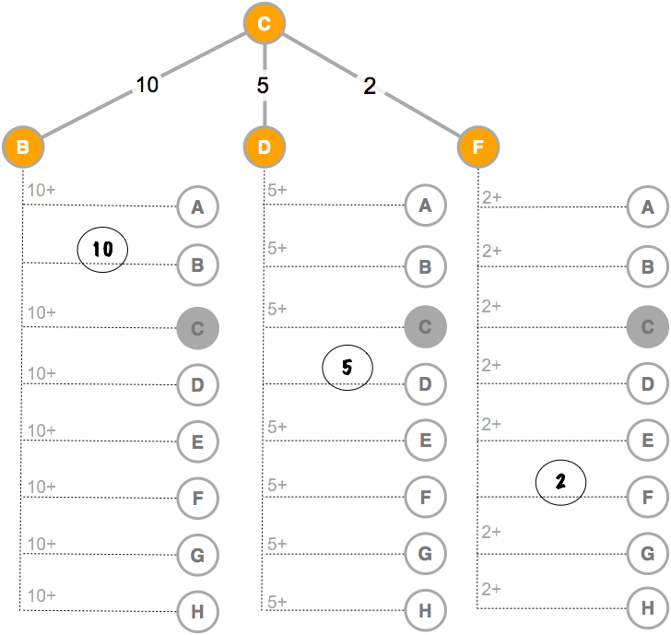

Activity Guide - How Routers Learn

You are the router!
In this activity, you and your classmates will act as routers. You will be directly connected to three other routers (three classmates) with whom you can exchange information about the best ways to route packets, and over time you will learn which is the best way to all the other possible destinations.

Your goal: For every possible destination, you are trying to find out which neighboring router is the best one to forward a packet to to reach that destination. You do this by talking with your neighboring routers and exchanging the best information you’ve got so far.

Example (diagram at right): Imagine that you are router X, and are directly connected to routers B, D, and H. You will use a routing table diagram to keep track of paths to other nodes that go through your neighbors.

The example assumes you have done a round of information exchange with router B and you have filled in everything you found out from B about paths to other nodes. From the table you can tell:
- You do not yet know about any path to C.
- You know two paths to D, but the best one is the direct connection with a cost of 4.
- You found that B can get to E with cost 1, so it’s a cost of 3 for you to get to E through B.
- There is a path to H through B that costs less than your direct connection to H. (Whoa!)

NOTE: All the other routers are learning all the time too, which means the next time you talk to B, she might have a path to C. She might also have an even better path to D. This means the numbers you calculate are just the best you know at that point in time.

When you exchange info with a neighbor | Examples
Neighbors exchange best-known paths to each possible destination | You: “Hey, router B, what is your best path to C? ...what about D?...and E?” etc.
When you are asked what is the best path you have, look across all the paths you currently know about to a destination and report the one with least cost. | You: “My best path to D right now has a cost of 4...I don’t have a path to G yet...my best path to H has a cost of 7” etc.
Update your table  For each response you get from a neighbor, update your routing table diagram: add the cost it takes you to get to the neighbor + the neighbor’s cost to the destination. | Neighbor says: “I don’t have a path to C, yet.”  (no action required)  Neighbor says: “My best path to H has a cost of 5” (update your table to show 5 + cost-to-neighbor)

Activity Guide - How Routers Learn

You are router: D
How to Exchange Information with a Neighbor
- Neighbors exchange best-known paths so far. Ask your neighbor what is the least cost path she knows about to each of the possible destinations.
- When you are asked what is the best path, look across all the paths you currently know about to a destination and report the one with least cost.
- Update your table: For each response you get from a neighbor, update your routing table diagram: add the cost it takes you to get to the neighbor + the neighbor’s cost to the destination.

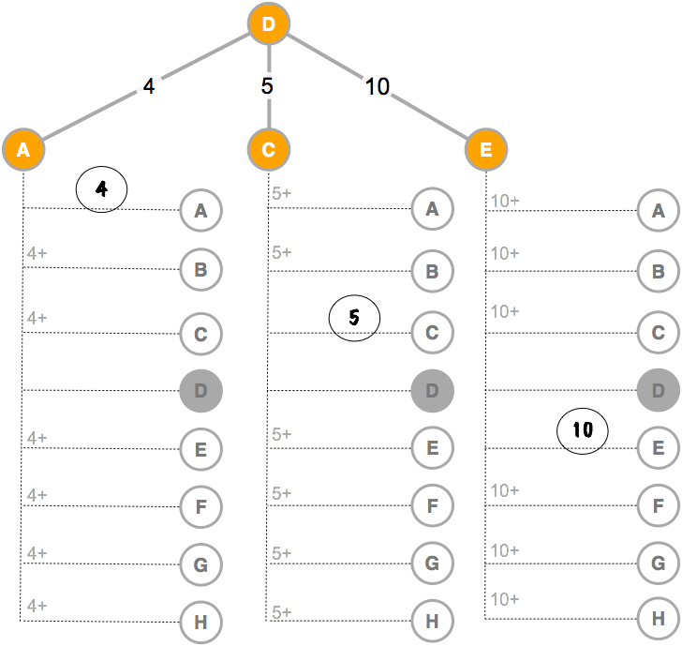

Activity Guide - How Routers Learn

You are the router!
In this activity, you and your classmates will act as routers. You will be directly connected to three other routers (three classmates) with whom you can exchange information about the best ways to route packets, and over time you will learn which is the best way to all the other possible destinations.

Your goal: For every possible destination, you are trying to find out which neighboring router is the best one to forward a packet to to reach that destination. You do this by talking with your neighboring routers and exchanging the best information you’ve got so far.

Example (diagram at right): Imagine that you are router X, and are directly connected to routers B, D, and H. You will use a routing table diagram to keep track of paths to other nodes that go through your neighbors.

The example assumes you have done a round of information exchange with router B and you have filled in everything you found out from B about paths to other nodes. From the table you can tell:
- You do not yet know about any path to C.
- You know two paths to D, but the best one is the direct connection with a cost of 4.
- You found that B can get to E with cost 1, so it’s a cost of 3 for you to get to E through B.
- There is a path to H through B that costs less than your direct connection to H. (Whoa!)

NOTE: All the other routers are learning all the time too, which means the next time you talk to B, she might have a path to C. She might also have an even better path to D. This means the numbers you calculate are just the best you know at that point in time.

When you exchange info with a neighbor | Examples
Neighbors exchange best-known paths to each possible destination | You: “Hey, router B, what is your best path to C? ...what about D?...and E?” etc.
When you are asked what is the best path you have, look across all the paths you currently know about to a destination and report the one with least cost. | You: “My best path to D right now has a cost of 4...I don’t have a path to G yet...my best path to H has a cost of 7” etc.
Update your table  For each response you get from a neighbor, update your routing table diagram: add the cost it takes you to get to the neighbor + the neighbor’s cost to the destination. | Neighbor says: “I don’t have a path to C, yet.”  (no action required)  Neighbor says: “My best path to H has a cost of 5” (update your table to show 5 + cost-to-neighbor)

Activity Guide - How Routers Learn

You are Router: E
How to Exchange Information with a Neighbor
- Neighbors exchange best-known paths so far. Ask your neighbor what is the least cost path she knows about to each of the possible destinations.
- When you are asked what is the best path, look across all the paths you currently know about to a destination and report the one with least cost.
- Update your table: For each response you get from a neighbor, update your routing table diagram: add the cost it takes you to get to the neighbor + the neighbor’s cost to the destination.
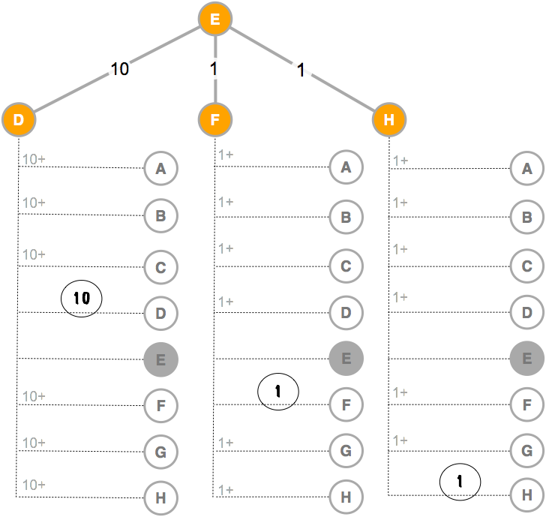

Activity Guide - How Routers Learn

You are the router!
In this activity, you and your classmates will act as routers. You will be directly connected to three other routers (three classmates) with whom you can exchange information about the best ways to route packets, and over time you will learn which is the best way to all the other possible destinations.

Your goal: For every possible destination, you are trying to find out which neighboring router is the best one to forward a packet to to reach that destination. You do this by talking with your neighboring routers and exchanging the best information you’ve got so far.

Example (diagram to right): Imagine that you are router X, and are directly connected to routers B, D, and H. You will use a routing table diagram to keep track of paths to other nodes that go through your neighbors.

The example assumes you have done a round of information exchange with router B and you have filled in everything you found out from B about paths to other nodes. From the table you can tell:
- You do not yet know about any path to C.
- You know two paths to D, but the best one is the direct connection with a cost of 4.
- You found that B can get to E with cost 1, so it’s a cost of 3 for you to get to E through B.
- There is a path to H through B that costs less than your direct connection to H. (Whoa!)

NOTE: All the other routers are learning all the time too, which means the next time you talk to B, she might have a path to C. She might also have an even better path to D. This means the numbers you calculate are just the best you know at that point in time.

When you exchange info with a neighbor | Examples
Neighbors exchange best-known paths to each possible destination | You: “Hey, router B, what is your best path to C? ...what about D?...and E?” etc.
When you are asked what is the best path you have, look across all the paths you currently know about to a destination and report the one with least cost. | You: “My best path to D right now has a cost of 4...I don’t have a path to G yet...my best path to H has a cost of 7” etc.
Update your table  For each response you get from a neighbor, update your routing table diagram: add the cost it takes you to get to the neighbor + the neighbor’s cost to the destination. | Neighbor says: “I don’t have a path to C, yet.”  (no action required)  Neighbor says: “My best path to H has a cost of 5” (update your table to show 5 + cost-to-neighbor)

Activity Guide - How Routers Learn

You are Router: F
How to Exchange Information with a Neighbor
- Neighbors exchange best-known paths so far. Ask your neighbor what is the least cost path she knows about to each of the possible destinations.
- When you are asked what is the best path, look across all the paths you currently know about to a destination and report the one with least cost.
- Update your table: For each response you get from a neighbor, update your routing table diagram: add the cost it takes you to get to the neighbor + the neighbor’s cost to the destination.
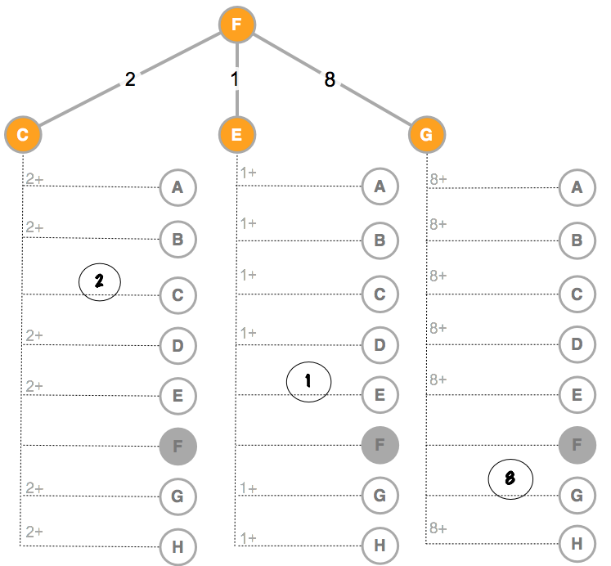

Activity Guide - How Routers Learn

You are the router!
In this activity, you and your classmates will act as routers. You will be directly connected to three other routers (three classmates) with whom you can exchange information about the best ways to route packets, and over time you will learn which is the best way to all the other possible destinations.

Your goal: For every possible destination, you are trying to find out which neighboring router is the best one to forward a packet to to reach that destination. You do this by talking with your neighboring routers and exchanging the best information you’ve got so far.

Example (diagram to right): Imagine that you are router X, and are directly connected to routers B, D, and H. You will use a routing table diagram to keep track of paths to other nodes that go through your neighbors.

The example assumes you have done a round of information exchange with router B and you have filled in everything you found out from B about paths to other nodes. From the table you can tell:
- You do not yet know about any path to C.
- You know two paths to D, but the best one is the direct connection with a cost of 4.
- You found that B can get to E with cost 1, so it’s a cost of 3 for you to get to E through B.
- There is a path to H through B that costs less than your direct connection to H. (Whoa!)

NOTE: All the other routers are learning all the time too, which means the next time you talk to B, she might have a path to C. She might also have an even better path to D. This means the numbers you calculate are just the best you know at that point in time.

When you exchange info with a neighbor | Examples
Neighbors exchange best-known paths to each possible destination | You: “Hey, router B, what is your best path to C? ...what about D?...and E?” etc.
When you are asked what is the best path you have, look across all the paths you currently know about to a destination and report the one with least cost. | You: “My best path to D right now has a cost of 4...I don’t have a path to G yet...my best path to H has a cost of 7” etc.
Update your table  For each response you get from a neighbor, update your routing table diagram: add the cost it takes you to get to the neighbor + the neighbor’s cost to the destination. | Neighbor says: “I don’t have a path to C, yet.”  (no action required)  Neighbor says: “My best path to H has a cost of 5” (update your table to show 5 + cost-to-neighbor)

Activity Guide - How Routers Learn

You are Router: G
How to Exchange Information with a Neighbor
- Neighbors exchange best-known paths so far. Ask your neighbor what is the least cost path she knows about to each of the possible destinations.
- When you are asked what is the best path, look across all the paths you currently know about to a destination and report the one with least cost.
- Update your table: For each response you get from a neighbor update your routing table diagram: add the cost it takes you to get to the neighbor + the neighbor’s cost to the destination.

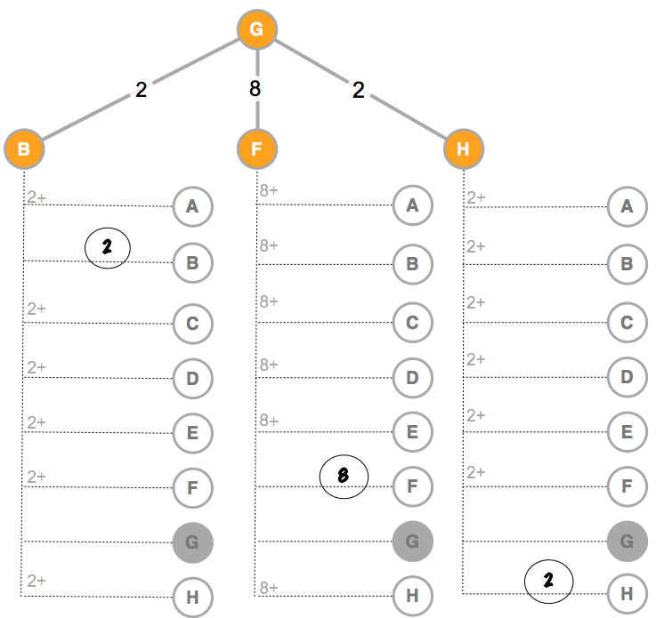

Activity Guide - How Routers Learn

You are the router!
In this activity, you and your classmates will act as routers. You will be directly connected to three other routers (three classmates) with whom you can exchange information about the best ways to route packets, and over time you will learn which is the best way to all the other possible destinations.

Your goal: For every possible destination, you are trying to find out which neighboring router is the best one to forward a packet to to reach that destination. You do this by talking with your neighboring routers and exchanging the best information you’ve got so far.

Example (diagram at right): Imagine that you are router X, and are directly connected to routers B, D, and H. You will use a routing table diagram to keep track of paths to other nodes that go through your neighbors.

The example assumes you have done a round of information exchange with router B and you have filled in everything you found out from B about paths to other nodes. From the table you can tell:
- You do not yet know about any path to C.
- You know two paths to D, but the best one is the direct connection with a cost of 4.
- You found that B can get to E with cost 1, so it’s a cost of 3 for you to get to E through B.
- There is a path to H through B that costs less than your direct connection to H. (Whoa!)

NOTE: All the other routers are learning all the time too, which means the next time you talk to B, she might have a path to C. She might also have an even better path to D. This means the numbers you calculate are just the best you know at that point in time.

When you exchange info with a neighbor | Examples
Neighbors exchange best-known paths to each possible destination | You: “Hey, router B, what is your best path to C? ...what about D?...and E?” etc.
When you are asked what is the best path you have, look across all the paths you currently know about to a destination and report the one with least cost. | You: “My best path to D right now has a cost of 4...I don’t have a path to G yet...my best path to H has a cost of 7” etc.
Update your table  For each response you get from a neighbor, update your routing table diagram: add the cost it takes you to get to the neighbor + the neighbor’s cost to the destination. | Neighbor says: “I don’t have a path to C, yet.”  (no action required)  Neighbor says: “My best path to H has a cost of 5” (update your table to show 5 + cost-to-neighbor)

Activity Guide - How Routers Learn

You are Router: H
How to Exchange Information with a Neighbor
- Neighbors exchange best-known paths so far. Ask your neighbor what is the least cost path she knows about to each of the possible destinations.
- When you are asked what is the best path, look across all the paths you currently know about to a destination and report the one with least cost.
- Update your table: For each response you get from a neighbor, update your routing table diagram: add the cost it takes you to get to the neighbor + the neighbor’s cost to the destination.
