

B3Networks CPaaS
Product Specification for the CPaaS MS Teams Operator Connect Solution

Table of Contents
Product Summary 4
Product Features 5
Product Requirements 7
CPaaS License Requirements 7
Microsoft Requirements 7
Functional Specs 10
Network Setup 10
High Availability Design 11
Deployment Overview 11
Security Overview 14
Workflow Sample 15
● Typical Workflow 15
● MS Teams Auto Attendant 15
● MS Teams Call Queue 16
● MS Teams Boss & Secretary 16
Use cases in various industries 17

Document control versioning

Document History
Date | Version | Applicable BMOs | Author | Comments
19 Oct 2022 | Version 1.0 | All | Hallie | Document creation
31 Oct 2022 | Version 1.1 | All | Shubham | Amendment

Product Summary
CPaaS Microsoft Teams Operator Connect enables customers to connect their numbers to their MS Teams Applications.
- Owned & Operated Nationwide Communication Network
- Modular Solutions - Deploy what you need, Hybrid Setup
- Future Proof - Fixed Mobile Convergence, APIs
- Infrastructure Reliability and Support
- Single Point of Contact and Responsibility
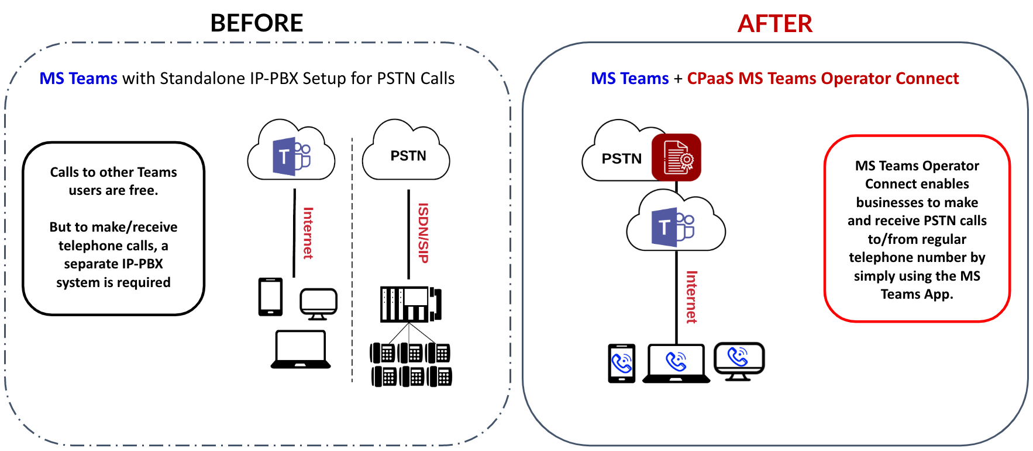

CPaaS MS Teams Direct Routing vs MS Teams Operator Connect
- The CPaaS Microsoft Teams Operator Connect is the upgraded version of CPaaS Microsoft Teams Direct Routing with Full API to assist Operators in integrating with Microsoft Calling Service.
- With CPaaS Microsoft Teams Operator Connect, Customers can cut off the below steps when provisioning:
- Grant access to Customers’ tenant profiles
- Connector Domain verification steps
- Powershell execution steps
- Operator Name will be broadcast on Microsoft Marketplace.
- Customers can proactively contact Operators directly via Microsoft page.

Product Features
Feature | Description
Call transfer | During an active call, users will have options available to do a Call Transfer.
Call hold | During an active call, users will have options available to do a Call Hold
Consult then transfer | Consult then Transfer, using MS Teams Directory on desktop, a chat box will appear to converse with the transfer destination. After which, the transferer can click on the Transfer button to complete the call.
Cloud voicemail | Cloud Voicemail deposits voicemail messages in a user's Exchange mailbox.
Call forwarding | You can forward calls to another number or Teams member, or ring another number at the same time as your work number.
Delegation/Shared line appearance | When making outgoing calls, the secretary is able to call as myself or on Boss’s behalf.
Auto attendant | - Auto-attendant is an IVR service which allows users to set up menu options to route the calls based on caller inputs.  - It provides a series of choices that guide callers to their desired destination quickly, without relying on a human operator to handle incoming calls.
Call queue | - Call queues provide a method of routing callers to people within the organization who can help with a particular issue or question.  - Calls are distributed one at a time to the people in the queue (who are known as agents).
PSTN Call Recording | - CPaaS Microsoft Teams Operator Connect provides a customer portal for easy search and retrieval of Call Recordings.  - Advance access rights management by per user and per team is supported.
IDD call controls | IDD Call Control can be controlled by per user or PIN and is supported by CPaaS Microsoft Teams Operator Connect IDD controls feature.
Inbound call filter | This function defines what action will be taken when an incoming call to the User's assigned number.
Call sharing and group call pickup | The call sharing and group call pickup features of Microsoft Teams let users share their incoming calls with colleagues so that the colleagues can answer calls that occur while the user is unavailable.
Music on hold | When a Microsoft Teams user places an incoming call on hold, the caller can listen to selected music.  The music that is played is either the default music provided by Microsoft or custom music that you upload and configure.
Internal call | Able to make internal calls from Extension to Extension
Caller ID management | Able to select the caller ID (Assigned / Private)
Call history | Comprehensive call history with call details and voicemail/call recording file
Call park and retrieve⁽¹⁾ | Call park and retrieve is a feature that lets a user place a call on hold. When a call is parked, the service generates a unique code for call retrieval. The user who parked the call or someone else can then use that code with a supported app or device to retrieve the call.
Configure call settings for your users⁽²⁾ | Administrators can change call forwarding & delegation settings for users.
Calling policies⁽³⁾ | Roll out policies for call control and forwarding on organizational, group, or user levels.
Common area phones⁽⁴⁾ | Available to be deployed on common areas to make or receive calls.

(1): Click here for more information.
(2): Click here for more information.
(3): Click here for more information.
(4): Click here for more information.

Product Requirements

CPaaS License Requirements
(*): optional
SKU Name | SKU Type | Unit of measure
CPaaS Licensing Requirements for MS Teams Auto Attendant / Call Queue
Phone System | Base License | per seat per month
Microsoft Teams Operator Connect Resource Account | Addon License | per extension per month
Number | Addon License | per extension per month
CPaaS Licensing Requirements for MS Teams Users
Phone System | Base License | per seat per month
Microsoft Teams Operator Connect | Addon License | per extension per month
Number | Addon License | per extension per month
*Call Recording (up to 1 year unlimited call recording storage) | Addon License | per extension per month
*Unlimited Call Recording Storage  (up to 7 year unlimited call recording storage)  - This is an Add-on license to the basic Call Recording license above - | Addon License | per extension per month

Microsoft Requirements
- Your account must have admin privileges to access the third-party admin portal:
- Microsoft licenses for:
  - Connector domain verification
  - Operator Connect user
  - Click here for more details.
- Global admin access on your Office 365 tenant
- In order to provision the numbers to your Teams tenant, please also complete the below pre-requisites:
  - Add us as the Operator - Configure Operator Connect - Microsoft Teams | Microsoft Docs, under Enable an operator
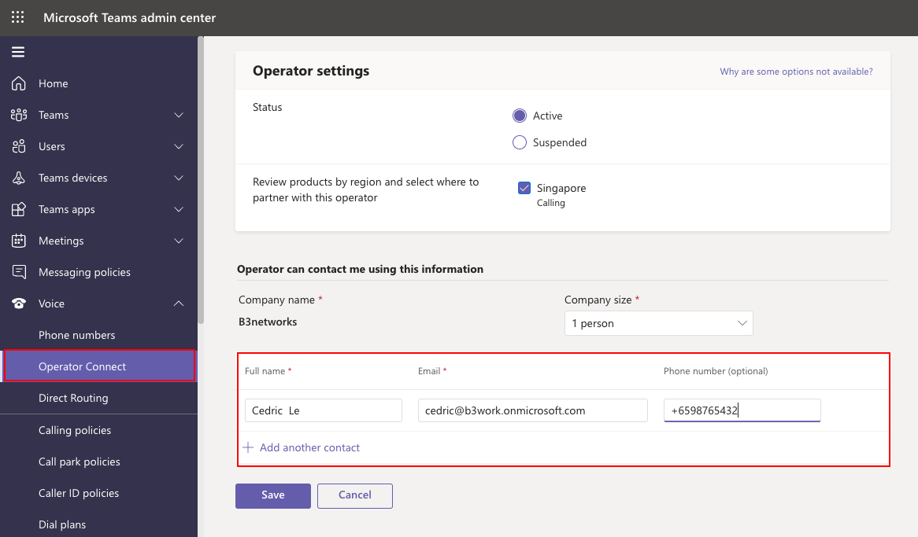
  - Provide us Microsoft tenant ID. - Find Tenant ID, Object ID, and partner association details in Azure Marketplace | Microsoft Docs
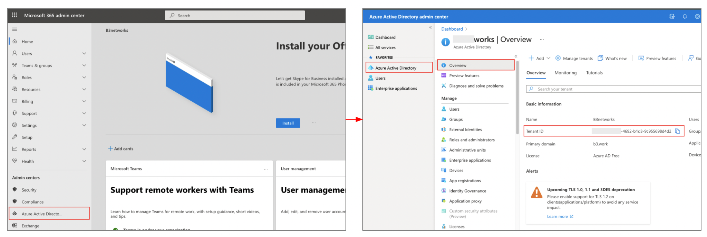

  - Upgrade your Microsoft tenant coexistence to “Teams only” Mode under “Teams” > “Teams upgrade settings”. - Set your coexistence and upgrade settings - Microsoft Teams | Microsoft Docs
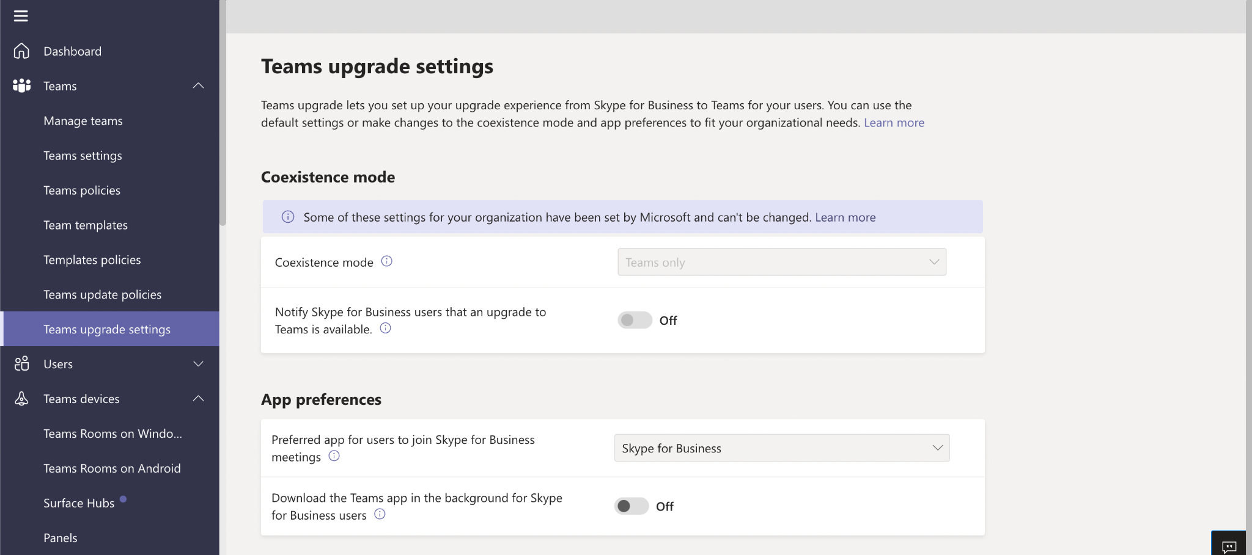
  - Add Emergency Addresses to Microsoft tenant. - Add, change, remove emergency locations - Microsoft Teams | Microsoft Docs
  - 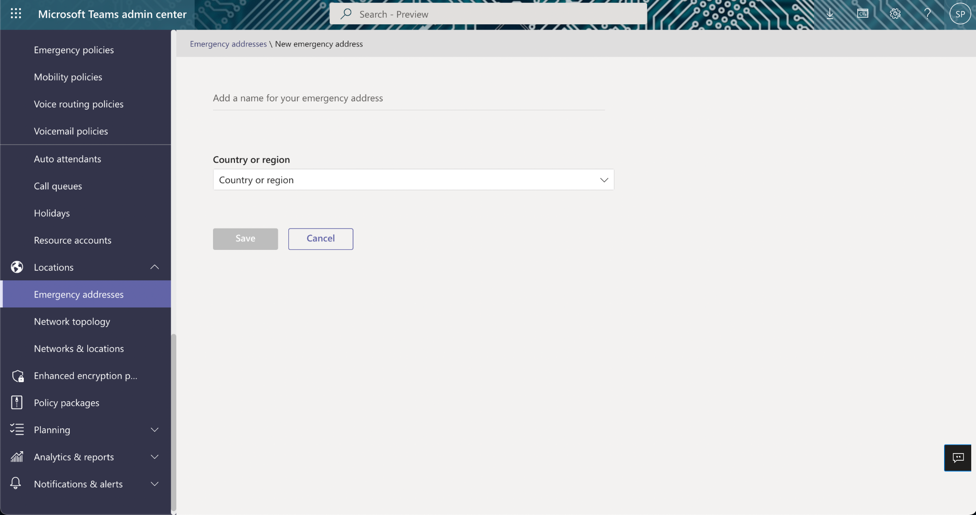

Functional Specs

Network Setup

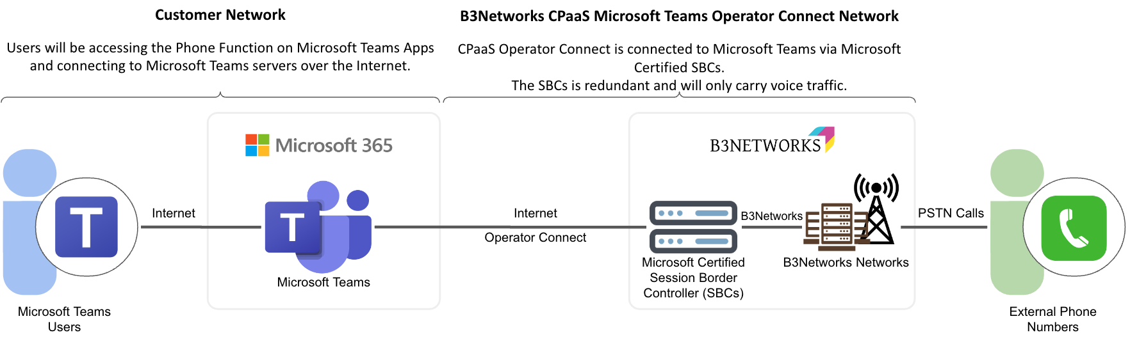

InfoSecurity | Quality of Service | 99.9% Uptime SLA
CPaaS Microsoft Teams Operator Connect has an inherent network separation advantage over the customer premise SBC option.  - The SBC is only connected to Microsoft Teams for voice traffic.  - Customer does not need to worry about having additional SBC in the network to secure.  - CPaaS Microsoft Teams Operator Connect undergoes Annual Vulnerability Assessment and Penetration Testing, ISO 27001 Certifications, with continuous NOC monitoring and upgrades. | CPaaS Microsoft Teams Operator Connect has an inherent quality advantage over hosted SBC option.  - Direct connectivity to B3Networks Network is the simplest setup with the lowest network latency.  - Customer does not need to worry about having a separate SIP setup.  - B3Networks CPaaS Microsoft Teams Operator Connect offers Operator Connect, High Availability SBCs setup, and Direct Network Connectivity to the B3Networks Infrastructure.

High Availability Design
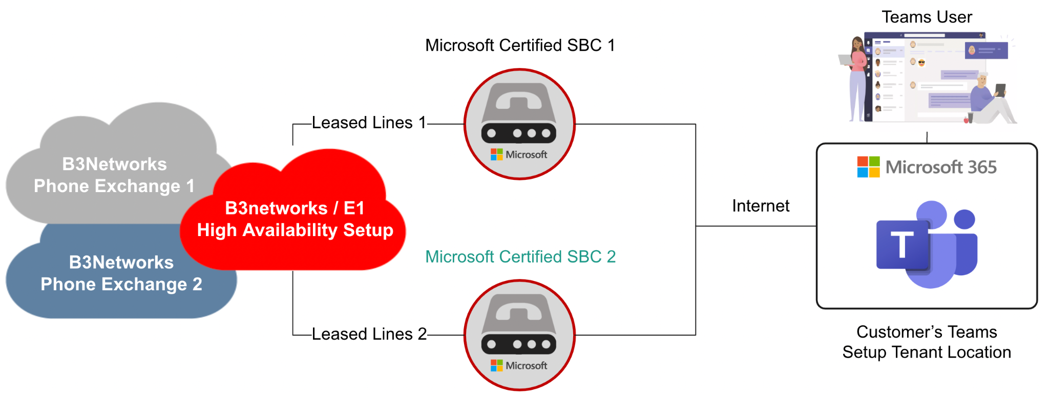
Microsoft Teams Firewall and Bandwidth Requirements
Ports | UDP ports 3478 through 3481
IP addresses | 13.107.64.0/18, 52.112.0.0/14, and 52.120.0.0/14
Bandwidth (Audio) | 30 to 84 kbps

Deployment Overview

Step 1: Purchase necessary CPaaS Microsoft Teams Operator Connect and Microsoft 365 Licenses
- B3Networks is directly connected to Microsoft Teams via Microsoft Operator Connect.
- No change is required on the customer network.

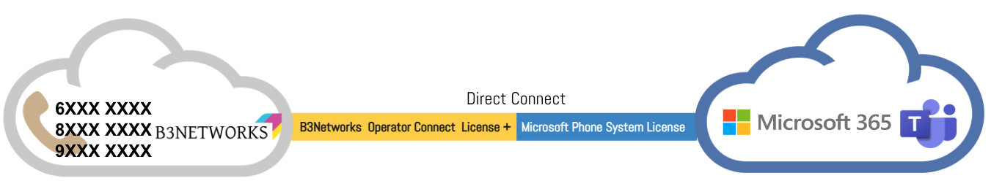

Step 2: Log in to B3Networks Portal & Connect to Microsoft Teams
This is only required for Admin. Admin will log in and assign Operator Connect License + number to CPaaS users
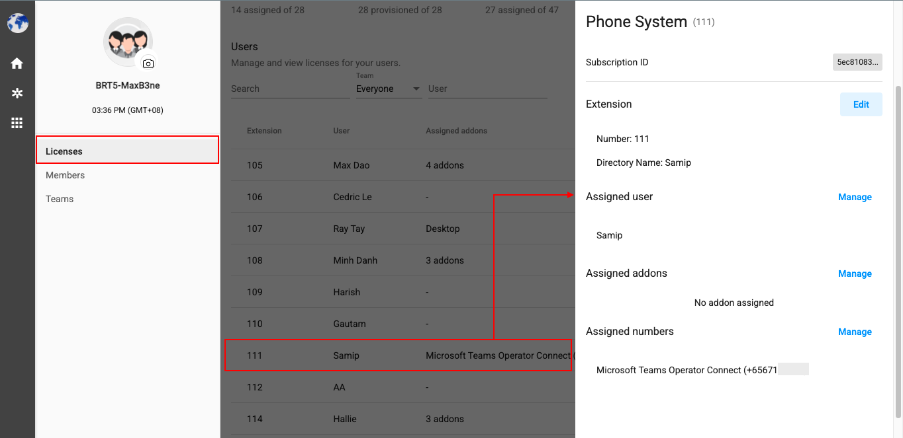
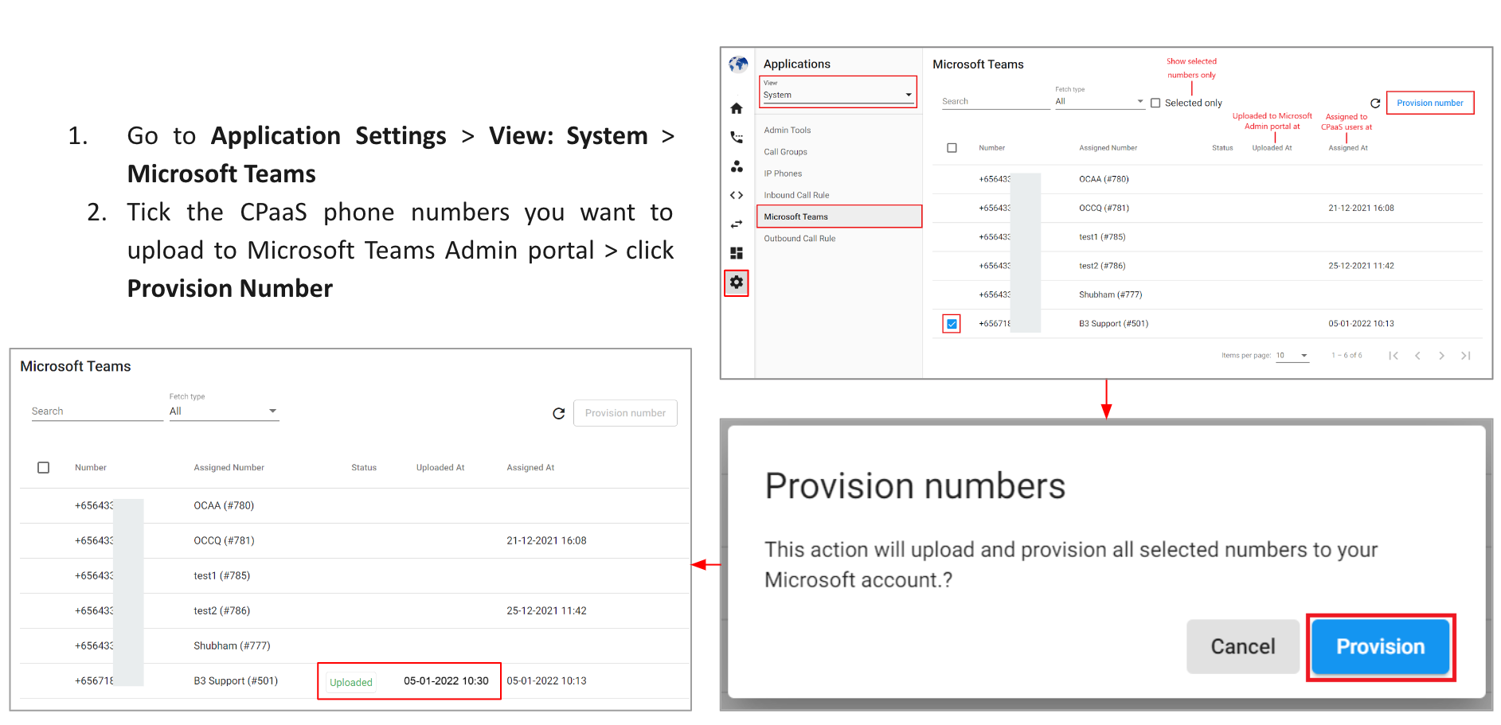

Step 3: Log in to Microsoft Portal & Assign CPaaS numbers to Users
- The service provisioning to Microsoft Teams is fully automated.
- Admin only needs to log in to Microsoft Portal and assign CPaaS numbers to Microsoft Users to start using the services
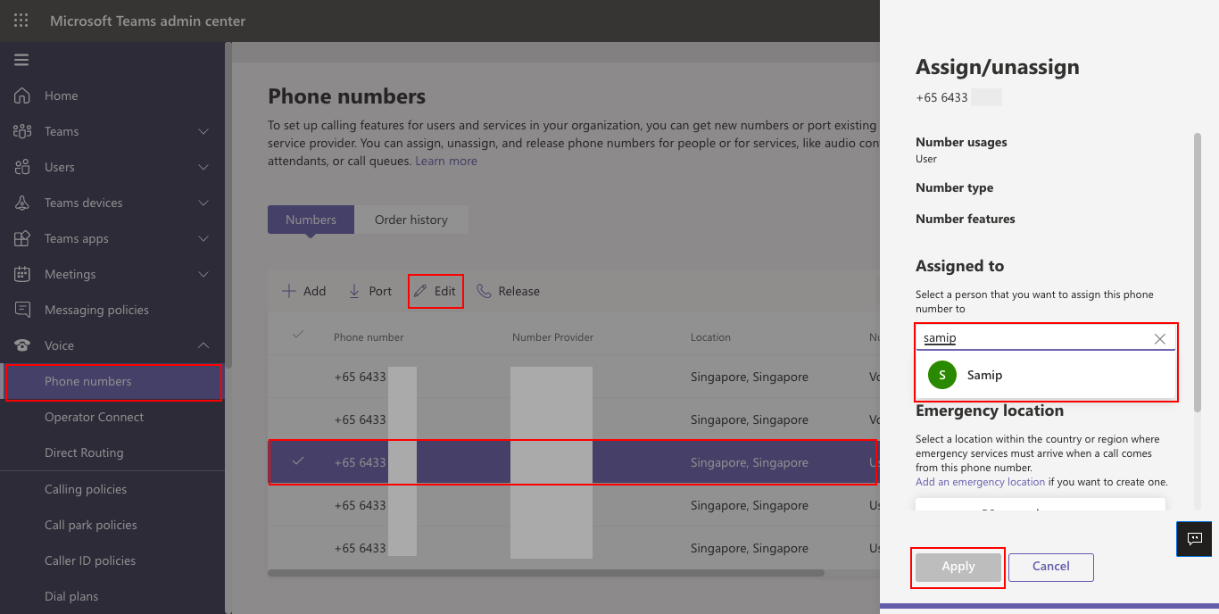

Step 4: Service Provisioning Completion
Call button and Phone Number will appear in Microsoft Teams App. Users can now receive and make outgoing PSTN calls.

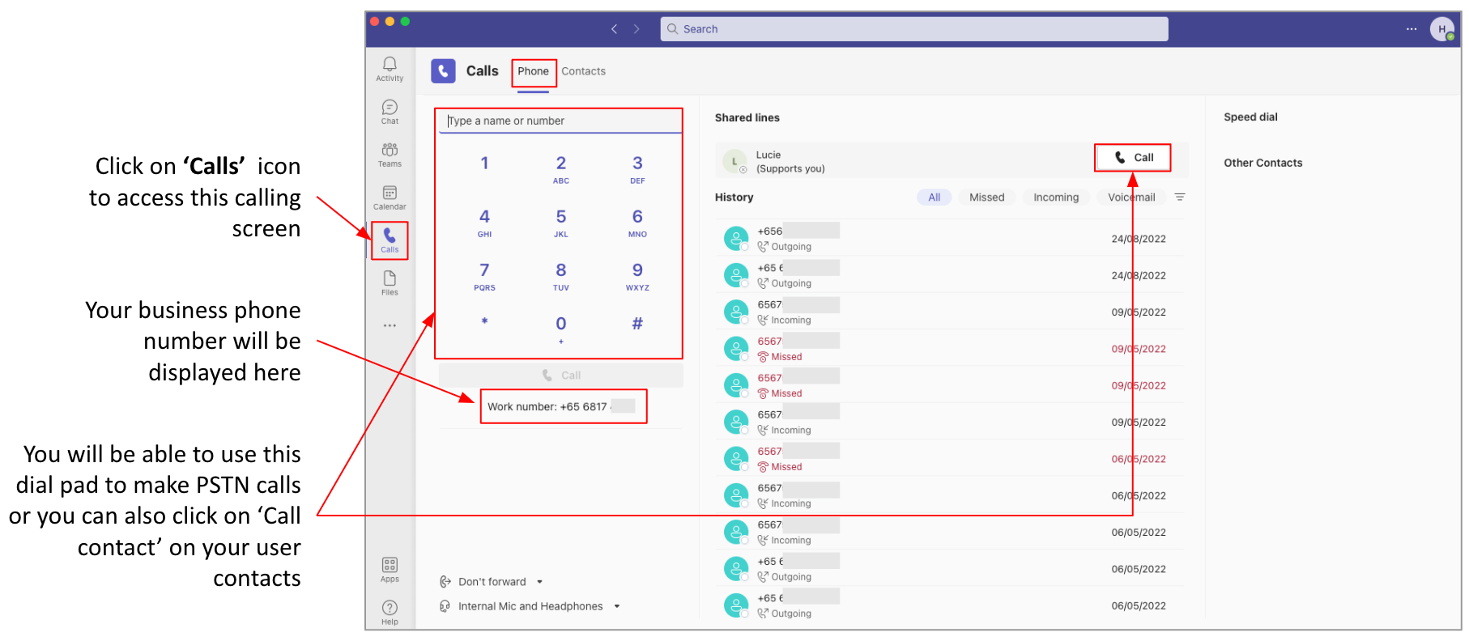

Security Overview
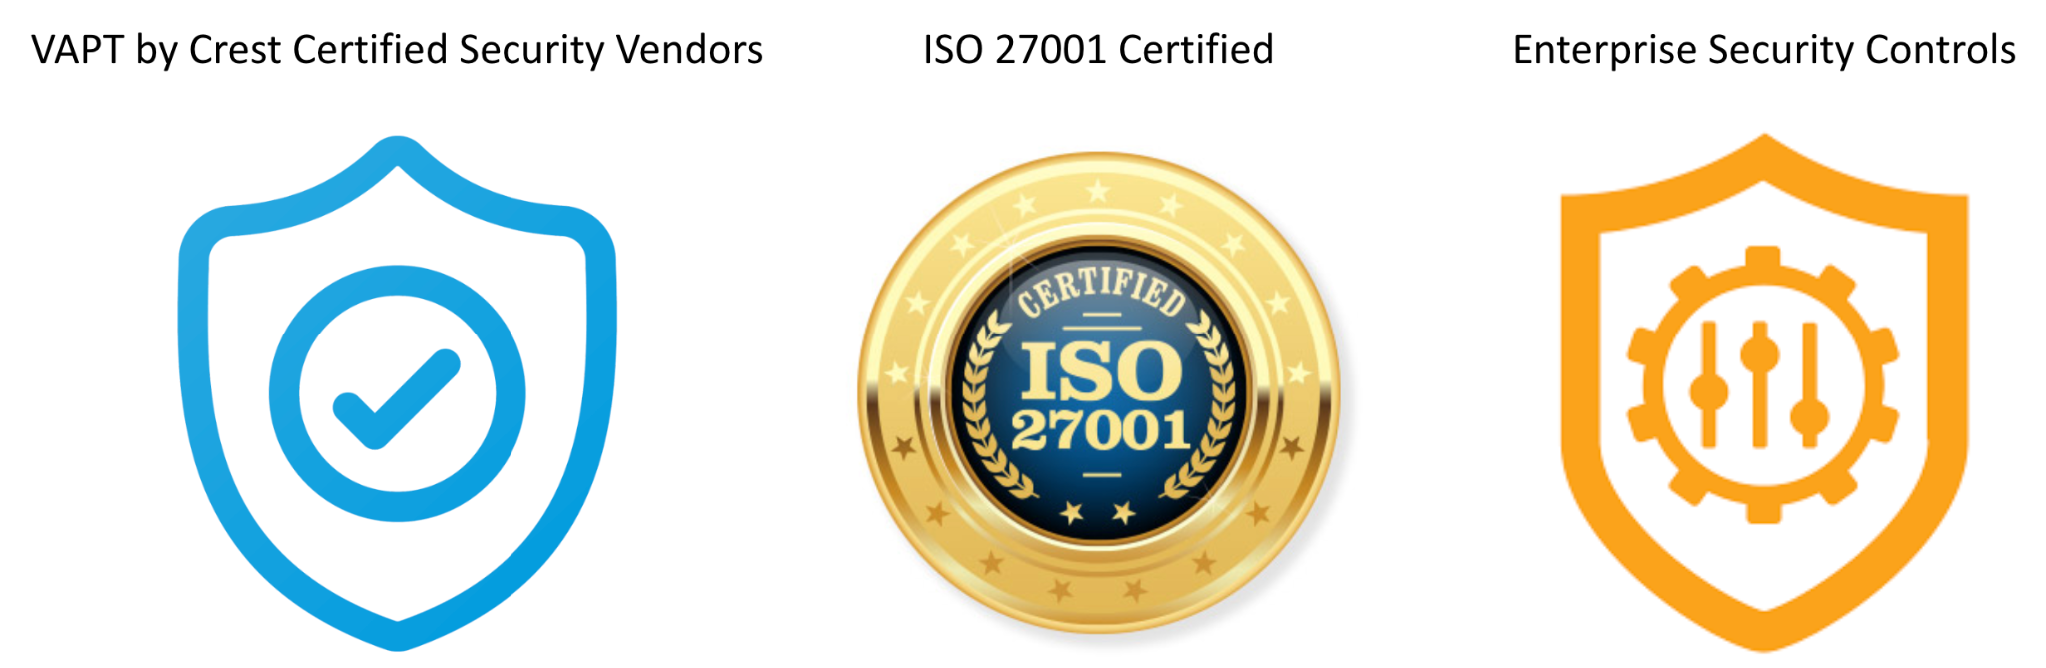
The system is designed with the following data security considerations.
- Data Minimisation
  - System can operate with minimum customer data.
  - Automated data reduction and tokenization capabilities.
- Data Encryption
  - Data encryption in transit and at rest for all data.
    - Data Encryption in Transit:
      - Transmission Protocols: HTTPS, SFTP, SIP TLS, SRTP
      - SSL Version: TLS 1.2
      - Certificate Authority: Amazon
      - Signature Algorithm: SHA256 + RSA
    - Data Encryption at Rest:
      - Encryption: AES-256
      - Key Provider: AWS KMS-Managed Keys
      - Key Management: AWS Managed
      - Key Access Logs: AWS Cloud Trail
  - Public key encryption options for call recordings.
  - Automated data transfer to customer local storage.

Workflow Sample

Typical Workflow

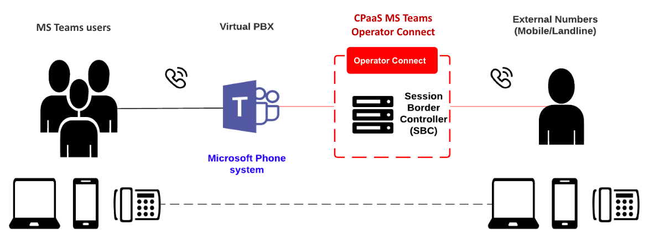

MS Teams Auto Attendant
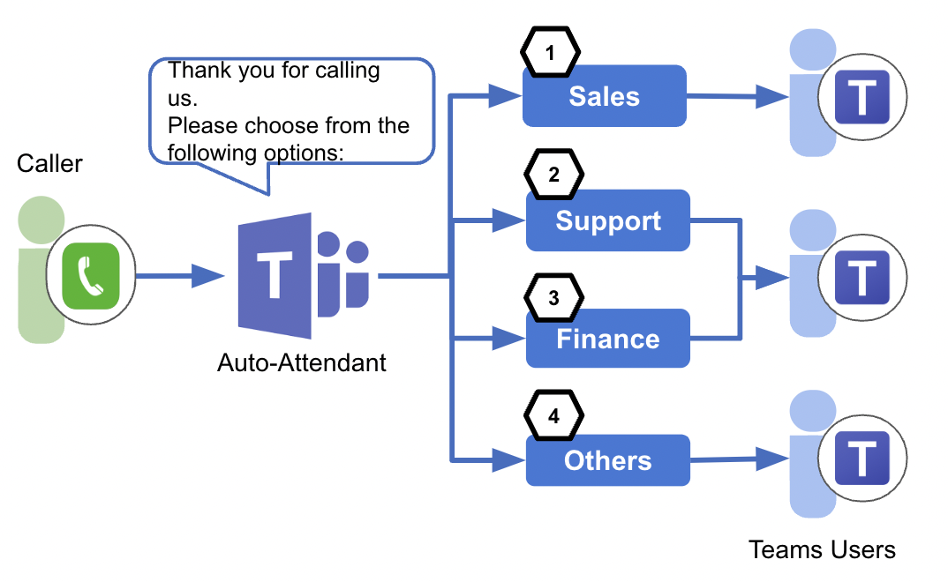

MS Teams Call Queue

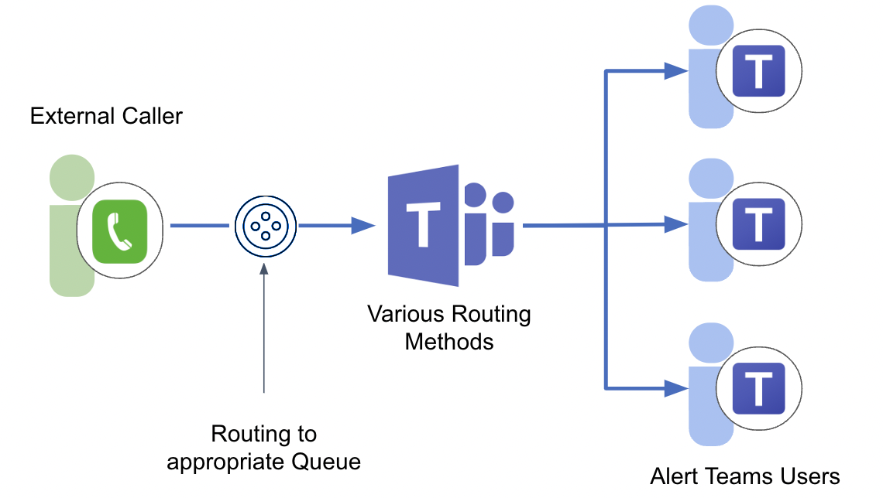

MS Teams Boss & Secretary

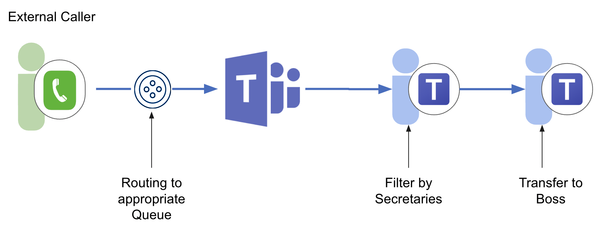

Use Cases in various industries

- Online Retail Store: more than 500+ users deployed for a leading online retailer in the Gaming and PC and Peripheral industry addressing their daily operational and collaboration needs using CPaaS MS Teams Operator Connect solutions.
- Packaging: a leading printing and packaging company in Singapore has applied our solution to enable remote workers during the pandemic situation and resulting hybrid work requirements.
- Consulting: one of the Big 4 consulting companies is using our solution to meet their unique requirement of a global presence and on-premise needs.
- Others: many FI’s and Logistics based companies are using our solution to the ever-changing landscape of hybrid and Remote requirements by leveraging and connecting to the nearest Microsoft’s PoP locations and Partner networks and ensuring High Availability and Low Latency services.
- Here is an example of the customer’s requirements that our solution was able to fulfill:
  - Authentication & Access in the CPaaS platform need to be centralized with clearly defined roles.
  - Have an Audit trail in the CPaaS platform which highlights changes made. (pending)
  - Call Recording:
    - Have an additional role created to manage and administer this feature to meet business needs. (pending)
    - Restrict any end-user changes to enable/disable at the end-user level and retain this feature only at the Admin level.
    - Meet business Compliance requirements by announcing a Call Recording message to the caller before recording the conversation.
  - Client needed to dial using Extension as used in the legacy systems (internal calling in Operator Connect)
  - Ability to call Satellite Services from ships or remote locations

