Name(s)_______________________________________________ Date ___________________
 | Activity Guide - User Testing (User) | 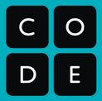
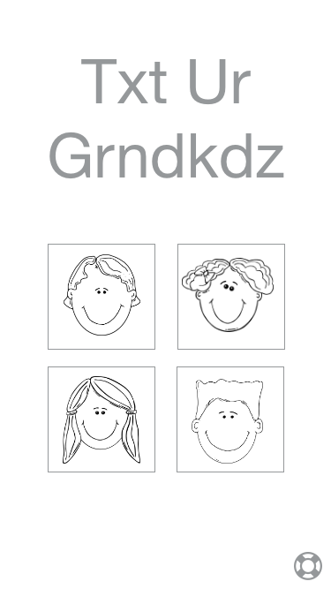


Click!

Test Cases

A test case is a specific user interaction that the developer of an app wants to test for. Choosing good test cases can ensure that when you test an app with a user, you hit all of the important functionality. In the table below, each row is a test case made up of a specific task that you are trying to perform, a space for you to document what you tried, and a space to record your reaction.

Prototype Testing

You’re going to test out this prototype with a partner. Your role is to be the User, interacting with the User Interface screens as if it’s an actual app. Your partner (the Computer) will take care of making sure the prototype responds as it was designed. Use the table below to try out different test cases and record the results. The last few rows are left blank to allow you to explore other areas of the app that interest you. The first row is completed as an example

Task | What I Tried | My Reaction
View Suzette’s information | Clicked on each of the of the faces until I found one that changed to Suzette’s screen. | It wasn’t really clear who was who on the home screen. It would be nice if it showed each kid’s name below their picture
Get help on how to use the app
Find out when Suzette’s birthday is
Send Suzette a message
Get the definition of an unknown acronym
Task | What I Tried | My Reaction
Change Suzette’s Age
Change Suzette’s Picture
Enable Notifications

