Title: Write your title here in Times New Roman, 16pt
Name of author 1, author 2, author 3, …author N
Affiliation of author 1, author 2, author 3, author N
Email of the corresponding author

1. Background of the Research: Provide a background and motivation for your research within 5-10 lines. Provide a background and motivation for your research within 5-10 lines. Provide a background and motivation for your research within 5-10 lines. Provide a background and motivation for your research within 5-10 lines. Provide a background and motivation for your research within 5-10 lines. Provide a background and motivation for your research within 5-10 lines. Provide a background and motivation for your research within 5-10 lines. Provide a background and motivation for your research within 5-10 lines.

2. Research Objectives: Summarize the aim and objectives of your research within 2-3 lines.Please write in 2-3 lines. Summarize the aim and objectives of your research within 2-3 lines.Please write in 2-3 lines. Summarize the aim and objectives of your research within 2-3 lines.Please write in 2-3 lines.

3. Research Problem/ Research Questions: Succinctly articulate the research problem you aim to address within 5-10 lines. Succinctly articulate the research problem you aim to address within 5-10 lines. Succinctly articulate the research problem you aim to address within 5-10 lines. Succinctly articulate the research problem you aim to address within 5-10 lines. Succinctly articulate the research problem you aim to address within 5-10 lines.

4. Approach: Explain your proposed solution to address the aforementioned problem within 10-20 lines. Figures may be employed to provide a clearer illustration of your approach. Explain your proposed solution to address the aforementioned problem within 10-20 lines. Figures may be employed to provide a clearer illustration of your approach. Explain your proposed solution to address the aforementioned problem within 10-20 lines. Figures may be employed to provide a clearer illustration of your approach.Explain your proposed solution to address the aforementioned problem within 10-20 lines. Figures may be employed to provide a clearer illustration of your approach.

5. Experiment/Methodology: Detail the methodology used to validate your concept. For survey-based studies, provide an overview of the survey profile. For experiments, describe the experimental environment. Utilize figures and tables as necessary to illustrate the environment or survey profile. Detail the methodology used to validate your concept. For survey-based studies, provide an overview of the survey profile. For experiments, describe the experimental environment. Utilize figures and tables as necessary to illustrate the environment or survey profile.Detail the methodology used to validate your concept. For survey-based studies, provide an overview of the survey profile. For experiments, describe the experimental environment. Utilize figures and tables as necessary to illustrate the environment or survey profile.

6. Results: Describe your findings 5-10 lines. You can use figures to explain your findings. Describe your findings 5-10 lines. You can use figures to explain your findings. Describe your findings 5-10 lines. You can use figures to explain your findings. Describe your findings 5-10 lines. You can use figures to explain your findings. Describe your findings 5-10 lines. You can use figures to explain your findings. Describe your findings 5-10 lines. You can use figures to explain your findings. Describe your findings 5-10 lines. You can use figures to explain your findings.

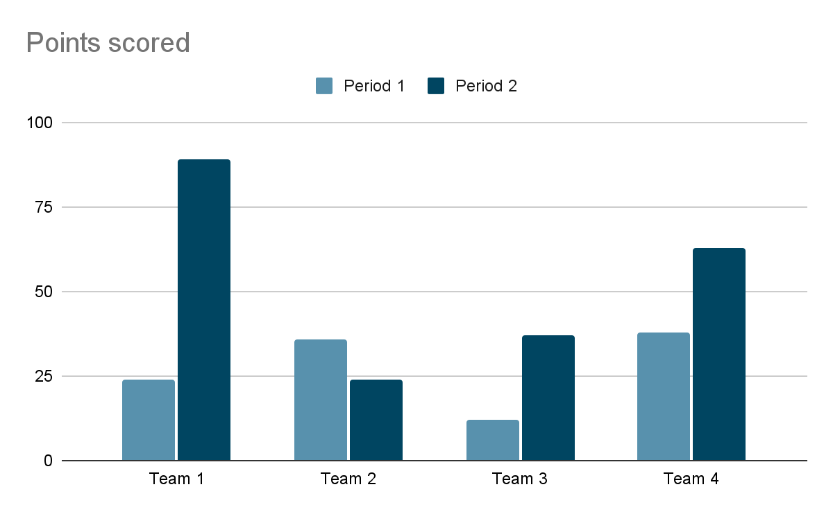

7. Conclusion and Future Work: Please provide a concise summary of your research along with future directions in 4-7 lines. Please provide a concise summary of your research along with future directions in 4-7 lines. Please provide a concise summary of your research along with future directions in 4-7 lines. Please provide a concise summary of your research along with future directions in 4-7 lines.

Acknowledgement: This section is optional. You may write this section in a maximum of 3 lines

References: Please list less than 5 references in IEEE style. Font size should be 8
[1]
[2]
[3]
[4]
[5]

*Please follow the instructions below.
Title: Times New Roman, 16pt
Author Name: Times New Roman, 9pt
Main Text: Times New Roman, 10pt
References: Times New Roman, 8pt
Please adhere to the specified font types and sizes for each section. The number of lines indicated is approximate, and you are allowed to adjust them slightly as needed. However, ensure that the paper for the poster does not exceed two pages; otherwise, it will be rejected immediately.

