Name(s)_______________________________________________ Period ______ Date ___________________

Activity Guide - Storage and Processing

Storage and Processing
Computers use algorithms to process information. Algorithms are steps or instructions the computer follows to turn input into output. Computers don’t process information exactly like humans, and so their steps might look slightly different from a human’s. Even still, the more steps an algorithm takes, the longer it’ll take to run.

When designing an algorithm you don’t just think about the steps of the algorithm. You need to think about the space it will take for a computer to process that information. This activity will help you think about the importance of storage in processing information a little more clearly.

Setup

- Shuffle a deck of cards
- Pick up about 10 cards and put them in a stack face down
- Have a stack of post-its or similarly sized pieces of paper on hand

Rules

- You can only use one hand through the entire challenge
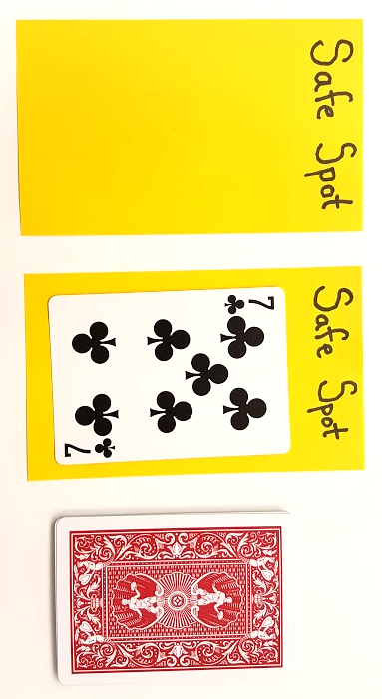
- Your hand can hold at most one card
- You can pull a new card off the deck and look at it whenever you like
- Once a card leaves your hand it is removed
- You may not remember anything about cards removed from the game
- At any time you may make a “safe spot” on the table by placing a post it
- A safe spot can hold at most one card, face up, preventing it from being removed from play

Challenge 1: Smallest Card
Create an algorithm that always finds the smallest card in your pile.

Input: __________________ Output: ___________ Storage: (How many safe spots did you use?) __________

Processing: Write your algorithm in the space below

Challenge 2: Largest Card
Create an algorithm that always finds the largest card in your pile.

Input: ________ Output: ___________ Storage: (How many safe spots did you use?) __________

Processing: Write your algorithm in the space below

Challenge 3: Second Largest Card
Create an algorithm that always finds the second largest card in your pile.

Input: ________ Output: ___________ Storage: (How many safe spots did you use?) __________

Processing: Write your algorithm in the space below

Challenge 4: Middle Card
Create an algorithm that always finds the middle or median card in your pile (the one that would be in the middle if you lined up all your cards in number order). You can assume you have an odd number of cards.

Input: ________ Output: ___________ Storage: (How many safe spots did you use?) __________

Processing: Write your algorithm in the space below

