SUMMATIVE TEST NO. 4
Mga Layunin | CODE | Bahagdan | Bilang ng Aytem | Kinalalagyan ng Bilang
produce sound by clapping, tapping, stomping, blowing and humming; and | S3FE-  IIIa-b-7 | 50% | 5 | 1-5
conclude that different objects make different sounds. | S3FE-  IIIa-b-7.3 | 50% | 5 | 6-10
 |  | 100 | 10 | 1 – 10
GRADE I – SCIENCE
SKAI KRU

SUMMATIVE TEST NO.4
GRADE I – SCIENCE
SKAI KRU

Pangalan:_____________________________________ Grade and Section:_________

I. Look at the following pictures and tell how sound is produced. Choose your answer in the word bank below. Do this on a separate sheet of paper.
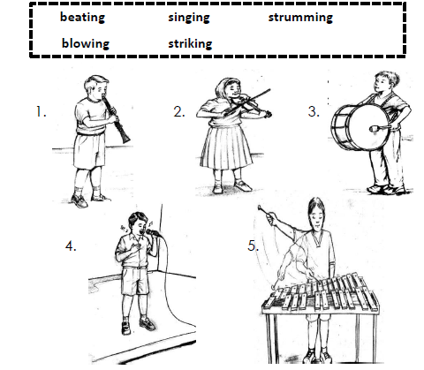

II. Choose the letter of the best answer. Write your answers on a separate sheet of paper.

1. Which of the following statements best describes soft sound?
A. barking dogs
  - B. a sleeping baby
  - C. mother singing lullaby
  - D. A band playing drums during the festival.
2. Which of the following statements best describes loud sound?
A. chirping of bird
  - B. A kid singing a song.
  - C. softly strumming a guitar
  - D. An ambulance rushing to the hospital.
3. Which of the following statements is NOT true?
A. Musical instruments are all loud.
  - B. Calm music is pleasant for the ears.
  - C. Strong force can produce a loud sound.
  - D. Softly strumming a guitar creates a pleasant sound.
4. Which is true about noise?
A. Soft sound produces noise.
  - B. Noise is pleasant for the ears.
  - C. Noise is not good for the ears.
  - D. Soft sound produces noise pollution.
5. Which of the following statements is NOT true about sound?
A. Too much sound can produce noise.
  - B. Loud sound is caused by a strong force.
  - C. Different objects produce different sounds.
  - D. Soft sound is caused by a weak force and it is unpleasant for the ears.

SUMMATIVE TEST 4 ANSWER KEY:
I.
1. BLOWING
2. STRUMMING
3. BEATING
4. SINGING
5. STRIKING
II.
6. C
7. D
8. A
9. C
10. D

