10th ICSSST 2025
10th International Conference on Solid State Science and Technology 2025
“Unlocking New Horizons in Material Innovation”
26-27 September 2025
Copthorne Hotel, Cameron Highlands,
Pahang, Malaysia

Scope
- Superconductivity and Magnetism
- Electronics and Devices
- Renewable Energy and Green Technology
- AI Semiconductor and Technology
- Nanoscience and Nanotechnology
- Materials and Synthesis
- Medical Physics and Bioinstrumentation
- Destructive and Non-Destructive Testing
- Physics Education
- Materials and Technology in Agriculture
- Fundamental and Computational Science

INVITATION TO SPONSOR
The Organizer welcomes individuals and organizations to become the sponsors for 10th ICSSST 2025.

Diamond Sponsors
RM20,000.00

DIAMOND SPONSOR BENEFITS:
- Introduced as main sponsor of 10th ICSSST2025.
- Logo prominently displayed on the Conference / Seminar banners, poster and website.
- Embossed company logo on Conference / Seminar poster.
- Company logo to be affixed on the following backdrop:
- Official opening ceremony
- Official closing ceremony
- Organization logo, summary of products and services included in program book (Full page back cover).
- Invited to the opening ceremony.
- Certificate of Appreciation.
- Advertise video promotion of the company product in the conference website
- Announcement as a DIAMOND sponsor in speeches during opening and closing ceremony.
- Two staffs are eligible to participate in the conference for FOC.
- Booth is provided for demonstrations of company product.
- 2 deluxe room (3 days 2 night) in Copthorne Hotel is provided.
- Introduction session (10 min) for company profile and product.

Ruby Sponsors
RM10,000.00
RUBY SPONSOR BENEFITS:

- Introduced as co-sponsor of 10th ICSSST2025.
- Logo prominently displayed on Conference / Seminar banners, poster and website.
- Organization logo, summary of products and services included in program book (Full Page).
- Invited to the opening ceremony.
- Certificate of Appreciation.
- Advertise video promotion of the company product in the conference website
- Announcement as a RUBY sponsor in speeches during opening and closing ceremony.
- Two staffs are eligible to participate in the conference for FOC.
- Booth is provided for demonstrations of company product.
- 1 deluxe room (3 days 2 night) in Copthorne Hotel is provided.
- Introduction session (5 min) for company profile and product.

Emerald Sponsors
RM5,000.00

EMERALD SPONSOR BENEFITS:
- Organization logo prominently displayed on conference website.
- Organization logo, summary of products and services included in program book (Half Page).
- Certificate of Appreciation.
- Advertise video promotion of the company product in the conference website
- Two staff is eligible to participate in the conference for FOC.
- Booth is provided for demonstrations of company product.

Sapphire Sponsors
RM3,000.00

SAPPHIRE SPONSOR BENEFITS:
- Organization logo prominently displayed on conference website.
- Organization logo, summary of products and services printed in program book (Quarter Page).
- Certificate of Appreciation.
- Advertise video promotion of the company product in the conference website
- One staff is eligible to participate in the conference for FOC.
- Booth is provided for demonstrations of company product.

Dinner Sponsors
RM10,000.00

DINNER SPONSOR BENEFITS:
- Introduced as dinner sponsor of 10th ICSSST2025.
- Logo prominently displayed on Conference / Seminar banners, poster and website.
- Organization logo, summary of products and services included in program book (Full Page).
- Invited to the conference dinner.
- Certificate of Appreciation.
- Two staff is eligible to participate in the conference dinner for FOC.
- Advertise video promotion of the company product in the conference website
- 1 deluxe room (3 days 2 night) in Copthorne Hotel is provided.

Gift Sponsor
Meal, Drink, Gift, Shopping Voucher Item

GIFT SPONSOR BENEFITS:
- Announcement as a GIFT sponsor.
- Logo displayed at conference website.
- Organization logo, summary of products and services printed in program book.
- Certificate of Appreciation.

SPONSOR REGISTRATION FORM
Corporate Name | :
Address | :
Website | :
Telephone No | :
Fax No | :
Contact person | :
Tel. No. (Office I Mobile) | :
E-mail Address | :
Type of sponsorships |  | Diamond Sponsor RM 20,000.00
 |  | Ruby Sponsor RM 10,000.00
 |  | Emerald Sponsor RM 5,000.00
 |  | Sapphire Sponsor RM 3,000.00
 |  | Dinner Sponsor RM 10,000.00
 |  | Gift Sponsor

All crossed cheque / bank draft should be made payable to
“BENDAHARI UNIVERSITI PUTRA MALAYSIA”
ICSSST2025 Secretariat
Department of Physics
Faculty of Science
Universiti Putra Malaysia
43400 UPM Serdang, Selangor
Malaysia
Reference Account : ICSSST2025 - Tabung Amanah (6427500)
Account no.: 80-0215196-3
Bank name: CIMB Bank Berhad (UPM branch)
Swift Code:CIMBBMYKL

UPM Payment Gateway

Payment Guideline
For Electronic Fund Transfer
1. Please click the link : https://paygate.upm.edu.my/action.do?do=&bahasa=bi
2. Click Make Payment
3. For BAYARAN KEPADA / PAYMENT FOR * section, please select ''ICSSST2025''
4. For KETERANGAN/ DETAILS section, please write "SPONSOR ICSSST2025''
5. For BAYARAN MELALUI / PAYMENT METHOD * section, please choose :
Local participant = Online Bank Transfer / Credit Card
International participant = Credit Card
6. Please fill all the details correctly.
7. The proof of payment will be sent to your email

*Please refer to guideline below
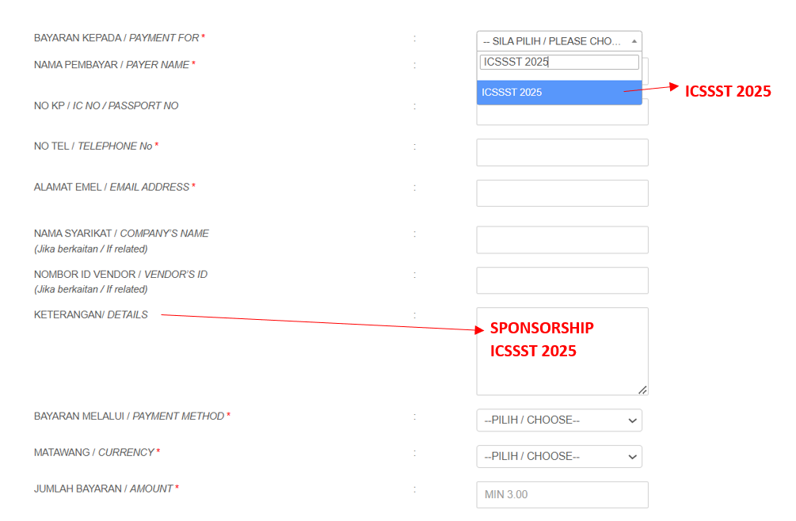

Payment:
Cheque No./ Bank draft No. :
Bank /Branch :

Please send this form together, with the cheque/No.EFT to the following address:
Secretariat 10th ICSSST2025
Department of Physics, Faculty of Science
Universiti Putra Malaysia,
43400 UPM Serdang,
Selangor, Malaysia.
Tel: (603) 8946 6646 Fax: (603) 8945 4454
Email: icssst10@gmail.com
Website: https://www.icssst.upm.edu.my/home

The organizer would like to thank you for your kind generosity.
Should you require further information, please contact 019-2140612 / 012-8112863 / 0183236930

