Name(s)_______________________________________________ Period ______ Date ___________________

|  | **Activity Guide - Using the Problem Solving Process** |  |
| --- | --- | --- |

# Word Search

## Overview

Working with a team, find the following words in the grid. They may be horizontal, vertical, or diagonal in any direction.

**DEFINE**, **PREPARE**, **TRY**, **REFLECT**, **PROBLEM**, **SOLVE**, **COMPUTER**, **SCIENCE**

## Objective

Find and circle all 8 words as quickly as you can!

E S Q H J H R C F A X M G M U E B L N I   
S R K E R E T U P M O C E C M Z T Y J C   
D X A P N X Q L Y V K L S X X N C E H N   
J M X P K W W O J Q B B O Q M H E A H T   
B I U O E Y H K M O A R L F R D L P H A   
N J H T Y R A E R C F L V M S C F A J M   
T I R Y Q W P P H D X Q E Q U N E R G S   
H Y R I M I X D Z K B M N G O J R B K U   
P U B U E U J E G D T F B D T I M V V P   
H V W S K F D G K V D M S O X Y O R S F   
S C I E N C E W P Q T E O R I A S Q M U   
H R G D Y V N H I J D C F G V H E M Z M   
U O H H N A G X O Q K K B I G M T W O L   
O P E I O Q G B A R V H P N N A Z E X V   
Y I S W N R N U U W G H X H A E B O P N   
L X D J X R P V Y J H U H X D Y F O I D   
F U D J X V U K F C V D Q B P D Z I B D   
F B R D S I W P K F K V T R D R G Y C R   
Y E T Y O D M X H L L V P T J V I J C D   
H E X K R O I P B W E T O Y X I B W V O

## Once You’re Done

Head to the last page of the activity guide and fill in the row there for the “Word Search” in the table.

# Birthday Guests

## Overview

A big group of 15 guests is getting together at a restaurant for a birthday. The restaurant has 3 tables that can each seat only 5 people. Below you can find some information about the people who are attending the party.

Aysha, Ben, Carla, Damien, Eric, Fan, Genaro, Hannah, Isaias, Jessica, Kyla, Laila, Max, Nazek, Owen

| **Close Friends** (Try to put them together)  Aysha and Damien  Max and Isaias  Nazek and Laila  Owen and Genaro  Ben and Jessica  Genaro and Eric | **In a Fight** (Try to keep them apart)  Aysha and Genaro  Ben and Hannah  Fan and Max  Damien and Laila  Isaias and Owen  Kyla and Jessica |
| --- | --- |

## Objective

Find the best possible arrangement of guests at the party. Draw your solution in the space below. To help you can cross out the letters of the names you’ve assigned in the row below.

| A | B | C | D | E | F | G | H | I | J | K | L | M | N | O |
| --- | --- | --- | --- | --- | --- | --- | --- | --- | --- | --- | --- | --- | --- | --- |

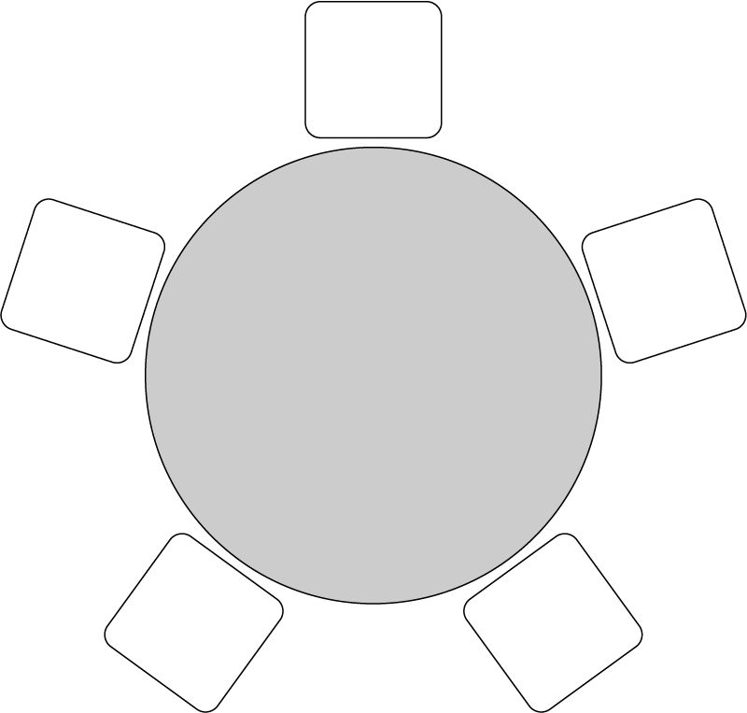



## Once You’re Done

Head to the last page of the activity guide and fill in the row there for the “Birthday Guests” in the table.

# Redesign Your Classroom

## Overview

You and your friends will be redesigning your classroom. You only have one school day to make it happen, but otherwise how you plan it is up to you. Plan the best looking classroom that you can!

## Develop Goals

Talk with your group for a few minutes. What are the most important things about the classroom? Can everyone see the teacher? How will you move everything? Write down the goals you’ll use to decide what makes a good plan.

| **Goals** | **How My Plan Helps Reach this Goal** |
| --- | --- |
| Everyone can still see the teacher |  |
| Everyone should be able to ________. |  |
|  |  |
|  |  |
|  |  |

## Make a Layout

Every member of your group should separately start designing a layout. You should select what should go where and make sure it all fits in the room. For each goal your group chose, list how your layout helps to reach it in the right column. In the space below draw or describe your redesigned classroom.

**New classroom design:**

## 

## 

## 

## Share Your Layout and Get Feedback

Share the layout you developed with your teammates and explain why you think it is the best possible layout given the goals you chose. Afterwards, record their feedback and reactions to your design in the space below. Is there anything that needs to change? How could your layout improve?

## 

## 

## 

## 

## 

## 

## 

## Improve and Finalize

Using the feedback from your teammates update your layout. In the space below, write down the new design that you and your group agreed on.

**Redesign**

## 

## 

## 

## 

## 

## 

## 

## 

## 

## 

## Once You’re Done

Head to the last page of the activity guide and fill in the row there for the “Redesign Your Classroom” in the table.

# Problem Solving Process Notes

## Reflecting on Using the Process

How did you use each step of the problem solving process to solve this problem? Give examples of what each step looked like as you were solving that problem.

|  | **Define** | **Prepare** | **Try** | **Reflect** |
| --- | --- | --- | --- | --- |
| **Word Search** |  |  |  |  |
| **Birthday Guests** |  |  |  |  |
| **Redesign Your Classroom** |  |  |  |  |

## The Purpose of Each Step

For each step in the problem solving process, write one sentence explaining its purpose. Why is it included in the problem solving process?

**Define:_______________________________________________________________________________________**

**_____________________________________________________________________________________________**

**Prepare: _____________________________________________________________________________________**

**_____________________________________________________________________________________________**

**Try:__________________________________________________________________________________________**

**_____________________________________________________________________________________________**

**Reflect:_______________________________________________________________________________________**

**_____________________________________________________________________________________________**

## Defining Problems with Questions

Before starting to solve a problem it’s important that you have defined it well. What questions or strategies can you use to better define or understand a problem? Record them in the space below.