AML Program Strengthening Toolkit
Toolkit Overview & How to Use This Guide
This toolkit helps fintech teams strengthen an AML program in a way that is practical, defensible, and aligned to partner-bank and regulator expectations. It is written for teams that may have limited experience building AML programs, or teams that have a program in place but need to tighten execution, documentation, and oversight.
Use this toolkit as a working playbook—assign owners, set dates, and save evidence as you go. The goal is not perfection on day one; it’s to build a repeatable program that can stand up to questions during a sponsor-bank review, audit, or examination.
What this toolkit will help you do
- Confirm your AML scope based on products, customer types, geographies, and delivery channels.
- Identify the highest-risk failure points in your onboarding, monitoring, investigations, and reporting flow.
- Strengthen controls and documentation so decisions are explainable and repeatable across the team.
- Set clear governance: ownership, escalation, reporting, and management oversight.
- Build a simple testing and quality process that catches issues before partners or regulators do.
How to use this toolkit (recommended order)
- Step 1: Baseline your AML scope and risk profile using the Program Snapshot and Risk Inventory.
- Step 2: Map your end-to-end AML workflow (CDD → monitoring → investigations → SAR decisioning).
- Step 3: Strengthen key controls (CDD standards, monitoring governance, SAR decisioning governance).
- Step 4: Implement oversight: metrics, escalation paths, and leadership reporting.
- Step 5: Add quality assurance and independent testing preparation.
- Step 6: Execute the 30-day action plan and track evidence in the documentation checklist.

Step 1 — Program Snapshot & Risk Inventory
Start by documenting what your AML program covers today. This becomes your baseline reference during reviews. If you cannot explain your scope in one page, your program is likely too informal or too fragmented.
1A. Program Snapshot (complete in one sitting)
Item | Your Answer (fill in)
Primary products / services
Customer types (B2C/B2B/MSB/merchant/etc.)
Geographies served & cross-border exposure
Use of sponsor bank / BaaS model
Core vendors (KYC, screening, monitoring, case mgmt)
Who owns AML day-to-day (role/title)
Who approves AML decisions (role/title)

1B. AML Risk Inventory (high-level)
List the main risk drivers for your model. Keep it simple—this is an inventory, not a full risk assessment.
Risk Driver | Examples | Inherent Risk (L/M/H) | Notes / Evidence Location
Customer risk | High-risk industries, PEPs, cash intensity, complex ownership
Product risk | Instant payouts, crypto rails, cross-border transfers, lending
Geography risk | Sanctioned/high-risk jurisdictions, corridors
Channel risk | API onboarding, remote identity verification
Third-party risk | Reliance on vendors for critical AML controls

Step 2 — Map the AML Workflow (So Gaps Are Obvious)
Most AML failures happen in handoffs—between onboarding, monitoring, investigations, and reporting. Mapping the workflow makes ownership and evidence requirements clear.
2A. Workflow Map (use this checklist)
- Customer onboarding: what data you collect, what you verify, and what triggers Enhanced Due Diligence (EDD).
- Screening: how and when you screen customers, beneficial owners, and related parties.
- Ongoing monitoring: what events trigger reviews (thresholds, typologies, alerts, complaints).
- Investigations: who investigates, how you document decisions, and how you escalate.
- SAR decisioning & filing: who decides, how you document rationale, and how you ensure timeliness.
2B. Ownership (RACI) — keep it simple
Workflow Area | Responsible | Accountable | Consulted | Informed
Onboarding / CDD
Screening
Monitoring
Investigations
SAR Decisioning & Filing
Partner Bank Reporting (if applicable)

Step 3 — Strengthen Core Controls (The “Exam Questions” Layer)
In reviews, partners and regulators typically test the same control themes: consistency, rationale, evidence, and oversight. Use the sections below to tighten those areas without rebuilding everything.
3A. CDD / EDD Standards
Define what “good onboarding” looks like for your business model. Make your standards clear enough that two different reviewers reach similar outcomes.
Requirement | Standard (what “good” looks like) | Evidence you retain
Identity verification
Beneficial ownership (if applicable)
Risk rating assignment
EDD triggers
EDD documentation package
Approval authority for high-risk customers

3B. Transaction Monitoring Governance
Monitoring doesn’t have to be complex to be defensible. What matters is that thresholds are intentional, documented, and reviewed.
Item | What to document | Owner | Review frequency
Alert logic / scenarios | Scenario purpose, typology link, data fields used
Threshold rationale | Why this threshold, what risk it targets, what changes trigger retuning
Tuning & changes | Approval, testing, and implementation evidence
Back-testing / validation | How you check performance and false positives

3C. SAR Decisioning Governance
Consistency is the goal. Create a simple decision framework so investigators know what “file” vs “monitor” means in your environment.
Decision Point | Guidance (write your standard) | Documentation required
When to escalate to SAR committee / approver
When to file vs monitor
Timelines and deadlines
Quality expectations for narratives
Law enforcement requests handling

Step 4 — Governance, Escalation, and Reporting (Leadership Layer)
A strong AML program is not just controls—it’s oversight. You need visible ownership, clear escalation, and reporting that shows management is paying attention.
4A. Escalation Triggers (define thresholds)
Trigger | Examples | Escalate to | Timeframe
High-risk customer onboarding | PEP, sanctioned geo exposure, complex ownership
Material fraud or suspected criminal activity | Account takeover, mule networks, repeated scams
Monitoring control issues | Scenario failure, system outage, vendor incident
Partner bank concern | Request for explanation, heightened monitoring, remediation

4B. Leadership Metrics Dashboard (starter set)
Use metrics that show risk and execution quality—not vanity numbers. Keep this to one page for leadership.
Metric | What it tells you | Target / Threshold | Owner
High-risk customers (% of base) | Risk mix and growth in higher-risk segments
Alerts generated vs cleared | Workload and potential tuning issues
SARs filed (monthly) + drivers | Reporting volume and typology trends
Case aging (median / 90th percentile) | Backlog and timeliness risk
Top 5 recurring issues | Control weaknesses driving repeated findings

Example chart: use this to visualize where you need to invest first.
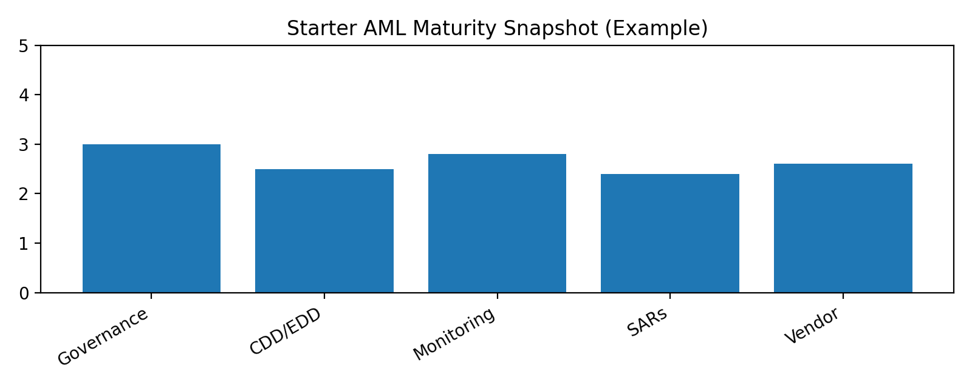

Step 5 — Quality Assurance & Testing Preparation
You don’t need a large team to run QA. You need a repeatable review sample, clear criteria, and a way to log fixes. QA also becomes evidence during sponsor-bank reviews and independent testing.
5A. Monthly QA sample plan (simple)
Item | Sample size (start) | QA checks | Where you log results
Onboarding / EDD files | 5–10 | Risk rating rationale, EDD completeness, approvals
Monitoring alerts | 10–20 | Decision rationale, completeness, timeliness
SAR narratives | 5 | Clarity, consistency, fields completed, decision support

5B. Issues log (what to capture)
- Issue description and category (CDD, monitoring, SAR, vendor, governance).
- Root cause (training gap, system limitation, unclear standard, staffing).
- Remediation owner and due date.
- Evidence of completion (screenshots, updated policy, updated threshold rationale).
- Status and management sign-off.

Step 6 — 30-Day AML Strengthening Action Plan
Use this plan if you need momentum quickly. Adjust weeks based on your staffing and partner expectations.
Week-by-week plan
Week | Focus | Actions (assign owners) | Deliverables / Evidence
Week 1 | Scope + ownership | Complete Program Snapshot; finalize RACI; set escalation triggers. | Snapshot + RACI + escalation table
Week 2 | CDD/EDD standards | Write onboarding/EDD standards; define approvals; align with partner bank. | CDD/EDD standard + checklist
Week 3 | Monitoring governance | Document scenarios/threshold rationale; define change control; start QA sampling. | TM governance doc + tuning log template
Week 4 | SAR governance + reporting | Finalize file vs monitor framework; implement metrics dashboard; executive review. | SAR decisioning doc + dashboard

Appendix
A1. Monitoring Threshold Change Log
Date | Change requested | Reason | Approver | Test evidence saved (Y/N) | Go-live date

A2. SAR Decisioning Checklist (per case)
- Describe the activity and why it is unusual for the customer.
- List key facts (dates, amounts, counterparties, channels, devices, IPs).
- Tie facts to a typology (fraud, structuring, mule behavior, sanctions evasion, etc.).
- State the decision (File / Monitor) and explain why.
- Capture approvals and any escalation (partner bank, legal, senior management).
A3. Evidence Folder Structure
- 01_Governance (charter, minutes, dashboards)
- 02_Risk_Assessment (risk inventory, methodology, updates)
- 03_CDD_EDD (standards, samples, approvals)
- 04_Monitoring (scenarios, thresholds, tuning, validation)
- 05_Investigations_SARs (case files, narratives, QA results)
- 06_Vendors (due diligence, contracts, monitoring, incidents)
- 07_Issues_CAPA (issue log, remediation evidence, signoffs)

