An algorithm is a list of instructions for accomplishing a task. We follow algorithms everyday when it comes to activities like making the bed, making breakfast, or even getting dressed in the morning.

These images are not in order. First, describe what is happening in each picture on the line to its left, then match the action to its order in the algorithm. The first one has been done for you as an example.

| Teeth are clean! |  |  | Step 1 |
| --- | --- | --- | --- |
|  |  | Step 2 |
|  |  | Step 3 |
|  |  | Step 4 |

Sometimes you can have more than one algorithm for the same activity. The order of some of these steps can be changed without changing the final product. Use the letters on the images below to create two algorithms for making a paper airplane.

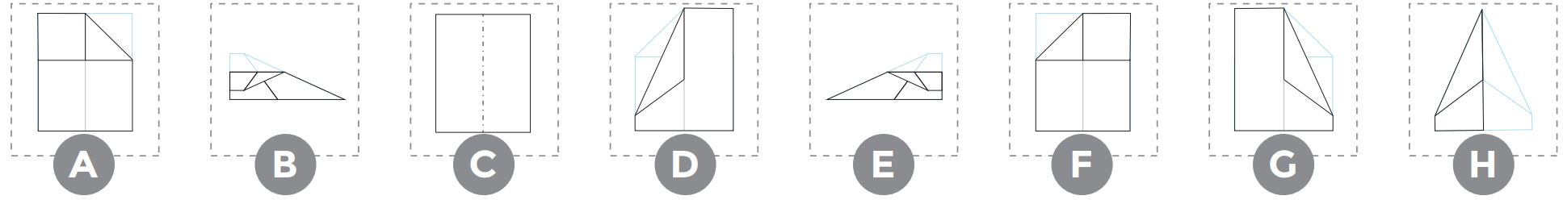

| **ALGORITHM 1:** | **______** | **______** | **______** | **______** | **______** | **______** | **______** | **______** |
| --- | --- | --- | --- | --- | --- | --- | --- | --- |
| **ALGORITHM 2:** | **______** | **______** | **______** | **______** | **______** | **______** | **______** | **______** |