Name(s)_______________________________________________ Period ______ Date ___________________

 | Activity Guide - Licensing Your Work | 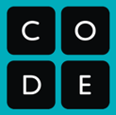

Knowing your rights, and respecting the rights of others

copyright - the exclusive legal right to print, publish, perform, film, or record literary, artistic, or musical material, and to authorize others to do the same

Creative Commons
The Creative Commons license helps content creators explain what other people can do with their work. The Creative Commons license has different parts that you choose from to say exactly what is and is not allowed.

For each part of the Creative Commons license, give a reason someone might want to use it.

Icon | Abbr | Description | Reason to Use It
 | BY | Attribution: Others who use this work must give credit to the original author. | A reason to use it is so that people know you created the work and you get credit.
 | NC | Non-Commercial: Others may not use this work for advertising or to make money. | A reason to use it is so that people can’t make money from your work.
 | SA | Share-Alike: Users of this work must share any new versions under the exact same license. | A reason to use it is so that other people can change your work and stay under your license and follow the same rules.
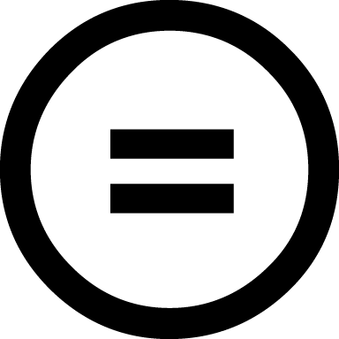 | ND | No Derivative Works: Users may only use this work as is and may make no changes. | Someone else can’t photoshop a picture into your work.

Other Options
As you look at creative works online, you will see other ways to publish works. You can always read the instructions to help you understand what is allowed and not allowed for that creative work. These are just a few examples.

Option | Short Description | Reason to Use It
GNU Free Documentation License (GFDL) | You can use the work how you want, but you must publish any new versions using the same license. | A reason to use it is so that other people can change the work, but the creator always gets credit when it’s shared.
Pixabay License | Don’t use the work to make people look bad, spread dishonest information about things, or sell exact copies of the work. | A reason to use it is to keep the work the way it was created and not make money from it.
Public Domain | Anyone can use the work, in any way that they want. | A reason to use it is when you want everyone to share your work however they want.

Choosing the Right License
For each of the scenarios below identify the Creative Commons license that best meets the needs of the content creator and explain why you chose that license.

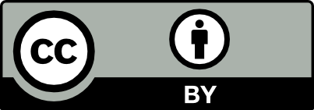  CC-BY | 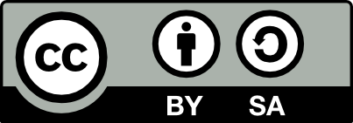  CC-BY-SA | 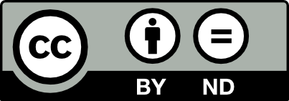  CC-BY-ND | 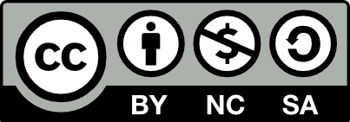  CC-BY-NC-SA

Scenario 1
Ernesto loves to sketch and posts all of his drawings on his art blog. Lately people have been taking his art and turning them into memes by adding snarky text to the bottom. Ernesto likes the idea of people sharing his work more broadly, but he doesn’t want people to mess with his original art.

- What is the best CC license that ensures Ernesto’s rights are preserved? Why?

CC-BY-ND BY means he will get credit when other people use it and ND means he doesn’t want people to change his work, like making it into a meme

Scenario 2
Maggie and Eric record short keyboard and guitar riffs which they trade with each other to make larger songs. They dream of one day having a real musician sample their riffs in a song, they just don’t want people to use their recordings without giving them credit.

- What is the best CC license that ensures Maggie and Eric’s rights are preserved? Why?

CC-BY BY means they will get credit as the original creators when other people use it.

Image Hunt

Go online and find two different images with two different licences. Describe the image and license in the chart below.

Image Description | License Type | Rules for using the image
A picture of a cat’s face. | CC-BY-NC-ND | The original creator gets credit. You can’t sell the picture and you can’t change it.
A picture of a dog’s face. | CC-BY-ND | The original creator gets credit and you can’t sell the picture.

