WORKSHEET
Screen Out the Mean

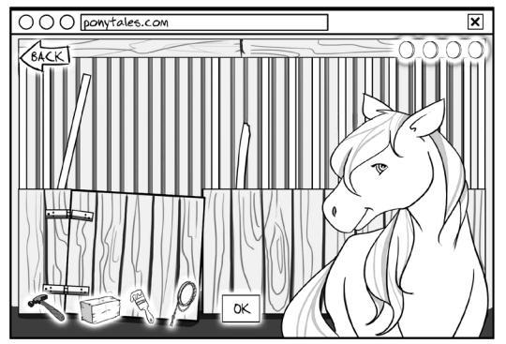
Directions
Jada’s parents let her play on a website where she can take care of a pet pony and decorate its stall. Her friend Michael has played with her in the past and knows her username and password.

One day Jada goes to the site to care for her pony. She finds that her pony’s stall is a mess and that there are some things missing.

What do you think happened?

How do you think Jada feels?

What should you do if someone starts cyberbullying you?


STOP using the computer until it is safe.
TELL an adult you trust.
Go ONLINE only when a trusted adult says it’s OK.
PLAY online only with kids who are nice.

