ASSESSMENT TEACHER KEY
Powerful Passwords

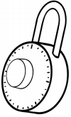
- Some websites make you type in a username and a __________ if you want to visit their site.

  - password

  - crossword

  - puzzle

Answer feedback
The correct answer is a. A secret word or phrase is called a password.

- True or False: Sam Slate’s password is sammyslate.

This is a great password because it has a lot of letters.

  - True

  - False

Answer feedback
The correct answer is b, False. Even though it’s true that a password with a lot of letters can be strong, this one isn’t. You should not use your name or nickname in a password. You should also combine numbers, letter, and symbols.

- Circle DO or DON’T next to each of the statements below.

DO DON’T share your password with your friends.

DO DON’T make passwords eight or more characters long.

DO DON’T use your street address in your password.
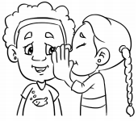
Answer feedback
You should never include private information in your password, or share them with people other than your parents. Short passwords are often weak because they can be easy for others to guess.

