Getting started with AppLab

1) Use

Click on this link below to access a simple app built with AppLab:

https://studio.code.org/projects/applab/XouF3JIDeay-s_Ct73hek6RATAbjn_oug6l1GaDiQoA
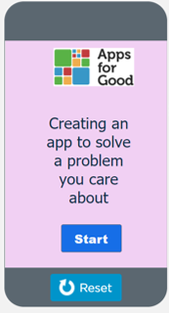

Try out the app and answer these questions:

- What does it do?
- What do you like about it?
- What don’t you like about it?
- Are there any functions that you might need to use for your own app?

2) Modify

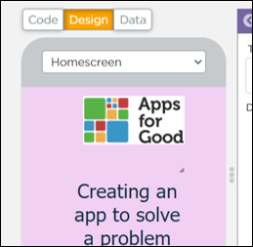
Click on View Code and then Remix — you will need to log in or create your AppLab account at this point if you have not already done so.

Switch to ‘Design view’, and use the drop-down menu to look at each screen:

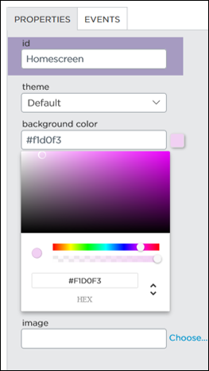
Click on the background of one of the screens and change the background colour, as shown:

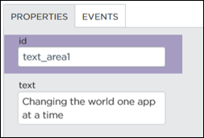
Click on some text and change to your own wording:

What other changes can you make to the text?
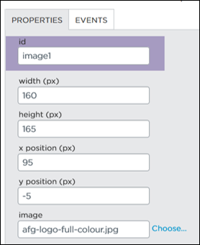

Click on the Apps for Good image on any page and replace it with one of your own images (select ‘Choose’ and upload an image, then click on ‘Choose’ again).

What other changes can you make to the image?

Explore the app in design mode and make some other changes. For example, can you:

- Add or delete a button
- Add more images
- Add another screen

Now switch back to ‘Code view’ and look at how the screens have been linked together:
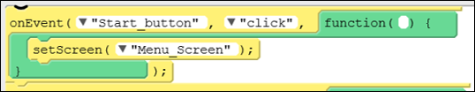

This code is saying that when the start button is clicked, the screen changes to the menu screen. This code can be dragged onto the workspace and clicked together (like a jigsaw).

If you have added a new screen, see if you can link it to another screen with a button.

Fix

Click on the link below to access a second app. This app has some bugs and errors, and it needs fixing. Can you find and fix all the bugs/errors?

https://studio.code.org/projects/applab/2yjJpgaZ4RuNbn5oYpZ-5ki8nO8j_3vLYVrz1vjQGuM

Create

Based on what you have learnt, it’s time to create your main screens and link them together with buttons.

