Symposium on Magnetism and Spintronics (SMS-3)
Indian Institute of Technology Hyderabad, India
January 21 – 24,2026
Organized by: IIT Hyderabad and NISER Bhubaneswar

Application for Champalal Prajapat Memorial Best Thesis Award

INFORMATION

SCOPE
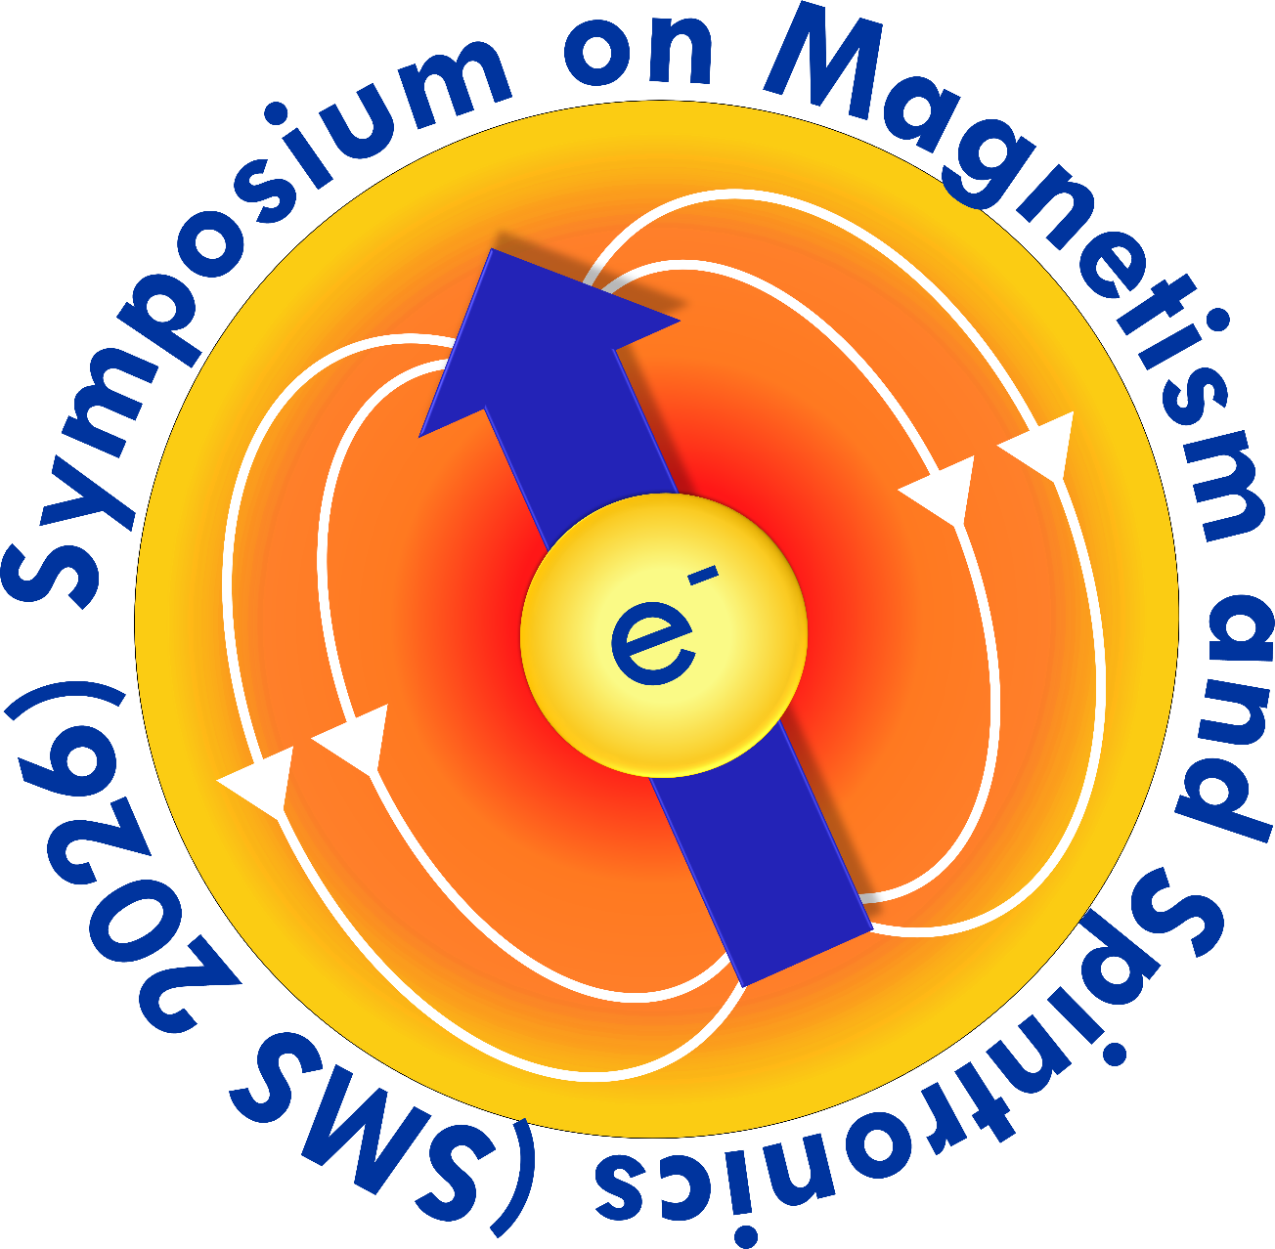
The Champalal Prajapat memorial best thesis award has been instituted by the friends of late Dr. Champalal Prajapat who was a senior scientist at Bhabha Atomic Research Center (BARC), Mumbai. This best thesis award has been aimed to appreciate outstanding PhD thesis work in the field of spintronics for which the work mainly caried out in India.

ELIGIBILITY
Any citizen of India, below the age of 32 Years as of the PhD defense date is eligible for the award. Additionally, the candidate should have finished (defended) his/her PhD in the period June 2024 till 25th October 2025.

SELECTION PROCEDURE
The selection of the candidates for the best thesis award will be based on the overall merit of work, mainly carried out in India. Candidates short-listed by the best thesis award Selection Committee will be invited to present their research work during the symposium in the form of posters and then a presentation. Final awardees will be selected based on their work and presentation. The presentation of Medals to Awardees will be made on the last day of the symposium.

APPLICATION PROCEDURE
Applications should be made in the prescribed format (Annexure-I) along with all supporting documents, and forwarded by the supervisor of the applicant. Applicant should submit soft copies of (up to) 3 publications which were published out of the thesis work.

Applications must be submitted via the google form (link in the website) with all the documents including the filled application form at the latest by October 31, 2025. Shortlisted candidates will be informed by 15th November 2025. The candidates need to be present physically to make their presentations at SMS3-2026 conference. No online presentations will be considered. No TA/DA will be provided to attend this conference.

ANNEXURE – I
APPLICATION FOR CHAMPALAL PRAJAPAT MEMORIAL BEST THESIS AWARD
Summary
Paper No. (Submitted online) | This can be left empty. This is for office use only.
Name

Ph.D. supervisor´s name
Address of the institute/university at which PhD has been obtained
Present Affiliation

Date of Birth

Date of completion of Ph.D

Total Number of Journal Publications

Total Number of Citations

h – Index

I. Personal Information
Name
Block letters Surname, followed by first & middle name
Name and address of institute/university from which PhD has been obtained
institutional address, telephone, fax and e-mail
Address for correspondence
Address for correspondence, telephone, fax and e-mail
Date of Birth
Age
As on May 31, 2024 age should not be more than 32. Please enclose a proof of age

II. Academic Qualifications (beginning with Bachelor’s degree)
Degree | Year | University | Marks / Grades

III. Conferences attended (mention the nature of presentation oral/poster/invited).
Name of the conference, Place, Country | Year

IV. Research Experience
Mention your expertise  (technique/method/equipment etc) | Nature of work you have carried out

V. Statement about the aim and objective of the thesis work (not exceeding 300 words)

(Selection for the award will be based mainly on the work done in India).

VI. Major outcome of the PhD thesis work (within 150 words preferred in a bulleted format)

VIII. Future outlook of the thesis work (within 100 words)

IX. If part of work has been done abroad, please indicate

 | % | Remarks if any
Extent of work done abroad (%)

Work done in India ( % )

X. List of patents, if any

S. No. | Details

XI. List of publications of the applicant coming out of the PhD thesis (Authors, Title, Journal, Vol, Page, Year)
(Please note that the manuscripts under preparation or under review should not be mentioned.)

- Published papers

Three most significant publications:

The above information's are true to the best of my knowledge.

Date:

Place:

(Signature)

Forwarded by:

Supervisor´s name
Designation

