Listen to this chapter

Java Code: A Modular Introduction
CC-BY
Printed in the United States of America
Unless otherwise noted, all parts of this book are licensed under the Creative Commons Attribution license. You are welcome to use some or all of the contents in this work for any purpose providing you credit the authors.
Dave Ghidiu
Carrie Krueger
Will McLaughlin
Aaron Sullivan
The cost of this book covers printing and administrative fees that go to the company used for printing. Additionally, a small portion of the price may also go to support allOpen.org, a website that supports the Creative Commons endeavor.
For conversation about this work, email Dave Ghidiu at dave@opencompsci.com
ISBN-10: 8-687429-38-2
ISBN-13: 979-8-687429-38-2

Java Code:

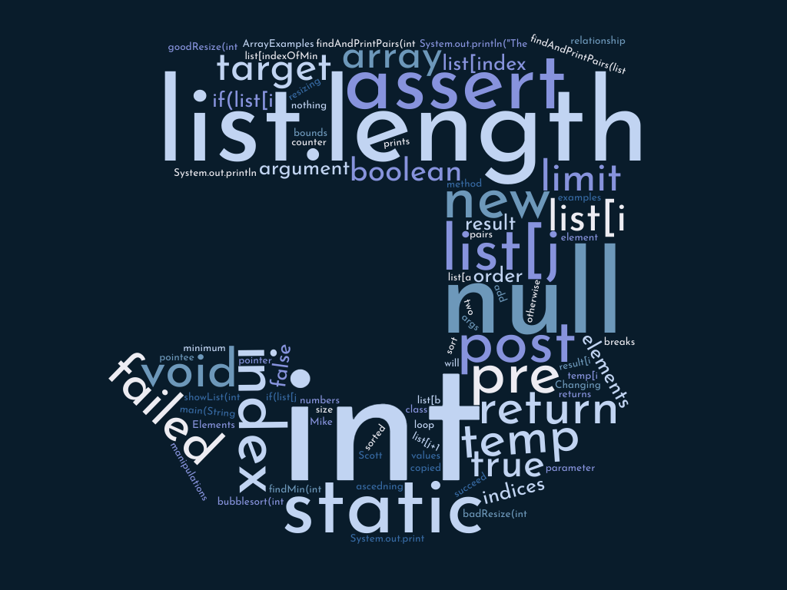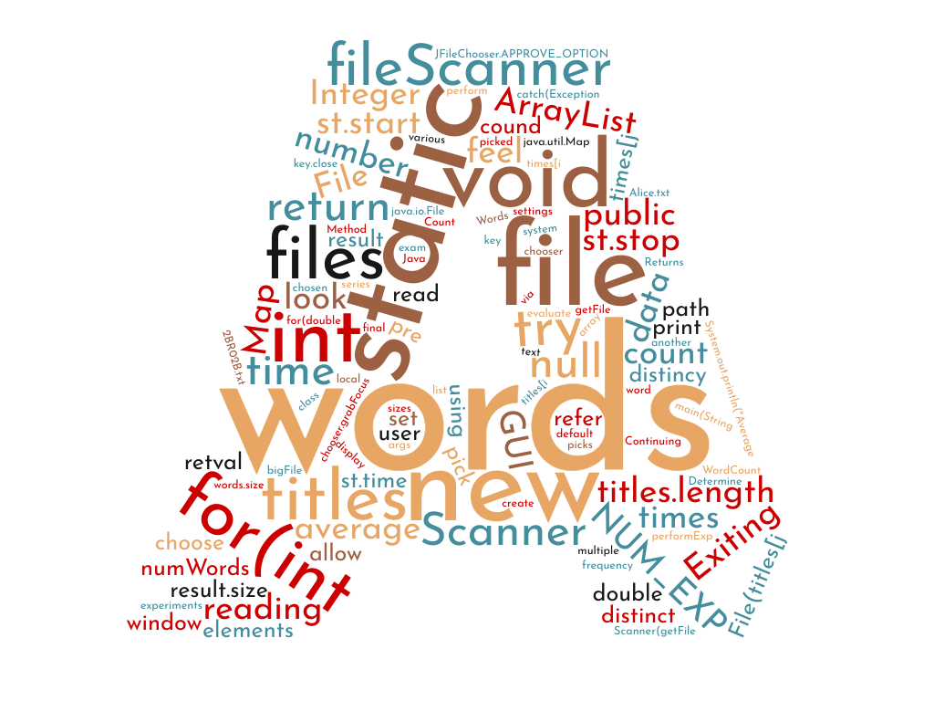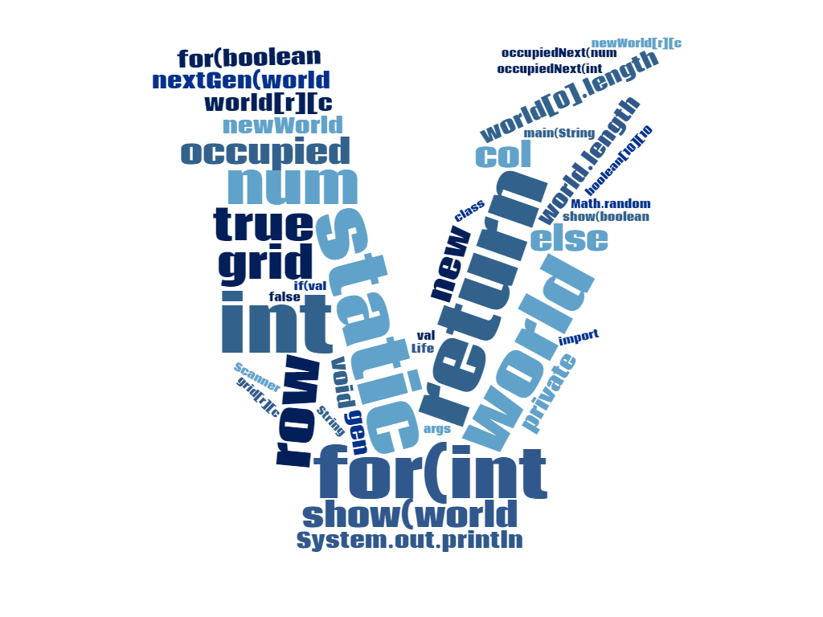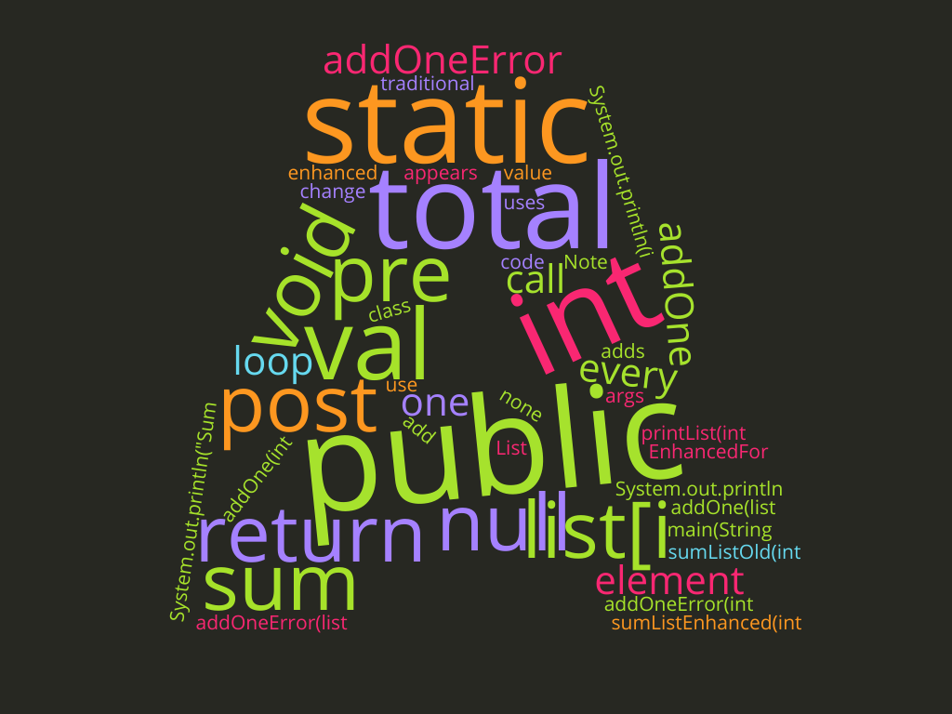

A Modular Introduction
VERSION 1.4.0

Finger Lakes Community College

Carrie Krueger
Will McLaughlin
Aaron Sullivan
Dave Ghidiu

Version 1.4.0

This is the fourth edition of the Introduction to Java textbook for Finger Lakes Community College. As such, there may be typos, grammatical mistakes, formatting issues, and erroneous content. If you find any of these mistakes, please email them to dave@opencompsci.com - you may get your name credited in the official version that follows this first edition! And it’s good karma. So be diligent in reporting your errors.

The Computing Sciences department at FLCC is a collaborative team. The primary authors for this book are Will McLaughlin, Aaron Sullivan, and Dave Ghidiu. But this text is a byproduct of excellence in pedagogy as demonstrated by all members in the department, especially Carrie Krueger, who added unquantifiable value to this text.

This book is also licensed under the Creative Commons - Attribution 4.0 International (CC-BY-4.0).

This is a human-readable summary of (and not a substitute for) the license. Disclaimer.
You are free to:
- Share — copy and redistribute the material in any medium or format.
- Adapt — remix, transform, and build upon the material for any purpose, even commercially.
- The licensor cannot revoke these freedoms as long as you follow the license terms.
Under the following terms:
- Attribution — You must give appropriate credit, provide a link to the license, and indicate if changes were made. You may do so in any reasonable manner, but not in any way that suggests the licensor endorses you or your use.
- No additional restrictions — You may not apply legal terms or technological measures that legally restrict others from doing anything the license permits.

Errata Help
- Many thanks to the students in CSC-115 at Finger Lakes Community College for providing feedback and editing.

Content Help
- Malcolm Kotok and Sophie Kotok played a big role in reviewing the flow of the book. A big thanks to John Ghidiu for lending his stellar programming knowledge.

Production Help
- A huge thank you to the FLCC staff who helped this project - namely Katie Nottke whose help and patience in producing this OER was instrumental, and Rachel Fairman whose expertise and speed led to a successful experience! And, of course, the FLCC Book Nook for exuberantly supporting OER.

We dedicate our efforts to April, whose leadership and expertise has had a profound impact on our students at FLCC. And not once did she ever say “No” when we had really, really bad ideas.

