Explore PT - Response 2a - All Samples

Computational Artifact
Your computational artifact must provide an illustration, representation, or explanation of the computing innovation’s intended purpose, its function, or its effect. The computational artifact must not simply repeat the information supplied in the written responses and should be primarily non-textual.

Computational Artifact
2a. Provide information on your computing innovation and computational artifact.
- Name the computing innovation that is represented by your computational artifact.
- Describe the computing innovation’s intended purpose and function.
- Describe how your computational artifact illustrates, represents, or explains the computing innovation’s intended purpose, its function, or its effect.
(Must not exceed 100 words)

Scoring Guidelines
Row and Task | Decision Rules
Row 1  Computational Artifact  The computational artifact:  • Identifies the computing innovation.  AND  • Provides an illustration, representation, or explanation of the computing innovation’s intended purpose, function, or effect. | The written response can be used to aid the understanding of how the computational artifact illustrates, represents, or explains the computing innovation’s intended purpose, function, or effect.  Do NOT award a point if any one of the following is true:  - there is no artifact;  - the artifact is not a computational artifact;  - the innovation identified in the artifact does not match the innovation described in the written response;  - the artifact does not identify the innovation clearly;  - the artifact does not illustrate, represent or explain the innovation’s intended purpose, function, or effect;  - the artifact illustrates a feature of the innovation instead of the purpose, function, or effect; or  - the computational artifact doesn’t clearly illustrate, represent, or explain as required in the scoring criteria AND the written response describes the innovation’s intended purpose and function without explaining how the computational artifact illustrates, represents, or explains the intended purpose, function, or effect..
Row 2  Response 2A  States a fact about the correctly identified computing innovation’s intended purpose OR function. | Do NOT award a point if:  - the identified innovation is not a computing innovation; or  - the written statement gives an effect (which is required for the scoring criteria in Row 3, not Row 2).

Student Response A - [Artifact] [Written Response] | Scoring Guidelines
My innovation is Blockchain, which is designed to create a framework for online transactions that is more secure (Rosic). Blockchain functions as a series of computers, called nodes. When one computer requests a transaction, each computer independently verifies the authenticity of the request, using certain algorithms. Then, once all of the nodes verify the request’s identity, the data about the request is added to a computerized ledger, creating another “block” in the “chain.” (Rosic) My artifact provides an illustration for each step of the process of how Blockchain works. It also allows the reader to see the amount of data blockchain uses). | Row 1 | 1
 | The response earned a point for this row. The computational artifact identifies a computing innovation, blockchain, and illustrates a function of blockchain: "verify your transaction and add the data to a digital ledger."
 | Row 2 | 1
 | The response earned a point for this row. The response states that "blockchain functions as a series of computers, called nodes."
Student Response B - [Artifact] [Written Response] | Scoring Guidelines
The computing innovation that I chose is virtual reality. This innovation has many different functions, depending on the design. Its intended purpose is to enhance or replace the world around you with a virtual one that can be modified. It can be used for things such as online shopping, gaming, and training. The computational artifact depicts an environment that is being filmed in virtual reality. It shows one of the many purposes of the innovation, allowing others to experience that environment without taking time to travel there. Also, the lower pictures illustrate how the innovation works and looks. | Row 1 | 1
 | The response earned a point for this row. The artifact identifies the computing innovation as Virtual Reality and illustrates that the purpose is to enhance or replace the world around you with a virtual one that can be modified.
 | Row 2 | 1
 | The response earned a point for this row. The response states a correct fact: "It can be used for things such as online shopping, gaming, and training."
Student Response C - [Artifact] [Written Response] | Scoring Guidelines
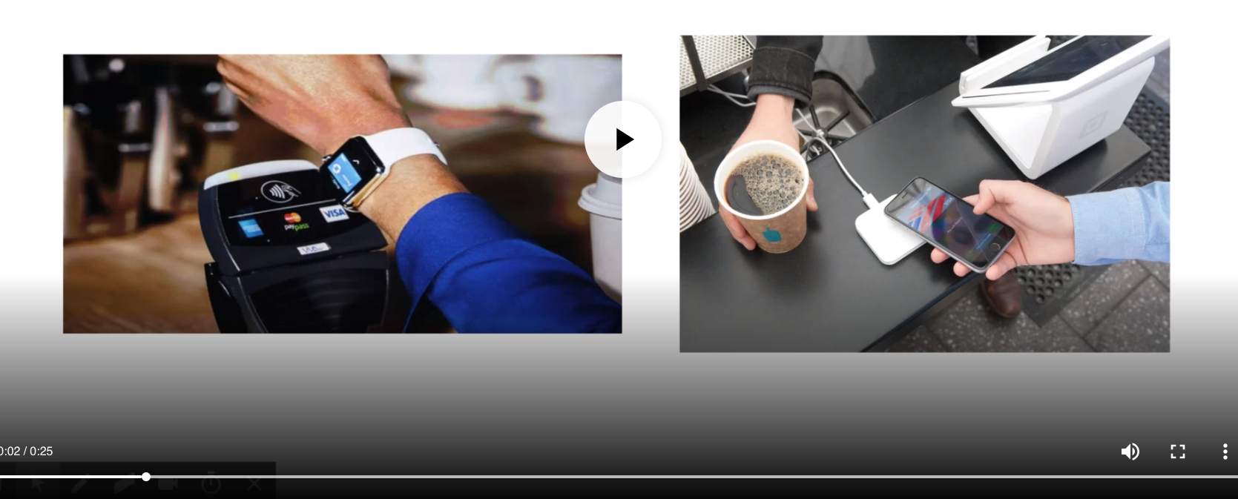  ** Video. Includes Audio Narration  The computing innovation represented by my computational artifact is Apple Pay. The purpose of this innovation is to allow users to make secure purchases with their phones. It achieves this by sending a Device Account Number over an encrypted NFC connection instead of using credit card information. My computational artifact illustrates and explains the purpose and function of Apple Pay by showing images of the intended purpose of Apple Pay and explaining how it is achieved. | Row 1 | 1
 | The response earned a point for this row. The artifact provides an explanation of the computing innovation's intended function stating that "Apple Pay uses tokenization in which it creates a device account number for each card."
 | Row 2 | 1
 | The response earned a point for this row. The response states a fact about the computing innovation: "allow users to make secure purchases with their phones."
Student Response D - [Artifact] [Written Response] | Scoring Guidelines
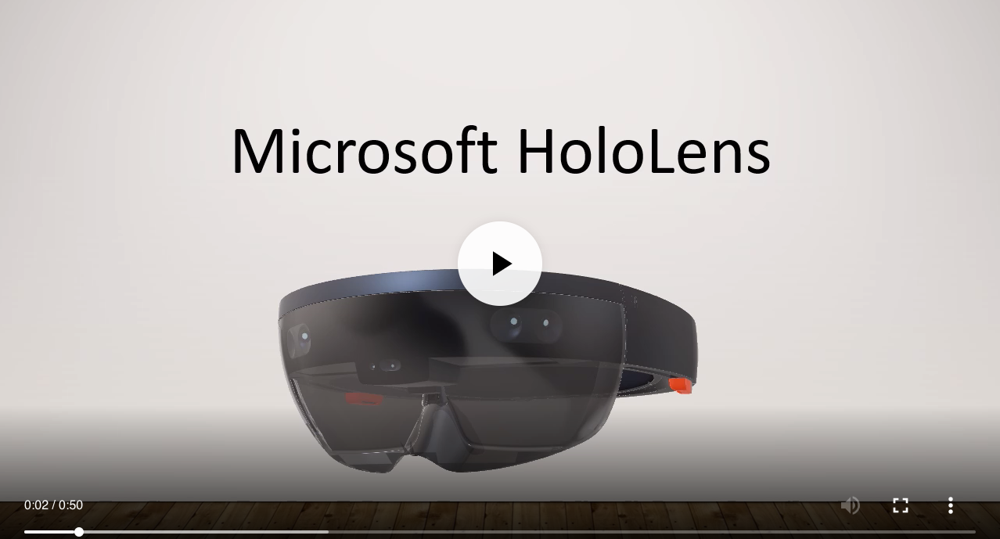  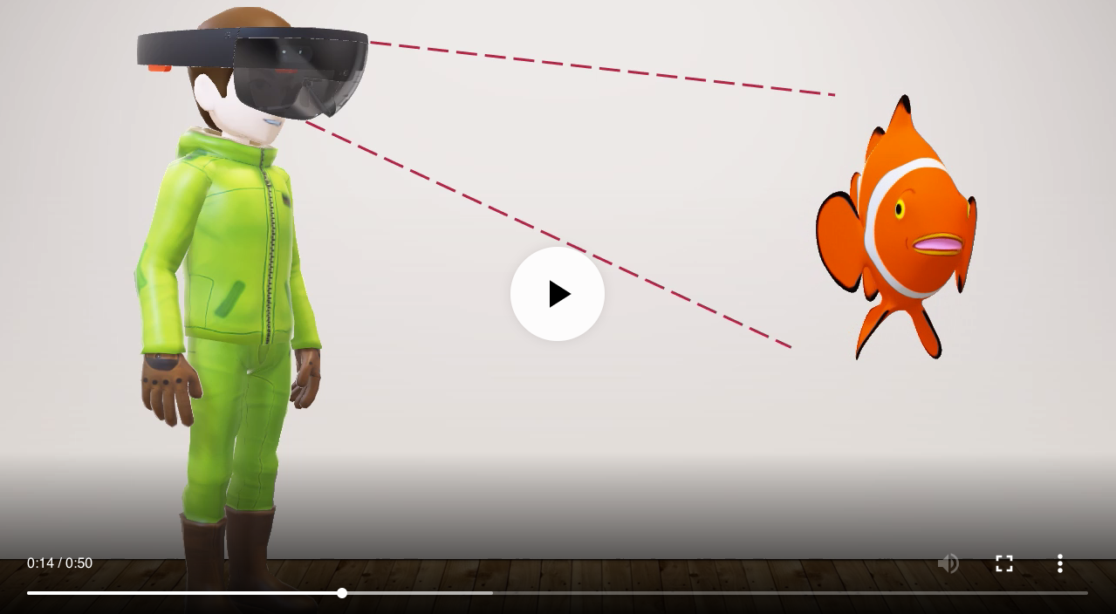  ** Video. No narration.  The computing innovation that is represented by the computational artifact is the Microsoft HoloLens. The intended purpose of the device is to produce holograms in the environment that the user is using and allow the user to see and interact with the hologram like a real-world object [2]. The computational artifact illustrates the purpose by showing the Microsoft HoloLens first scans the user’s environment by using its cameras and sensors, then the device will produce a realistic 3D hologram that the user can interact with. | Row 1 | 1
 | The response earned a point for this row. The artifact identifies the computing innovation as Microsoft HoloLens and illustrates the purpose is to "produce a realistic 3D hologram that the user can interact with."
 | Row 2 | 1
 | The response earned a point for this row. The response states a correct fact: "The intended purpose of the device is to produce holograms in the environment that the user is using and allow the user to see and interact with the hologram like a real-world object."
Student Response E - [Artifact] [Written Response] | Scoring Guidelines
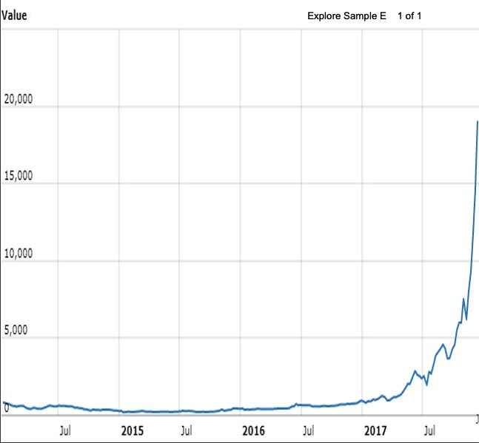  Bitcoin is a digital currency that has become highly popular among investors and traders alike. Bitcoins are mined in a series of block chains that include generating hashes to open hatches in order to open a Bitcoin block which gives a reward of a predetermined amount of Bitcoins [4]. The creator’s intended purpose of creating the virtual currency, known as Bitcoin, was to make an international currency that is accepted anywhere in the world without language barriers, currency barriers, or exchange rate [4]. | Row 1 | 0
 | The response DID NOT earn a point for this row. The artifact does not provide an illustration, representation, or explanation of the computing innovation's intended purpose, function, or effect.
 | Row 2 | 1
 | The response earned a point for this row. The response states a fact about the computing innovation: "Bitcoin is a digital currency that has become highly popular among investors and traders alike."
Student Response F - [Artifact] [Written Response] | Scoring Guidelines
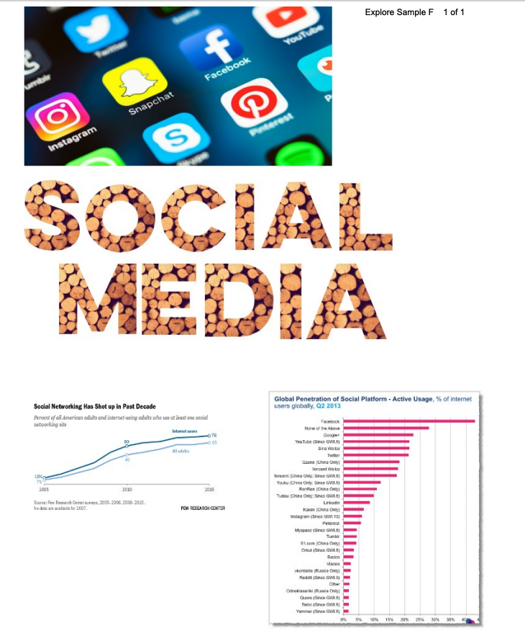  Social Media, which is defined as websites and applications that enable users to create and share content or to participate in social networking (7), has become a highly discussed topic in this day and age. The intended purpose of social media is based on the core principle of the ability to share content with others. In the simplest case, social media can provide a highly personalized and relevant ‘Table of Contents’ by keeping up to date with current research, popular science and broader issues such as science policy, funding, publishing, or personal career development(1). | Row 1 | 0
 | The response DID NOT earn a point for this row. The artifact does not provide an illustration, representation, or explanation of the computing innovation's intended purpose, function, or effect.
 | Row 2 | 1
 | The response earned a point for this row. The response states a fact that the computing innovation "is defined as websites and applications that enable users to create and share content or to participate in social networking."
Student Response G - [Artifact] [Written Response] | Scoring Guidelines
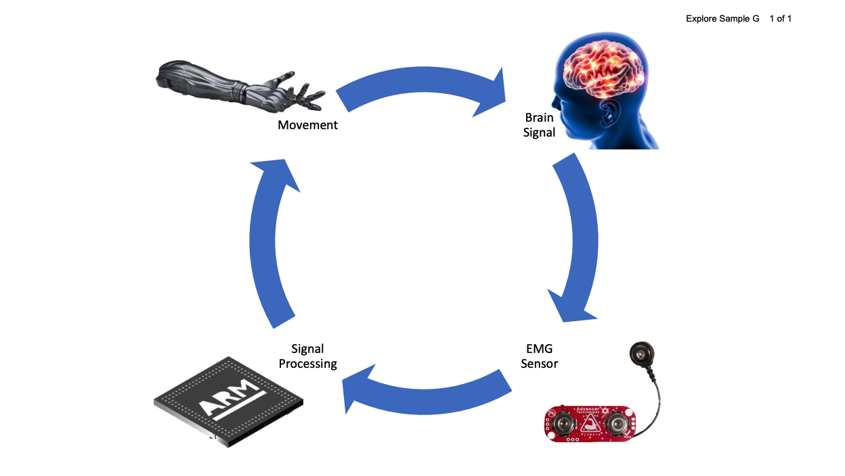  The computing innovation I chose to represent with my artifact submitted is Electromyographic (EMG) prosthetic limbs. EMG prosthesis is meant to provide those who are missing limbs an opportunity to live a normal life. Thanks to the technology's ability to sense brain signals, process them and actuate a prosthetic limb. My computational artifact shows the cycle of how this process takes place. | Row 1 | 1
 | The response earned a point for this row. The artifact identifies the computing innovation as Electromyographic (EMG) prosthetic limbs and illustrates the purpose is to provide those who are missing limbs with an opportunity to live a normal life.
 | Row 2 | 1
 | The response earned a point for this row. The response states a correct function: "... EMG prosthesis unlocks the possibility for virtually natural motion and limited sensations for those missing limbs."
Student Response H - [Artifact] [Written Response] | Scoring Guidelines
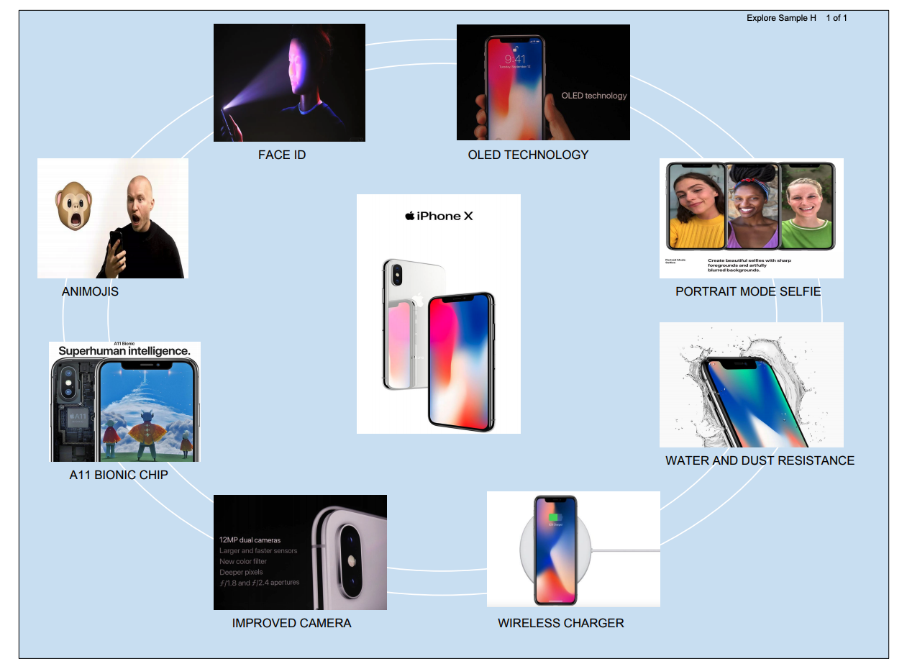  The computing innovation that is represented by my computational artifact is apple iphone x. Iphone x is the latest version of iphone with lots of new features. The purpose and function of iphone x is to make a improved technology with new features like the face ID, entirely screen, improved display, etc. The computational artifact illustrates the new features of iphone x such as the face ID, animojis, organic light emitting diode (OLED) technology, wireless charging, water and dust resistance, improved camera, A11 bionic chip (1), (25% faster performance and 75% faster efficiency) and portrait mode selfies with lighting effect. | Row 1 | 1
 | The response earned a point for this row. The computational artifact illustrates functions of the iPhoneX such as Animojis, Face Id, and portrait mode selfie.
 | Row 2 | 1
 | The response earned a point for this row. The response states that "The purpose and function of iPhone x is to make a improved technology with new features like the face ID, entirely screen, improved display, etc."
Student Response I - [Artifact] [Written Response] | Scoring Guidelines
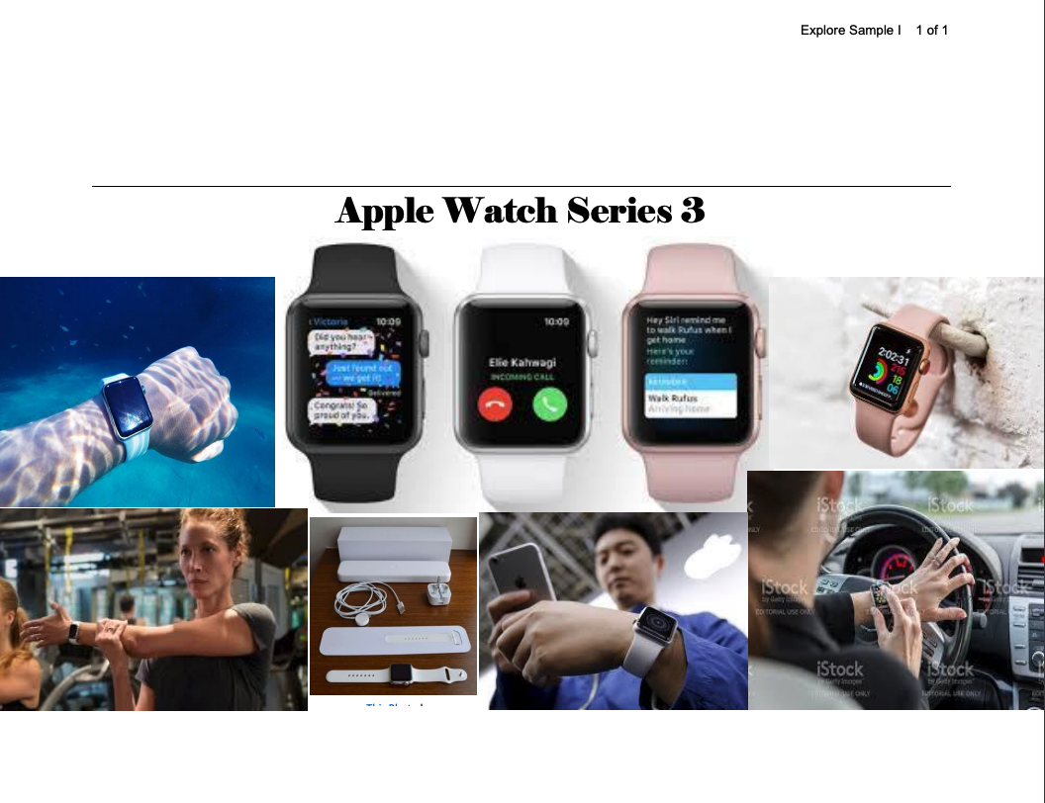  The Apple watch is to help people to not get in a car crash. 1.3 million people get a car crash every year. In a meeting or other places, people don’t have to take out their phone and distant others. The computer artificial “your phone on your waist”, you can do anything on it. Apple watch is better than your phone. They have everything from your phone plus tracks your health. So, one day leave your phone and you will be protect. You also don’t have to be scared of someone taking your phone from your pocket or anywhere. | Row 1 | 1
 | The response earned a point for this row. The artifact identifies the computing innovation as Apple Watch Series 3 and illustrates the purpose as allowing users to make calls, send text messages, and track their health.
 | Row 2 | 1
 | The response earned a point for this row. The response states a correct fact; it tracks one's health.
Student Response J - [Artifact] [Written Response] | Scoring Guidelines
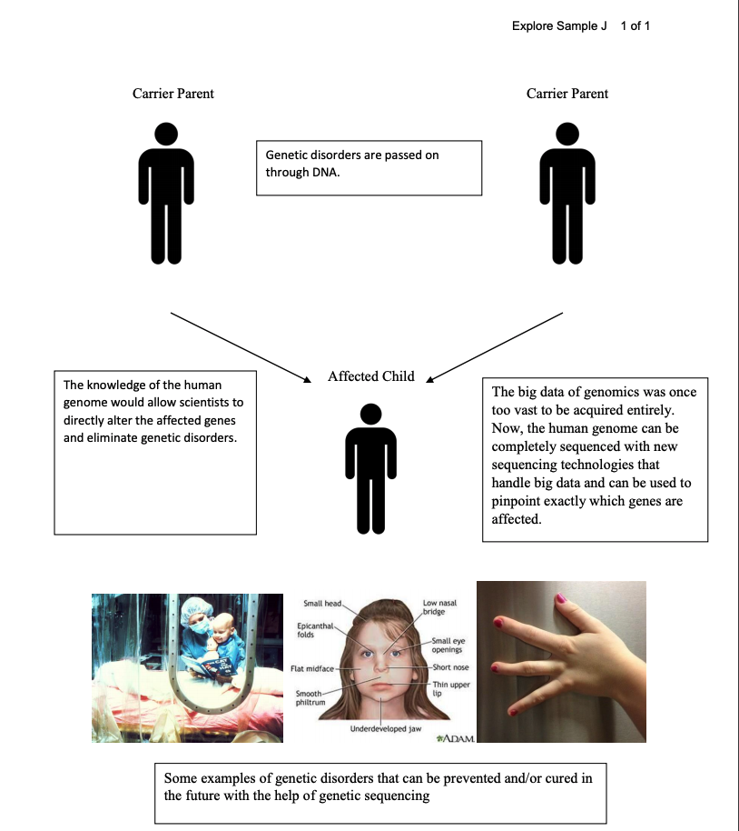  My computational artifact represents the benefits of human genome sequencing. The human genome project uses highly distributed data acquisition and is in the process of converting to single-molecule sequencing technologies with much longer reads to handle the astronomical growth of the genomic big data. Once the human genome can be completely sequenced, we would be one step closer to preventing and curing genetic disorders[1], which is what is depicted by my artifact. | Row 1 | 1
 | The response earned a point for this row. The artifact provides an illustration of the purpose for Human Genome Sequencing. Even though computing is involved in order to complete Human Genome Sequencing, it is not considered a computing innovation. The response can earn this row even though it isn't a computing innovation.
 | Row 2 | 0
 | The response DID NOT earn a point for this row. Even though in order to complete Human Genome Sequencing, computing is involved, it is not considered a computing innovation.

