  GRADES 1 to 12  DAILY LESSON LOG | School: | DepEdClub.com | Grade Level: | VI
 | Teacher: | File created by Ma'am ANNALICE R. QUINAY | Learning Area: | MATHEMATICS
 | Teaching Dates and Time: | JANUARY 16 – 20, 2023 (WEEK 9) | Quarter: | 2ND QUARTER

 | MONDAY |  |  | TUESDAY | WEDNESDAY | THURSDAY |  | FRIDAY
I. OBJECTIVES
- Content Standard | The learner demonstrate understanding of order of operations, ratio and proportion, percent, exponent, and integers
- Performance Standard | The learner is able to apply knowledge of order of operations, ratio and proportion, percent, exponent, and integers in mathematical problems and real-life situations
- Learning Competencies / Objectives | performs addition on integers.  M6NS-IIi-156 |  | performs subtraction on integers.  M6NS-IIi-156 |  | performs multiplication on integers.  M6NS-IIi-156 | performs division on integers.  M6NS-IIi-156 |  | Weekly test
II. CONTENT | Numbers and Number Sense |  | Numbers and Number Sense |  | Numbers and Number Sense | Numbers and Number Sense
III. LEARNING RESOURCES
- References
- Teacher’s Guide pages | 21st Century Mathletes 6, pp 50  Lesson Guide in Elem. Math Gr. 6 p.353 |  | 21st Century Mathletes 6,  pp53-56  Lesson Guide in Elem. Math Gr. 6 p.356, 358 |  | 21st Century Mathletes 6, pp. 50-53 | 21st Century Mathletes 6,  pp 53
- Learner’s Materials pages
- Textbook pages | 21st Century Mathletes 6, pp158-165 |  | 21st Century Mathletes 6, pp158-165 |  | 21st Century Mathletes 6, pp. 152-157 | 21st Century Mathletes 6,  pp 158
- Additional Materials from Learning Resource (LR) Portal | DLP 6 Mod 69 |  | DLP 6 Mod 69
- Other Learning Resources | Mathletes 6 textbook, video clip, power point presentation |  | Mathletes 6 textbook, video clip, power point presentation |  | Mathletes 6 textbook, video clip, power point presentation | Mathletes 6 textbook, video clip, power point presentation
IV. PROCEDURES
- Reviewing previous lesson or presenting the new lesson | Drill: Which of the two integers in each pair has a greater distance from zero?  - +5 & -4  - -2 & -9  - -10 & -6  - +7 & -3  - -12 & + 1  Review:  Use algebra tiles to show the answer to the following:  - (+6) + (-4)  - (-8) – (+5)  - (-2) X (+3)  - (-8) ÷ (+2) |  | Drill:  Give the opposite of each given integers.  - +50  - +12  - +42  - -120  - -29  Review:  Quick Review of  Adding Integers |  | Warm-up: What two numbers will give you a product of 64 and a quotient of 4?  Solution:  - 16 and 4  - 16 x 4 = 64  - 16 ÷ 4 = 4  Review: Subtract the ff.  - 18- 7  - -26-12  - 35- (-8)  - 20- (-20)  - -25-(-25) |  | Have a quick review on multiplying integers:  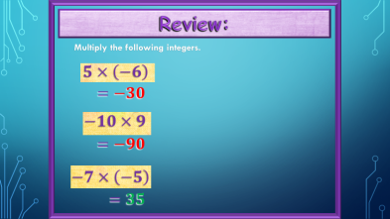
- Establishing a purpose for the lesson | Problem: You want to buy house that costs Php800,000. You only have Php500,000. If you buy the house, what will your debt be?  If you spend more money than you have, you go into debt. (Debt is a good example of working with negative integers.) |  | The highest point in Asia is the top of Mount Everest, at a height of 29,028 feet above sea level. The lowest point is the Dead Sea, which 1312 feet below sea level. How much higher is Mount Everest than the Dead Sea? |  | Problem: You are Php300 in debt. If your debt is increased 2 times, how much is your debt?  -300 x 2 = -600  Multiplying by a negative number is multiplying your debt.
- Presenting Examples/Instances of new lesson | Use a number line to help visualize the addition of integers.  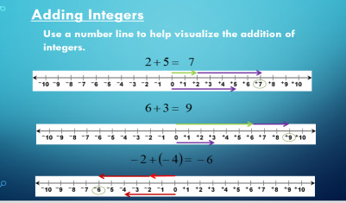  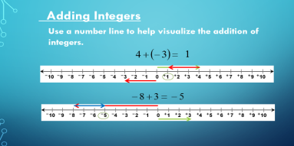  (Discuss “explain” on page 152 of txbk) |  | Discuss the answer to the problem using the 3 Steps to Subtract Integers  1.Keep  Keep the 1st number  2.Change  Subtraction sign to Addition  3.Opposite  Write down the opposite of the 2nd number  -Then add the way you normally do. |  | Present the rules in multiplying integers using power point presentation.  - Rule 1:  Positive x Positive = POSITIVE  - Rule 2:  Negative x Negative = POSITIVE  - Rule 3:  Negative x Positive = NEGATIVE  - Rule 4:  Any Number x 0 = ZERO |  | Present to the pupils the discussion on how to divide integers. (See power point presentation)  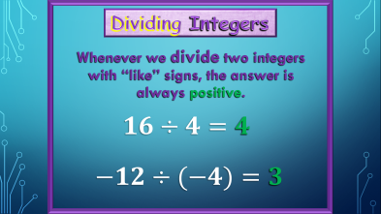
- Discussing new concepts and practicing new skills #1 | Show video clip on how to add integers |  | Show video clip on how to subtract integers. |  | Show video clip on how to multiply integers |  | Show video clip on how to divide integers
- Discussing new concepts and practicing new skills #2 | 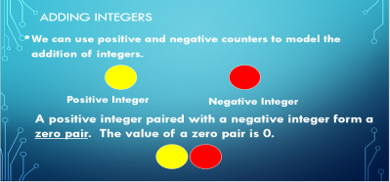  Demonstrate adding positive and negative integers using counters.  (On the slides of power point presentation)  Do you notice a pattern or rule?  Adding Integers with like signs.  - When the signs are the same, add the numbers together and keep the sign.  Demonstrate Adding Integers with like signs.  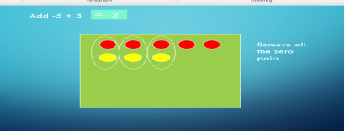  (On the slides of power point presentation)  Did you notice a pattern or rule?  Adding integers with unlike signs.  - When the signs are different, subtract the integers and keep the sign of the larger digit. |  | Demonstrate another example of subtraction of integers using a number line  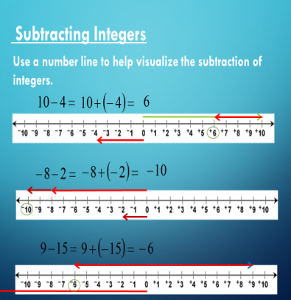 |  | Demonstrate another example of multiplication of integers.  Original File Submitted and Formatted by DepEd Club Member - visit depedclub.com for more  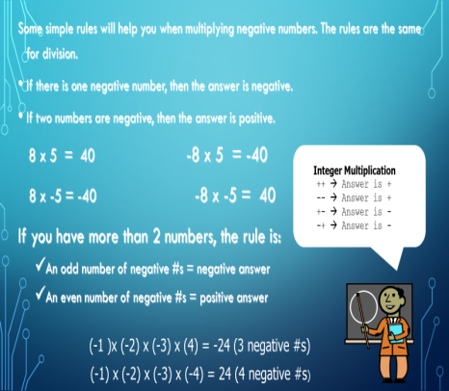 |  | Divide the pupils into 5 groups. Let them answer the problems on the slides.  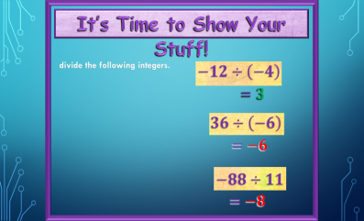
- Developing mastery  (Leads to Formative Assessment) | Group Activity:  Add the ff. integers:  1) -8 + 8 =  2) -9 + -11 =  3) 13 + (-19) =  4) 7 + 5 =  5) -12 + 10 =  6) -22 + (-16) =  7) 18 + (-5) = |  | Group Activity:  Materials: flash cards/power point, show-me-board  Mechanics:  a.Divide the class into 5 groups.  b.Choose a leader  c. Teacher flashes numbers on the slides  d.Leader will write the correct answer on the show-me-board  e.The first group to flash the correct answer will get 1 point  f.The teacher checks the answers.  g.The group having the most number of correct answers wins. |  | Group Activity:  Materials: flash cards/power point, show-me-board  Mechanics:  a.Divide the class into 5 groups.  b.Choose a leader  c. Teacher flashes numbers on the slides  d.Leader will write the correct answer on the show-me-board  e.The first group to flash the correct answer will get 1 point  f.The teacher checks the answers.  g.The group having the most number of correct answers wins. |  | 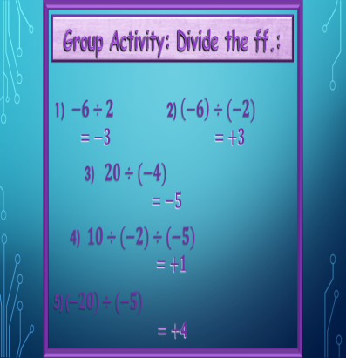
- Finding practical applications of concepts and skills in daily living | Pair-share: Add the ff.  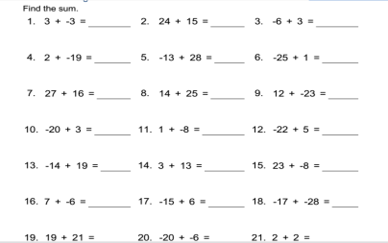  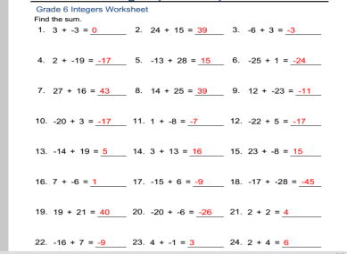 |  | PRACTICE BY PAIR:  - -7 – 15 =  - 23 – 98 =  - -48 - ⁻13 =  - 5 - ⁻6 =  - 17 – 8 = |  | 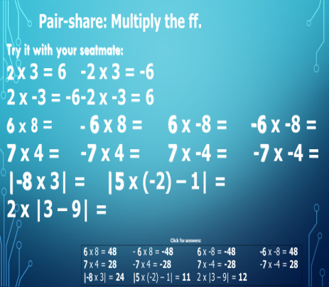 |  | Try this with your seatmate:  54 ÷ 6 =  -54 ÷ 6 =  54 ÷ -6 =  -54 ÷ -6 =  |-12 ÷ -4| =
- Making generalizations and abstractions about the lesson | How do we add integers with like sign? Unlike sign?  Adding Integers with like signs.  - When the signs are the same, add the numbers together and keep the sign.  -9 + -3 = -12  Adding integers with unlike signs.  - When the signs are different, subtract the integers and keep the sign of the larger integer.  -9 + 3 = -6 |  | How do we subtract integers?  (Subtraction of integers means adding the minuend and the opposite of the subtrahend.) or  Subtract Integers  1.Keep  Keep the 1st number  2.Change  Subtraction sign to Addition  3.Opposite  Write down the opposite of the 2nd number  -Then add the way you normally do. |  | How do we multiply integers?  1. IF THE SIGNS ARE THE  SAME THE ANSWER  IS POSITIVE  2. IF THE SIGNS ARE DIFFERENT THE ANSWER  IS NEGATIVE |  | How do we divide integers?  (on the slides)
- Evaluating Learning | 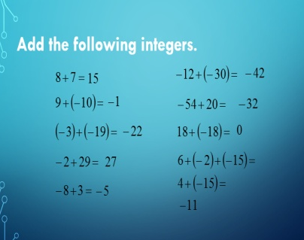 |  | 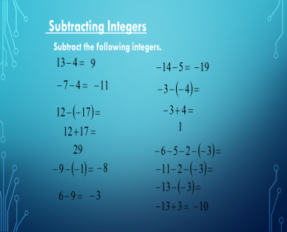 |  | 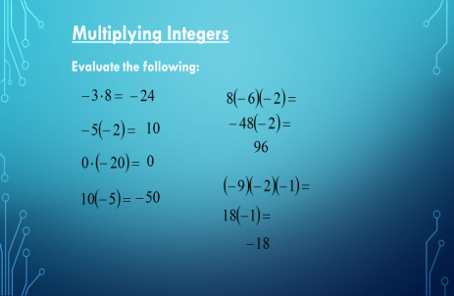 |  | 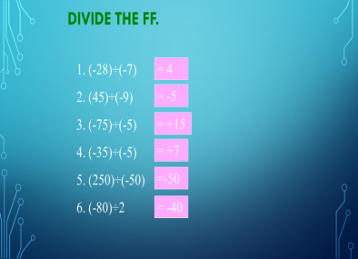
- Additional activities for application and remediation | If the temperature was -7 degrees (Fahrenheit) at 6 AM, rose 4 degrees by 7 AM and then rose another 8 degrees by 8 AM, what was the temperature at 8 AM? | Answer the ff. |  |  | Let the pupils do the additional activities on the slides. |  | Let the pupils answer the activity cards.
V. Remarks
VI. REFLECTIONS
- No. of learners who earned 80% on the formative assessment
- No. of learners who require additional activities for remediation who scored below 80%
- Did the remedial lessons work? No. of learners who have caught up with the lesson
- No. of learners who continue to require remediation
- Which of my teaching strategies worked well? Why did this work?
- What difficulties did I encountered which my principal or supervisor can help me solve?
- What innovation or localized materials did I use/discover which I wish to share with other teachers?

