Honors: Finding Objects in the Sky Lab Report
Name:

Introduction: Star charts, sometimes called “star maps,” are handy tools that describe and plot the night sky for virtually every day of the year. In this activity, your goal is to use a star chart to locate objects in the night sky.

Objective: How do we use star maps to locate stars and planets in the night sky?

Materials:
- Star charts for January and July

Procedure:

- Open the “Where Are the Planets” chart for the month of January. Locate and circle Polaris on the chart. Describe how you could use this chart to locate Polaris in the night sky.

- You heard some planets will be visible tonight and want to find them. Describe how you could use this star chart to help locate planets.

- Open the star chart for July. Compare this with the chart for January. Describe any similarities and differences you observe.

- What are some of the constellations visible during both January and July? Why are they visible during both months?

Evaluation and Conclusions:

- Why do we have different star charts for the same location on Earth?

- Imagine you had to show a young child how to use a star chart. Briefly describe how to use a star chart to a child.

- These star charts were constructed for 35° north latitude. Orlando, FL is at approximately 26° north latitude. How would a star chart for Orlando, FL compare to the ones provided?

- Compare how ancient civilizations had to rely on stars to navigate land and sea to how we can navigate land and sea in today’s world.

For questions #5-7, use the star chart below.
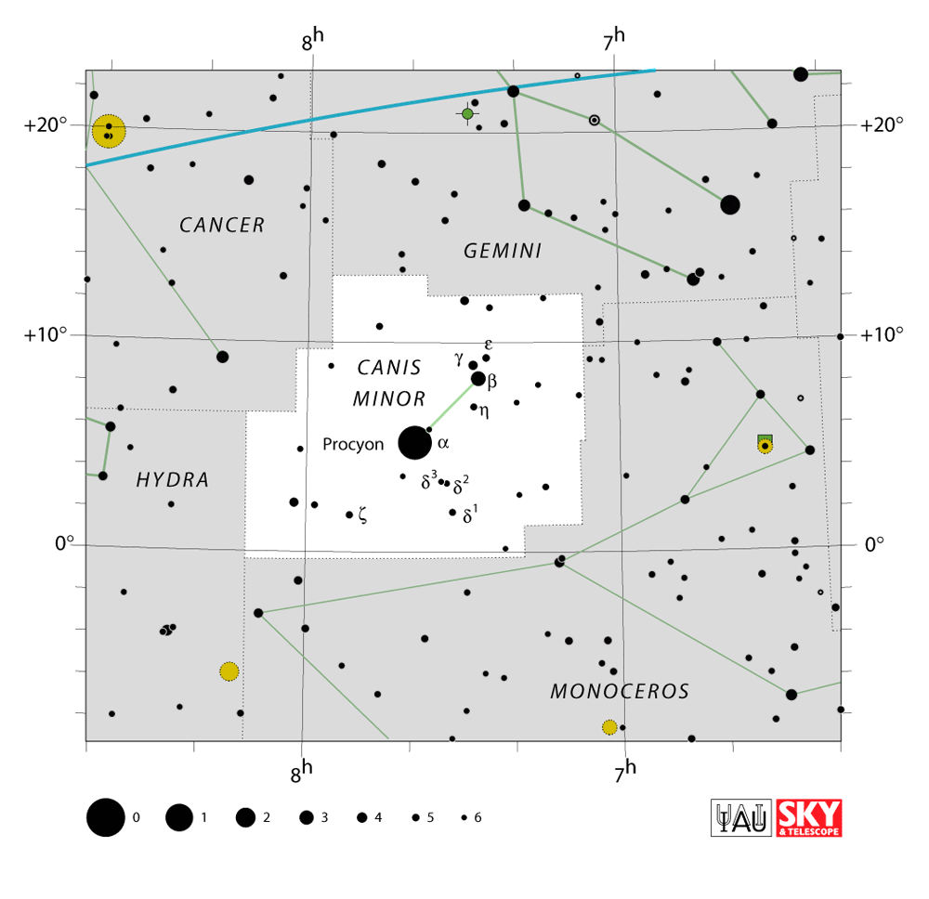
Source: https://www.iau.org/static/public/constellations/gif/CMI.gif

- An astronomer points her telescope to the coordinates 16 degrees declination and 8 hours 40 minutes right ascension. Which constellation is she looking at?

- Your friend notices a bright object in the sky at approximately 4 degrees declination and 7 hours 40 minutes right ascension. He thinks it might be Saturn because he learned Saturn is very bright in the sky. Do you agree or disagree? Explain your answer.

- Select a star in the constellation Canis Minor. Provide the celestial coordinates for your chosen star. If you wanted to find that star in the night sky tonight, describe how you would do this.

