Unit 1 Lesson 6

Name(s)____________________________________________ Period ______ Date ________________

 |  | Worksheet - Sending Numbers for Graphing | 

Outgoing Graph: Create your drawing on the left, translate the coordinates to binary, and log the bits on the right. (This is the message you will send to your partner.)
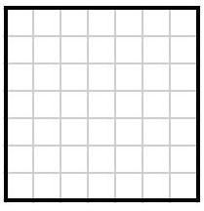

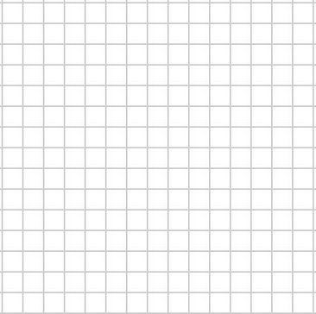



Incoming Graph: Log your partner’s binary message below, translate it into coordinates, and plot on the graph to the right.

