Unit 5 Lesson 12
Name(s)_______________________________________________ Period ______ Date ___________________
Decision 1 - When to Post

Define
You want to know when to post a picture online to get the greatest response.

Prepare
To answer this question you and your friends posted images to your favorite apps for a week. You kept track of likes and comments to see if there were any different patterns.

Try
You collected information about when you made a post and how many likes and comments you received. Average likes and comments for each time to post are shown below.
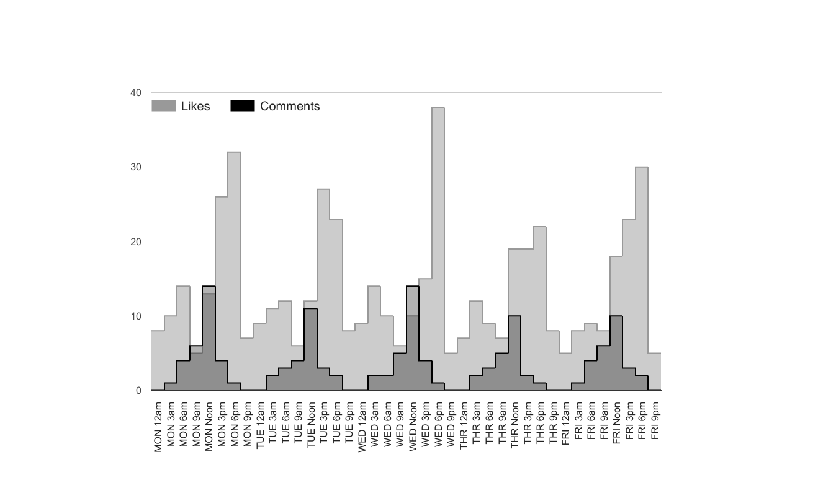

Reflect
Now it’s your turn to help. Can you make a recommendation for what time to post:

- If you want the most likes? ________________________________________________________________

- If you want the most comments? __________________________________________________________

- What other information would you want to collect to make an even better decision? _________________
____________________________________________________________________________________
Name(s)_______________________________________________ Period ______ Date ___________________
Decision 2 - Making Meals

Define
The cafeteria would like to decide how best to reduce their food waste after noticing they are throwing out food each day.

Prepare
To answer their question the cafeteria decided to collect information about the number of meals prepared, daily attendance, the type of meal, and the number of meals eaten vs. wasted.

Try
The cafeteria collected this data and created the chart below.

 | Monday | Tuesday | Wednesday | Thursday | Friday
Meal | Pizza | Hamburgers | Chicken Fingers | Salad | Grilled Cheese
Meals Prepared | 100 | 100 | 100 | 100 | 100
Attendance | 85 | 90 | 90 | 95 | 85
Meals Eaten | 80 | 82 | 88 | 75 | 80
Meals Wasted | 20 | 18 | 12 | 25 | 20

Reflect
Now it’s your turn to help. Can you make a recommendation for how the cafeteria could reduce food waste?

- How many meals should they prepare each day? ________________________________________________

- Should they vary how many meals they make based on the meal served or attendance? _________________
________________________________________________________________________________________
________________________________________________________________________________________

- Is there more information you’d want to collect to make your decision? ________________________________
________________________________________________________________________________________
________________________________________________________________________________________

Name(s)_______________________________________________ Period ______ Date ___________________
Decision 3 - Locker Selection

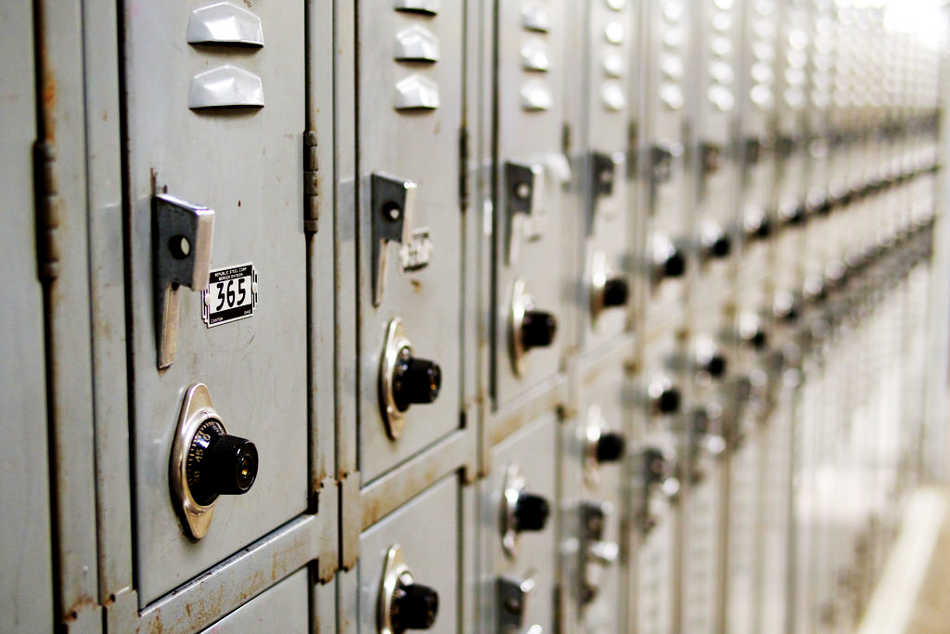
Define
Starting next year your school has decided to allow you to choose your own locker so that it’s most convenient for your schedule. You need to make a data driven decision to decide which locker you’re going to request.

Prepare
To answer their question you and your friends collected some information about how long it takes you to walk from each locker to your classes by walking through the halls with a stopwatch.

Try
Here’s the data you collected.

 | Time to 1st Period | Time to 2nd Period | Time to 3rd Period | Time to 4th Period | Time to 5th Period | Average Time  (Go to locker all periods) | Average Time  (Skip locker on “Bad” periods) | Most Classes of Books You’ll Carry if you skip “Bad” periods
Locker A | 1 min (Good) | 2 mins (Good) | 5 mins (Bad) | 5 mins (Bad) | 1 min (Good) | 2.8 mins | 1.3 mins | 3 periods
Locker B | 2 mins (Good) | 3 mins  (OK) | 2 mins (Good) | 4 mins  (OK) | 3 mins  (OK) | 2.8 mins | 2.8 mins | 1 period
Locker C | 6 mins (Bad) | 1 min (Good) | 6 mins (Bad) | 1 min (Good) | 6 mins (Bad) | 4.0 mins | 1 min | 2 periods
Locker D | 0 mins (Good) | 5 mins (Bad) | 5 mins (Bad) | 1 min (Good) | 1 min (Good) | 2.4 mins | .6 min | 3 periods

Reflect
Now it’s time to make a decision. Discuss with your group and decide:

- Which locker do you want? __________________________________________________________________

- Why? What data convinced you? _____________________________________________________________
________________________________________________________________________________________

- Are there other pieces of data that you’d also like to see before making a decision? ____________________
________________________________________________________________________________________

