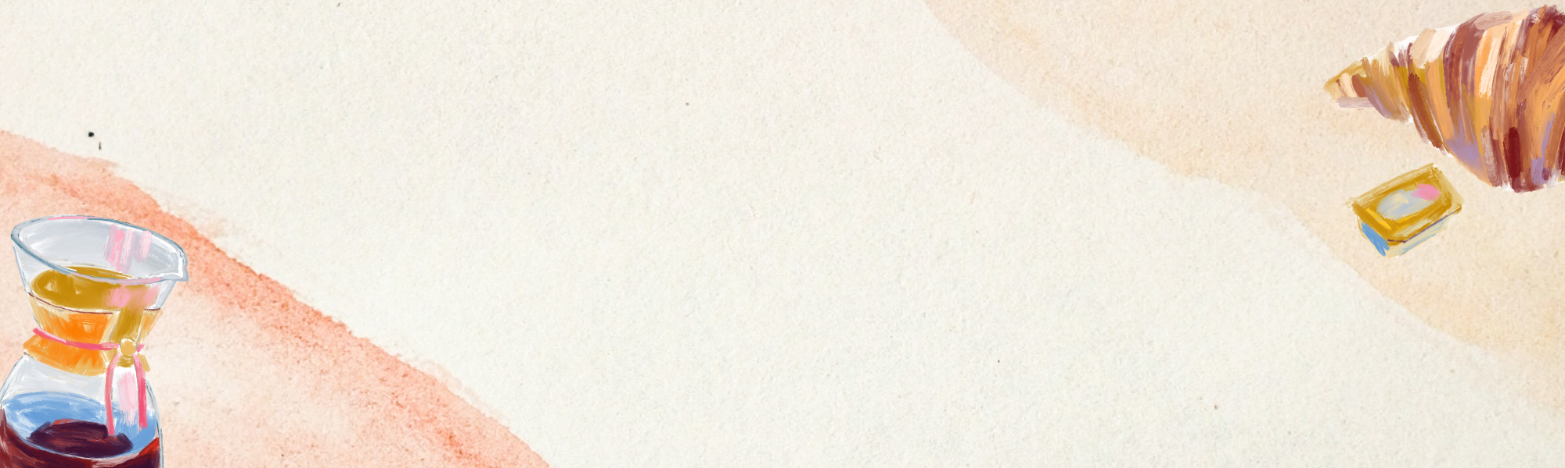
GROCERY LIST
Fruits 🍎  - Apples  - Bananas  - Oranges  - Strawberries  - Grapes  - Pears  - Blueberries  - Mangoes  - Pineapples | Vegetables 🥦  - Lettuce  - Tomatoes  - Carrots  - Onions  - Potatoes  - Broccoli  - Spinach  - Peppers  - Cucumbers
Dairy & Alternatives 🥛  - Milk  - Cheese  - Yogurt  - Eggs  - Butter  - Cream  - Almond Milk  - Oat Milk  - Soy Milk | Pantry Staples 🍚  - Rice  - Pasta  - Flour  - Sugar  - Salt  - Pepper  - Olive Oil  - Canned Goods  - Bread
Meat & Seafood 🥩  - Chicken  - Beef  - Pork  - Fish  - Shrimp  - Turkey | Other 🛒  - Spices  - Coffee  - Tea  - Snacks  - Juices  - Water

