 | Explore PT Annotated Sample H - Score 4/8 | 

Total score | Row 1 | Row 2 | Row 3 | Row 4 | Row 5 | Row 6 | Row 7 | Row 8 | This document combines student sample, scoring guidelines and scoring commentary from: Explore PT Sample H
Sample: H | 1 | 1 | 0 | 0 | 0 | 0 | 1 | 1

Computational Artifact
Your computational artifact must provide an illustration, representation, or explanation of the computing innovation’s intended purpose, its function, or its effect. The computational artifact must not simply repeat the information supplied in the written responses and should be primarily non-textual.

Student Response | Scoring Guidelines
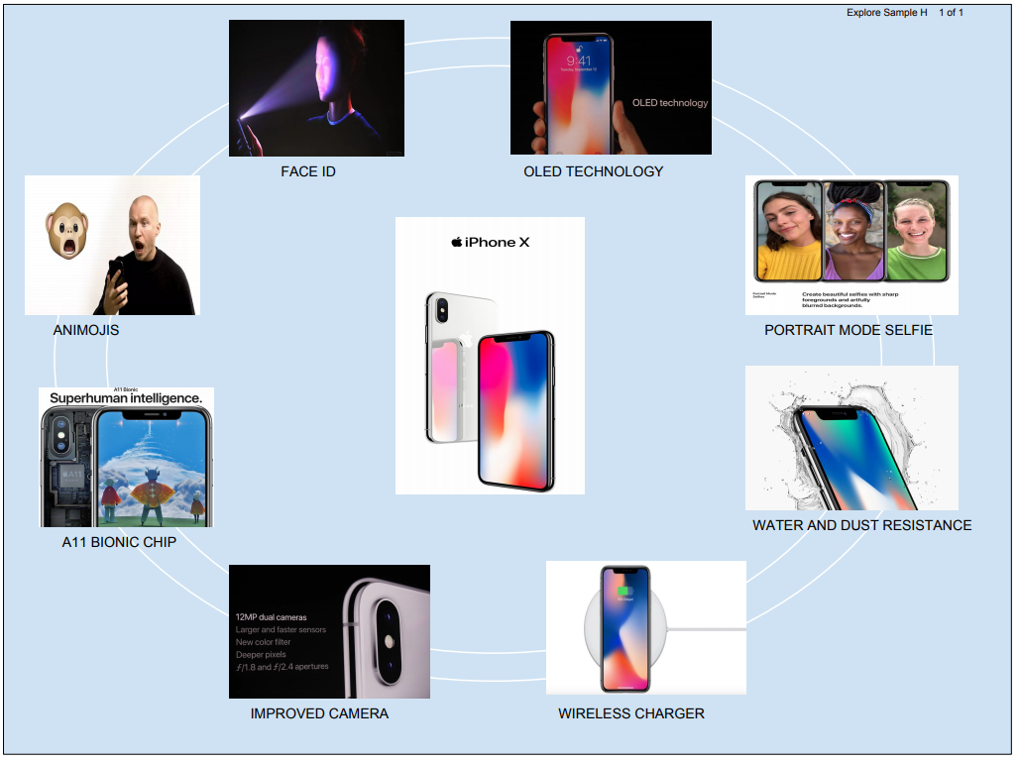 | Row and Task | Decision Rules
 | Row 1  Computational Artifact  The computational artifact:  • Identifies the computing innovation.  AND  • Provides an illustration, representation, or explanation of the computing innovation’s intended purpose, function, or effect. | The written response can be used to aid the understanding of how the computational artifact illustrates, represents, or explains the computing innovation’s intended purpose, function, or effect.  Do NOT award a point if any one of the following is true:  - there is no artifact;  - the artifact is not a computational artifact;  - the innovation identified in the artifact does not match the innovation described in the written response;  - the artifact does not identify the innovation clearly;  - the artifact does not illustrate, represent or explain the innovation’s intended purpose, function, or effect;  - the artifact illustrates a feature of the innovation instead of the purpose, function, or effect; or  - the computational artifact doesn’t clearly illustrate, represent, or explain as required in the scoring criteria AND the written response describes the innovation’s intended purpose and function without explaining how the computational artifact illustrates, represents, or explains the intended purpose, function, or effect..
 | The response earned a point for this row. The computational artifact illustrates functions of the iPhoneX such as Animojis, Face Id, and portrait mode selfie.

Computational Artifact
2a. Provide information on your computing innovation and computational artifact.
- Name the computing innovation that is represented by your computational artifact.
- Describe the computing innovation’s intended purpose and function.
- Describe how your computational artifact illustrates, represents, or explains the computing innovation’s intended purpose, its function, or its effect.
(Must not exceed 100 words)

Student Response | Scoring Guidelines
The computing innovation that is represented by my computational artifact is apple iphone x. Iphone x is the latest version of iphone with lots of new features. The purpose and function of iphone x is to make a improved technology with new features like the face ID, entirely screen, improved display, etc. The computational artifact illustrates the new features of iphone x such as the face ID, animojis, organic light emitting diode (OLED) technology, wireless charging, water and dust resistance, improved camera, A11 bionic chip (1), (25% faster performance and 75% faster efficiency) and portrait mode selfies with lighting effect. | Row and Task | Decision Rules
 | Row 2 - Response 2A  States a fact about the correctly identified computing innovation’s intended purpose OR function. | Do NOT award a point if:  - the identified innovation is not a computing innovation; or  - the written statement gives an effect (which is required for the scoring criteria in Row 3, not Row 2).
 | The response earned a point for this row. The response states that "The purpose and function of iPhone x is to make a improved technology with new features like the face ID, entirely screen, improved display, etc."

2b. Describe your development process, explicitly identifying the computing tools and techniques you used to create your artifact. Your description must be detailed enough so that a person unfamiliar with those tools and techniques will understand your process.
(Must not exceed 100 words)

Student Response | Scoring Guidelines
The computing tool I used to create my artifact is google drawing. At first I searched on google for some pictures that could represent my topic. I got some pictures from google images that shows the new features of my computing innovation. I placed the images in google drawing, and I had to crop some of the images to make it more efficient. I created a circle shape artifact to make it more creative. I did this by first Explore Sample H 1 of 4 placing the images in a circle then placing the pictures on top of the circles and gave it a blue color square background and finally converted it to a PDF. | Row and Task | Decision Rules
 | -- | ---
NOTE: This response is not officially scored, but you can use this section to cite any sources used in the creation of your computational artifact. This section may also be referenced if there is any suspicion of plagiarism. Do not skip!
- All images, diagrams, or information that appears in your computational artifact and that you yourself did not make should appear both in your citations and within this response.
- Also, by briefly describing the tool used to make the artifact and how you went about it can further help verify that you are the author of your artifact and did not merely submit someone else’s work.

Computing Innovation
2c. Explain at least one beneficial effect and at least one harmful effect the computing innovation has had, or has the potential to have, on society, economy, or culture.
(Must not exceed 250 words)

Student Response | Scoring Guidelines
One of the beneficial effect of iphone x is it’s display. The iphone x has a Organic Light Emitting Diodes (OLED) display technology. It is much thinner, much lighter, fast response time, better viewing angle, better color accuracy, image contrast accuracy, and higher brightness (4). One of the harmful effect of iphone x is it’s glass on the back and stainless steel frame which is very easy to scratch and break and repairing it is really expensive (2) . The glass back allow the phone to have wireless charging. Smartphone device insurer SquareTrade,Inc. Said in a youtube video, that it is the most breakable, highest priced, and most expensive to repair iphone ever. And they give a breakability score of 90 high risk (3). | Row and Task | Decision Rules
 | Row 3 - Response 2C  Identifies at least ONE effect of the identified or described computing innovation. | The effect does not need to be specifically identified as beneficial or harmful. The effect must be identified, but it doesn’t have to be described to earn the point.  Do NOT award a point if any one of the following is true:  - the described innovation is not a computing innovation; or  - the identified effect is actually a purpose for using the computing innovation (e.g., allows me to make videos to share with my family); or  - the identified effect is actually a function or use of the computing innovation (e.g., self-driving cars can drive me to work); or  - the identified effect is not a result of the use of the innovation as intended (e.g., a self-driving car is not intended to crash, therefore, its exposure to hacking is not an effect of its intended use).
 | The response DID NOT earn the point for this row. All the identified effects are features of the iPhoneX. For example, the OLED display, and the glass back are features of the phone.
 | Row 4 - Response 2C  ● Identifies a beneficial effect of the identified or described computing innovation.  AND  ● Identifies a harmful effect of the identified or described computing innovation. | Responses that earn this point will also earn the point for Row 3. Responses should be evaluated on the rationale provided in the response not on the interpretation or inference on the part of the scorer.  Do NOT award a point if any one of the following is true:  - the described innovation is not a computing innovation; or  - the response is missing the adjectives harmful or beneficial (or synonyms thereof); or  - the response is missing a plausible beneficial effect; or  - the response is missing a plausible harmful effect; or  - the identified effect is actually a purpose for using the computing innovation (e.g., allows me to make videos to share with my family); or  - the identified effect is actually a function or use of the computing innovation (e.g., self-driving cars can drive me to work); or  - the identified effect is not a result of the use of the innovation as intended (e.g., a self-driving car is not intended to crash, therefore, its exposure to hacking is not an effect of its intended use).
 | The response DID NOT earn a point for this row. While the response attempts to describe a beneficial and a harmful effect of the iPhoneX, the response identifies features of the phone, not effects of the phone.
 | Row 5 - Response 2C  Explains how ONE of the identified effects relates to society, economy, or culture. | Responses that earn the point for this row must have earned the point for Row 3.  Responses should be evaluated on the rationale provided in the response not on the interpretation or inference on the part of the scorer.  Do NOT award a point if any one of the following is true:  ● the described innovation is not a computing innovation; or  ● the explanation does not connect one of the effects to society, economy, or culture
 | The response DID NOT earn a point for this row. The response does not relate any of the effects to society, economy, or culture

2d. Using specific details, describe:
- the data your innovation uses;
- how the innovation consumes (as input), produces (as output), and/or transforms data; and
- at least one data storage concern, data privacy concern, or data security concern directly related to the computing innovation.
(Must not exceed 250 words)

Student Response | Scoring Guidelines
The data that iphone x use is mobile data. Iphone x consumes as input as that there is touch screen, apps, games, etc and produces as output as that it uses audio, voice, power, etc. The iphone x’s uses lots of data for the new feature, face ID. The data from the infrared camera is sent to A11 chip to process, in which it compare the information about you on the phone(5). Apple has analyzed over a billion images for data about faces(5). One of the data storage concern is that the there is limited space to store files for example, pictures and videos have bigger size because of improved cameras, so it require more data to store. The face ID has some security concerns, someones can crack the Face ID with a composite mask of 3-D-printed plastic, silicone, makeup, and simple paper cutouts, which in combination trick an iPhone X into unlocking (6). So there is concern about the security of face ID on iphone x. | Row and Task | Decision Rules
 | Row 6  Response 2D  ● Identifies the data that the identified or described computing innovation uses  AND  ● Explains how that data is consumed, produced, OR transformed. | Responses should be evaluated on the rationale provided in the response not on the interpretation or inference on the part of the scorer.  Do NOT award a point if any one of the following is true:  - the described innovation is not a computing innovation; or  - the response does not state the specific name of the data or simply says “data”; or  - the response confuses or conflates the innovation with the data: response fails to explain what happens to the data; or  - the response confuses the source of the data with the data.
 | The response DID NOT earn a point for this row. The input data is not identified. The response does mention audio and voice as output, which would be produced by the phone, not used by the phone
 | Row 7  Response 2D  ● Identify one data storage, data privacy,  OR  ● data security concern related to the identified or described computing innovation. | Responses should be evaluated on the rationale provided in the response not on the interpretation or inference on the part of the scorer. Responses can earn this point even if they refer to the data in a general without specifically identifying the data being used.  Do NOT award a point if any one of the following is true:  ● the described innovation is not a computing innovation; or  ● the response identifies or describes a concern that is not related to data
 | The response earned a point for this row. A security concern is identified: "The face ID has some security concerns, someones [sic] can crack the Face ID with a composite mask of 3-D printed plastic, silicone, makeup, and simple paper cutouts, which in combination trick an iPhone X into unlocking"

References
2e. Provide a list of at least three online or print sources used to create your computational artifact and/or support your responses through in-text citation to the prompts provided in this performance task.
- At least two of the sources must have been created after the end of the previous academic year.
- For each online source, include the complete and permanent URL. Identify the author, title, source, the date you retrieved the source, and, if possible, the date the reference was written or posted.
- For each print source, include the author, title of excerpt/article and magazine or book, page number(s), publisher, and date of publication.
- If you include an interview source, include the name of the person you interviewed, the date on which the interview occurred, and the person’s position in the field.
- Include in-text citations for the sources you used.
- Each source must be relevant, credible, and easily accessed.

Student Response | Scoring Guidelines
1.(https://www.fool.com/investing/2017/09/13/3-things-you-need-to-know-about-apples-a1 1-bionic.aspx ), Ashraf Eassa, “3 Things You Need to Know About Apple's A11 Bionic Chip”, September 13, 2017 2. ( https://www.cnet.com/news/apple-iphone-x-drop-test/ ), Vanessa Hand Orellana, “The iPhone X cracked on the first drop”, November 4, 2017  3. ( https://www.youtube.com/watch?v=T_OT1FQSWuU&feature=youtu.be ), SquareTrade,inc., “SquareTrade iphone x breakability”, November 6, 2017  4. ( http://www.displaymate.com/iPhoneX_ShootOut_1a.htm ), Dr. Raymond M. Soneira President, DisplayMate Technologies Corporation, “iPhone X OLED Display Technology Shoot-Out” 2017 5. ( https://www.computerworld.com/article/3224569/apple-ios/iphone-x-and-face-id-everyt hing-you-need-to-know.html ), Jonny Evans, Computerworld, “iPhone X & Face ID: Everything you need to know”, SEP 13, 2017  6. ( https://www.wired.com/story/hackers-say-broke-face-id-security/ ), Andy Greenberg, “Hackers say they’ve broken face ID a week after iphone x release”, November 12, 2017 | Row and Task | Decision Rules
 | Row 8  Response 2E & Artifact  References, through in-text citation, at least 3 different sources. | The in-text citations can be in either the artifact or the written response. The in-text citations may be oral in the computational artifact.  Do NOT award a point if any one of the following is true:  ● the response contains a list of sources only, no in-text citations;  ● the response contains less than three in-text citations; or  ● there are not three in-text citations with corresponding references.
The response earned a point for this row. Three references and three in-text citations are included.

[1] Referenced in 2a
[2] Referenced in 2c
[3] Referenced in 2c
[4] Referenced in 2c
[5] Referenced in 2d
[6] Referenced in 2d

