  GRADES 1 to 12  DAILY LESSON LOG | School: | DepEdClub.com | Grade Level: | VI
 | Teacher: | File created by Ma'am ANNALICE R. QUINAY | Learning Area: | MATHEMATICS
 | Teaching Dates and Time: | DECEMBER 12 – 16, 2022 (WEEK 6) | Quarter: | 2ND QUARTER

 | MONDAY | TUESDAY | WEDNESDAY | THURSDAY | FRIDAY
I. OBJECTIVES
- Content Standard | The learner demonstrate understanding of order of operations, ratio and proportion, percent, exponent, and integers
- Performance Standard | The learner is able to apply knowledge of order of operations, ratio and proportion, percent, exponent, and integers in mathematical problems and real-life situations
- Learning Competencies / Objectives | Gives the meaning of exponent, and base  Describes the exponent and the base in a number expressed in exponential notation.  M6NS-IIf-146 |  | Evaluates an expression involving exponents  Gives the value of numbers expressed in exponential notation.  M6NS-IIf-147 | States, explains, and interprets parenthesis, multiplication, division, addition, subtraction (PMDAS) or grouping, multiplication, division, addition, subtraction (GMDAS) rule.  M6NS-IIf-148 | Evaluate an expression with two different operations without exponents and parenthesis/ grouping symbols  M6NS-IIf-149 |  | Evaluate an expression with more than 2 operations with  exponents and parenthesis/grouping symbols  M6NS-IIf-149
II. CONTENT | Exponent and base |  | meaning of exponent and base  Evaluating expressions involving exponents | PMDAS and GMDAS Rule | Evaluating expressions |  | Evaluating an expression with more than 2 operations with  exponents and parenthesis/grouping symbols
III. LEARNING RESOURCES
- References
- Teacher’s Guide pages | Lesson Guide in Elem. Math Gr. 6 p.6  DLP Gr. 6 Module 1 |  | Lesson Guide in Elem. Math Gr. 6 p.9  DLP Gr.4 Module 32 | Lesson Guide in Elementary Mathematics Grade VI pages 14, 17, 23-24,  Curriculum Guide Math 6:. M6NS-IIf-148 | . Math Textbook  Curricilum Guide Math 6: M6NS-IIf-149 |  | M6NS-IIf-149  Math Textbooks  Lesson Guide in Elem. Math Gr. 6 p.13, 17, 21, 25, 28
- Learner’s Materials pages
- Textbook pages
- Additional Materials from Learning Resource (LR) Portal
- Other Learning Resources | Power point presentation |  | Power point presentation | Power point presentation | Power point presentation |  | Power point presentation
IV. PROCEDURES
- Reviewing previous lesson or presenting the new lesson | Let the pupils describe the pattern shown.  Fig. 1 Fig. 2 Fig. 3  Let them draw the next figure in the pattern.  How many squares are there in the 2nd figure? in the 3rd figure?  Discover the rule in finding the next figure?  How many squares will be in the fifth figure? |  | Drill  Game: Think and Try  Can you find a pair of numbers whose sum is equal to their product?  Example: 2 + 2 = 2 x 2 = 4  Expected Answers:  3 + 1.5 = 3 x 1.5 = 4.5  5 + 1.25 = 5 x 1.25 = 6.25  11 + 1.1 = 11 x 1.1 = 12.1 | A.Drill  Evaluating the expression  Mechanics:  Form 4 groups of pupils.  The teacher flashes the cards with expressions.  The groups are given 60 seconds to evaluate the expression.  One member of each group simultaneously goes to the board and writes the answer.  The teacher checks the answer.  The group with the most number of correct answer wins  Sample item:  a.3×4+1 = b.62+3 =  c. (6+3) + 2 = e. (15 + 3) × 2 =  d. (16 ÷ 4) × 3 =  B.Have a review on the divisibility rules. Provide exercises written on the flash cards. |  | a. Activity 1 – Game on Numerical Expressions  b. Activity 2 – Game on Naming the Word Expression  c. Review past lessons  (Refer to TG) | 1. Drill  a. Activity 1 – Evaluating the Expression  b. Activity 2 – Completing the Evaluation  (Refer to TG)
- Establishing a purpose for the lesson | a) Show pictures of the map of the Philippines and of General Emilio Aguinaldo and let them read the following sentences.  1) General Emilio Aguinaldo is the First President of the Philippine Republic.  2) The Philippines is in Southeast Asia.  3) Most Filipinos celebrate Christmas in the 10th month of the year.  b) Ask them which sentence is true or false. Let them tell why.  c) If sentences can be true or false, in mathematics there are sentences that are either true or false. |  | Ask: What are the different dreaded diseases? (TB, cancer, etc.)  Today we are going to read something about cancer cells. | Ask pupils about the occupation of their parents. Let them tell how they help their parents earn a living. |  | Ask the pupils about the occupation of their parents. Let them tell how they help their parents earn a living. | What do you observe when somebody in your home is sick? Does he take medicine? Is it liquid or tablets? How are tablets kept?  Original File Submitted and Formatted by DepEd Club Member - visit depedclub.com for more
- Presenting Examples/Instances of new lesson | Activity 1: Present this problem  Rhoda has to sew a tablecloth 9 dm by 9 dm for their square-shaped table in the living room. How big is the area of the tablecloth? |  | Present the selection below  In a particular clinical research, a special type of cancer cells affecting the skin was discovered to exist as a pair in the beginning and was found out to double every 24 hours. The table shows the listing of the number of cancer cells present for the first 10 days.  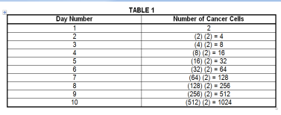 | Present the situation to the class.  Lulu comes from school with a heavy heart because of homework. Her elder brother gives her a helping hand. He has seen the following:  Evaluate the expressions:  12 – 3 + 18 ÷ 6 × 3  7 × 9 – 3 + 8  18 – 12 ÷ 6 + 7  9 × 9 ÷ 3 – 9 + 6  16 ÷ 4 × 5 – 7 + 8  Ask: What are the given data?  What operations must be done first? second? next? last? Why? |  | Activity 1 – Use of Role Play in a Sari-Sari Store  Jethro was helping his mother in their store when a delivery man delivered 20 dozens of eggs at 42 a dozen. If the delivery man gave him 160, how much was his money? Was he right in asking for a change of 260, if his money was 1,000? Why?  Ask the following questions:  Who helped mother in the store?  Who delivered dozens of eggs?  How many dozens of eggs were delivered to them ?  If you were Jethro:  will you help your family earn a living? Why?  will you keep the change given by the delivery man? Why?  Have each pair of pupils act it out using play money and ask them to answer the following:  What are the given data?  What are the operations to be used?  . | a. Activity 1 – Use of Flats and Longs  In a certain drugstore, the pharmacist daughter of the owner helps her mother account the medicines for fever. She finds specialized square holders of tablets. She has recorded 4 groups of 10 layers of 10 tablets on each side of the holders and 6 sets of 10 tablets. Is she right in reporting that there are 40 060 tablets? Why?  1) Ask the pairs of pupils the questions below:  a) What is the profession of the daughter of the drugstore owner?  b) What does the pharmacist do?  c) What does she find?  d) If you were the pharmacist, will you also have a systematic arrangement of your medicines? Why?
- Discussing new concepts and practicing new skills #1 | Answering questions about the problem  How will you find the area of the table cloth?  What number sentence will be used to solve the problem?  Are the two quantities equal?  Write the equation about the problem. (9 x 9 = 81)  How many times did you multiple 9 to get 81? The product 9 x 9 can be written as power of 9² where 9 is the base and 2 is the exponent.  The exponent tells how many times the base is used as a factor to form a product.  The base is the factor which is to be multiplied by itself the number of times indicated in the exponent to obtain the product.  In the problem, how big is the tablecloth to be sewed by Rhoda?  Write the equation for the problem in exponential notation of the problem.  Valuing:  a) Who has to sew a tablecloth?  b) Where will she put the tablecloth?  c) If you were Rhoda, will you also sew a tablecloth? Why? |  | What do you notice about the cancer cells from day 1 to day 10? (They are doubled each day.)  How is this obtained?  (The number of cancer cells in a given day is obtained by multiplying the number of cancer cells present on the preceding day by 2 since the cancer cells double daily.)  If we try to rewrite this product in terms of the number of cancer cells present on the first day, we will have the following table:  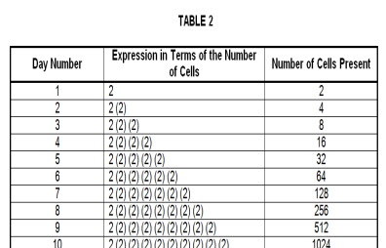 | Encourage the pupils to work in pairs. Have each pair of pupils evaluate the expressions.  Lead the pair of pupils to process how to get the answer. |  | Lead each pair of pupils to think of an expression related to the problem.  Let them evaluate the expression they have formulated.  160 + (20 x P42)  160 + P840  1,000 money of Jethro  Require them to analyze the operations they used in arriving at the exact change | 2)Have each pair of pupils use flats and longs to visualize the problem. Let them answer the following questions:  a) What will you find in the problem?  b) What are the data given?  c) What are the operations to be used?  3) Lead each pair of pupils to think aloud of a numerical expression about the problem.  (4 x 10³) + (6 x 10)  4) Ask them to decide on: Is she right in reporting that they have 40 060 tablets? Why? Have them evaluate the expression as in:  (4 x 10³) + (6 x 10)  (4 x 1000) + (6 x 10)  4000 + 60  4060  5) Draw from the pairs of pupils through analysis which operation should be done first, second, next, and last. Include also in the analysis the meaning of parenthesis in the expression and the direction it gives when evaluating the expression.
- Discussing new concepts and practicing new skills #2 | Pair-share: Activity 2  The side of a small cutout square is 7cm. What is its area?  Write an expression about the problem.  What is the equation?  Can you write 7 x 7 in another way? How?  What do you call 7 in 7²? 2 in 7²?  What is the exponent? base? |  | Let us focus our attention on the expression that describes the number of cancer cells in a given day in terms of cancer cells present on the first day. This is seen in the second column of table 2.  What can you say about how the expression is written? Why? (It becomes tedious because we write the number repeatedly.)  It is for this reason that in 1637, Rene Descartes, a French mathematician, introduced a system of writing numbers indicating repeated multiplication.  What can you say about Rene Descartes? Do you want to be like him someday? Why?  Now, here is another table, let us study this table.  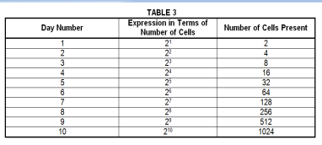  In general, if N is the number of days the cancer cells have been present, then the expression for the number of cells present during the n^{th} day is 2^{n}. The letter n is called an exponent of base 2.  In 2², what is the exponent? What is the base? In 2³? 2⁴? etc. What does the exponent indicate?  (It indicates the number of repeated multiplication.)  So, what does 2³ mean?  (It means 2 x 2 x 2.)  How is it read? (“two to the third power” or “two with the exponent three.” (Give some more examples). | After all the pairs process their answers, ask: “How did you find the activity? How were you able to come up with the correct answers? What did you do?”  Discuss with the pupils the rules on how they were able to solve the order of operations. Give more examples.  Solutions:  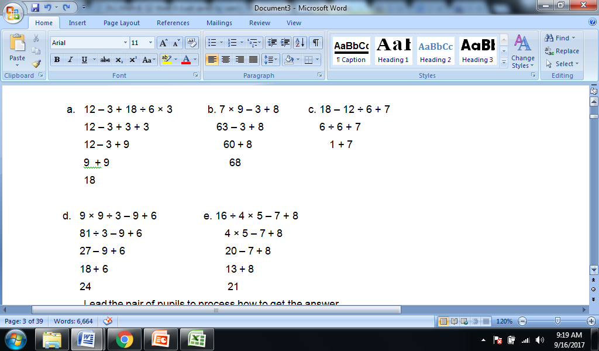  Discuss the presentation under Explore and Discover on LM Then, give the following exercises.  Ask the pupils to perform the series of operation.  1.(7 × 9) + (3 ×21)  2. (18 – 5) + 6 + 2  3. ( 3 + 5) × (42 ÷ 7)  4. 36÷ 2 + 4×(4-2) |  | Group Activity– Use of Test Items  Tita was absent for a week because she was sick. When she went to school, she had to take a test. Few of the items given are shown below.  a) 2 x 3 + 4  b) 7 x 9 – 3  c) 18 – 12 ÷ 2  d) 35 – 6 x 3  e) 3 x 2 + 4  f) 48 ÷ 12 + 8  Can you answer these? Let us try to answer the items.  Ask each pair of pupils to answer the following questions:  What facts are given?  What operations are in each problem? Which operations come first? Which operation will you do first?  Guide each pair of pupils to evaluate the expressions | b. Activity 2 – Use of Illustration  Emma helps her mother arrange the items in their store. Her mother has specialized square tray for quail eggs. She finds 4 groups of 5 rows with 5 quail eggs placed in trays and 3 groups with 10 quail eggs. She informs her mother that they have 1 030 quail eggs. Is she right? Why?  Have the pairs of pupils answer the following questions:  Who helps her mother in the store?  What does Emma do to help her mother?  If you were Emma will you also arrange the items for sale in the store of your mother? Why?  Ask each pair of pupils the questions below. Use these illustrations. (Refer to TG)  What facts are given?  What are the processes to be used?  Guide them to think aloud of the numerical expression that can best represent the problem.  Let them think critically: Is Emma right? Why?  Ask them to evaluate the numerical expression.  (4 x 5²) + (3 x 10)  (4 x 25) + (3 x 10)  100 + 30  130  Have the pairs of pupils analyze which operation should be used first, second, next, and last to arrive at the answer.
- Developing mastery  (Leads to Formative Assessment) | Group Activity: Give the base and the exponent in each of the following orally.  1.2⁵ 2. 4² 3. 7³  4. 1⁸ 5. 6⁴  Complete the equation.  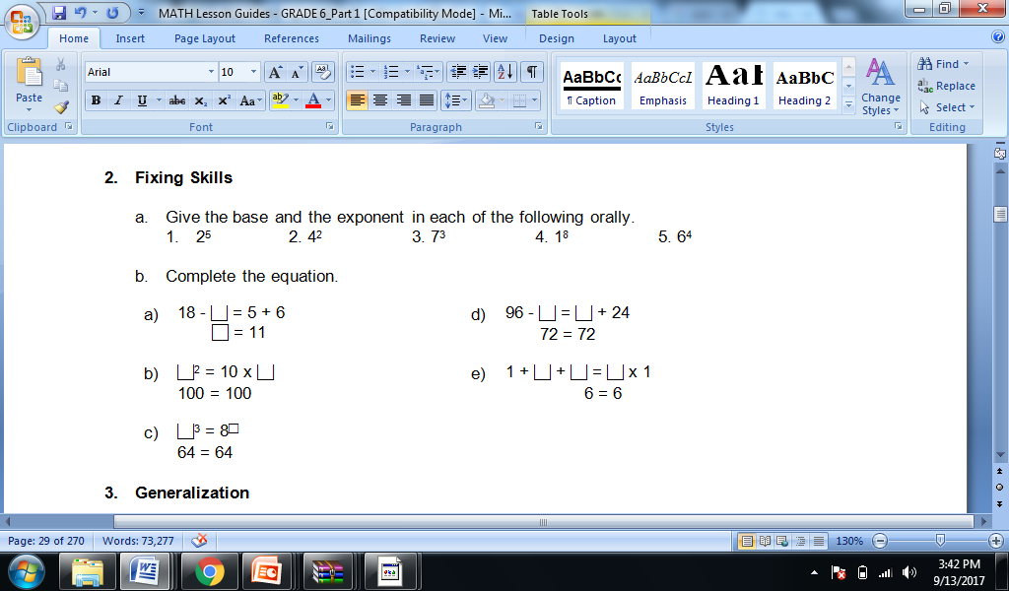 |  | Group Activity:  Let us have 3 learning stations. Do the activity in each learning station by group. Once you have finished an activity, go to the next station and do the activity indicated there. Do the activities as fast as you can.  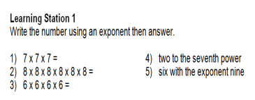  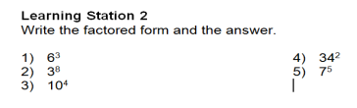  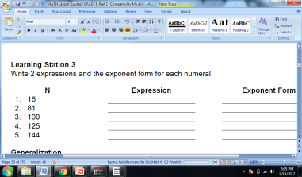 | Group Activity:  Ask pupils to work on items 1 to 5 under Get Moving and items 1-5 under Keep Moving on LM Math |  | Group Activity: Evaluate the expression.  a) 8 + 4 ÷ 2  b) 5 x 8 ÷ 4  c) 65 – 91 ÷ 7  d) 72 ÷ 3 x 8  e) 67 + 33 ÷ 25 | c.Activity 3: Group Activity  Bing asks her son to do his homework and looks at his notebook. She finds the following:  Evaluate the expressions:  1) 6 + (2 x 7 + 5²)  2) 3 x (4 x 82) – 8  3) 5 x [24 ÷ 2 x (10 – 8)2 ÷ 10]  4) (15 – 6) + (4 – 1) x 23  5) 3 x [3 + 2 x (10 – 32)]  a) Ask each pair of pupils to answer the questions below:  1) What are the facts given?  2) Which operation should be done first? second? third? last? Why?  b) Have each pair of pupils evaluate the expressions.
- Finding practical applications of concepts and skills in daily living | a. Rewrite each of the following using exponents. Determine the numerical value.  1. second power of 7  2. fourth power of 5  3. 2 x 2 x 2 x 2 x 2 x 2  4. 8 x 8 x 8  5. 15 x 15  b. Write the >, < or = in the box to make the statement true.  1)52 25  2)72 3 2 (70) + 3  3)2(32 + 22) 82  4)32 + 32 + 32 3 (32)  5)6 (2 + 3)2 3 + 72 |  | Based on tables 1, 2, and 3, how many cancer cells have grown on the fifteenth day? | Ask pupils to do items under Apply Your Skills on LM. |  | Write an expression about the problems. Then evaluate the expression.  1)In a certain eatery, there are 5 glass racks having 24 glasses and 8 left over. The answer says there are 130 glasses in all. Is it right? Why?  2)Use numbers less than 7 once to make the expression right.  (Refer to TG) | Evaluate the ff. expressions:  a) (114 – 4) x (12 ÷ 4)² + 3  b) 16 + 82 ÷ (4 + 4)  c) (36 – 6) x (3 x 4)² + 7  d) 122 x 30 + (890 ÷ 2)  e) 6² x 23 + (400 ÷ 2)
- Making generalizations and abstractions about the lesson | What is an exponent? base?  -The exponent tells how many times the base is taken as a factor.  The base is the bottom part of anything. It is the number used as the factor. |  | The exponent tells the number of times the base is used as a factor.  The base is the number used as a factor. | Guide the pupils to give the following generalizations by asking: What rule would you follow in order to perform the order of operation?  Rules in the Order of Operation:  Perform the operations within each pair of grouping symbols (parenthesis, brackets, and braces) beginning with the innermost pair.  Simplify the expression with exponents.  Perform multiplication and division as they occur from left to right.  Perform addition and subtraction as they occur from left to right. |  | How do we evaluate an expression with two different operations without exponents and parenthesis/grouping symbols? | How do we evaluate an expression with more than two operations with exponents and parenthesis/grouping symbols?
- Evaluating Learning | A. Evaluate  1.) 6 2² + 7  2.) 3 7² + 5 5²  3.) 9² - 7² + 10  4.) 2⁵ 5² - 3² 4³  5.) (10 + 2)² - 10²  B. Find the value of n to make the statement true  1.) 2^{n} = 16  2.) 4 5^{n} = 4 125  3.) 7³ = n  4.) 2 10^{n} = 2 000  5.) 3 2^{n} = 192  C.Write the base, exponent, value, equation, and the meaning of the following expressions. Number 1 is done for you.  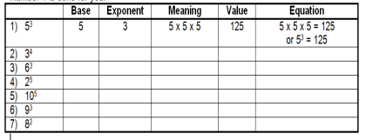 |  | A.Complete the following sentences:  1) In 5³, _____ is the base and ______ is the exponent.  2) 6² is the exponential form of 6 x _____.  3) 144 is the ___ power of 12.  4) 2² means 2 multiplied by _.  5)7⁴ means _____ is multiplied by itself four times.  B.Give the value of the ff: | Evaluate the following expressions by following the rules:  (9 – 2) + (3 × 21)  (18 + 14) ÷ (6 + 2)  (36 ÷ 22 + 4 × (4 – 2)  (36 – 6) + [(3 × 42) + 7]  (72+ 15) × 4 – (625 ÷125)  4 × (15 – 32) + 16  (93 + 7) × 6 + 10  12 × 30 +(890 ÷10)  [(144 ÷ 12) 2 × 3] ÷ 3 × 6  (16 + 82) ÷ (4 + 4) |  | Evaluate the following expressions.  1) 4 x 3 + 8  2) 84 ÷ 3 x 4  3) 76 – 8 + 5  4) 53 + 7 – 20  5) 3 x 5 ÷ 25  6) 7 x 8 + 130  7) 195 ÷ 3 x 5  8) 3 + 83 – 73  9) 76 – 8 x 9  10) 90 x 5 ÷ 75  (Refer to TG for the Continuation) | 1.Evaluate the following expressions:  a) (9 – 2) + (3² x 21)  b) (18 + 14) ÷ (6 + 2)  c) 36 ÷ 22 + 4 x (4 – 2)  d) (36 – 6) + [(3 x 42) + 7]  e) (72 + 15) x 4 – (625 ÷ 125)  f) 4 x (15 – 32) + 16  g) (93 + 7) x 6 + 10  h) 12 x 30 + (890 ÷ 10)  i) [(144 ÷ 12)2 x 3] ÷ 3 x 6  j) (16 + 82) ÷ (4 + 4)  2.Evaluate the expression if:  a) R = 2  2.[(6^{R} + R x 8) ÷ 13] – 5 + R  b) S = 3  [(7^{S} – S) x 6] + 6^{S} – S x 5
  1)6³ = __  2)4⁵ = __  3)2⁷ = __ | 4)9² = __  5)7⁴ = ___
- Additional activities for application and remediation | Evaluate  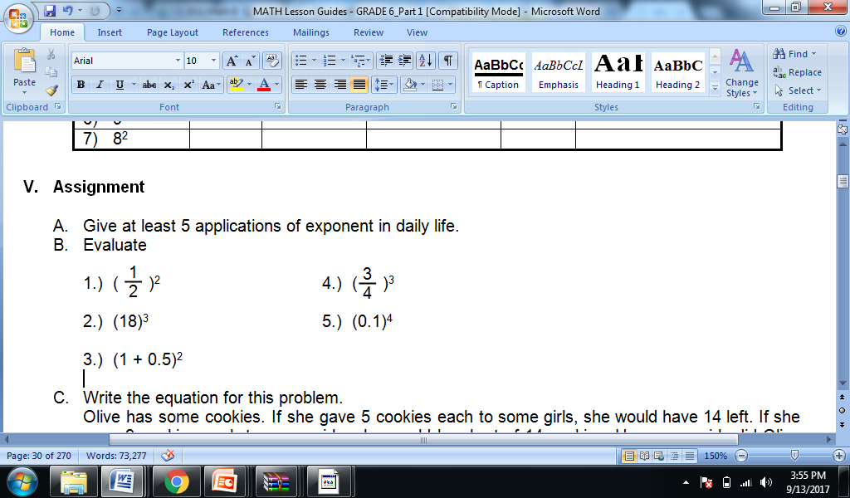  Write the equation for this problem.  Olive has some cookies. If she gave 5 cookies each to some girls, she would have 14 left. If she gave 9 cookies each to some girls, she would be short of 14 cookies. How many girls did Olive give the cookies to? Ans. (5 x n) + 14 = (9 x n) - 14 | Fill in the blanks.  1) 9 = 3 x 3 = 3_  2)16 = _____ x _____ = _____²  3)8 = 2 x 2 x 2 = 2-  4)10² = 10 x 10 = _____  5)10³ = _____ x _____ x ______ = _____ |  | Evaluate the following expressions by following the rules:  63 ÷ 7 + 5 + 2 – 6 + 3  6 + (2 × 7 + 5)  3 × (4 + 82) – 8  37 + 3 × 2 ÷ 6  14 ÷ 2 – 3 + 2 × 2  Enrichment  Evaluate the following expressions.  (114 – 4) × ( 12 ÷ 4) + 3  16 + 82 ÷ (4 + 4)  (36 – 6) × ( 3 × 4) + 7  122 × 30 + (890 ÷ 2)  6 × 23 + (400 ÷ 2) |  | 1. Evaluate the following expressions.  (See TG) | 1. Evaluate the following expressions:  (34 – 4) x (75 ÷ 52)  (35 – 3) x 32 + 9  (38 – 7) + 6 ÷ (2 x 3)  2.Insert an operation symbol and parenthesis to make a whole number that is the:  highest possible answer  least possible answer  22 3 4 6  3.Write a problem. Make an expression about it. Then evaluate.
V. REMARKS
VI. REFLECTIONS
- No. of learners who earned 80% on the formative assessment
- No. of learners who require additional activities for remediation who scored below 80%
- Did the remedial lessons work? No. of learners who have caught up with the lesson
- No. of learners who continue to require remediation
- Which of my teaching strategies worked well? Why did this work?
- What difficulties did I encountered which my principal or supervisor can help me solve?
- What innovation or localized materials did I use/discover which I wish to share with other teachers?

