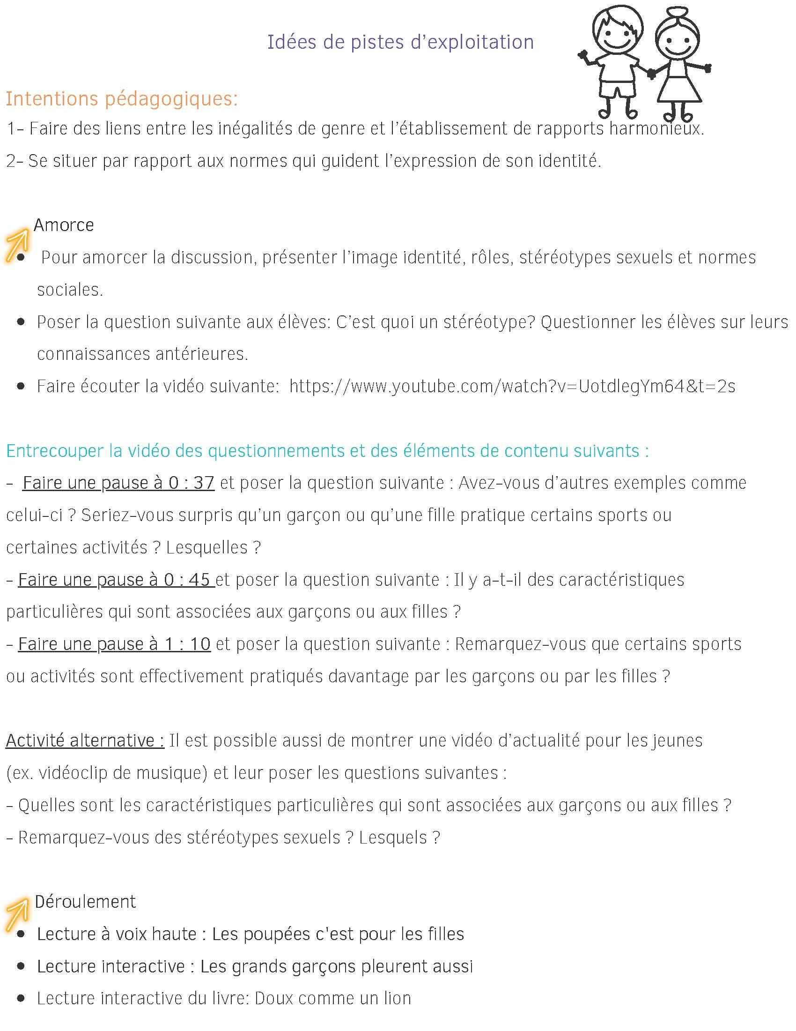

Lien You tube cliquable : https://www.youtube.com/watch?v=UotdlegYm64&t=2s

