Title

Naomichi Hatano¹, Hideaki Obuse^{2,1}, Takashi Oka³, and Masatoshi Sato⁴

¹Institute of Industrial Science, The University of Tokyo, Japan
²Department of Applied Physics, Hokkaido University, Japan
³ The Institute for Solid State Physics, The University of Tokyo, Japan
³ Yukawa Institute for Theoretical Physics, Kyoto University, Japan

Email: pos.byd@eng.hokudai.ac.jp

This is the Microsoft Word template file for an abstract for POS&BYD.

The preferred format is:
- Total length: 1 page
- Title: Times New Roman Bold, 18pt
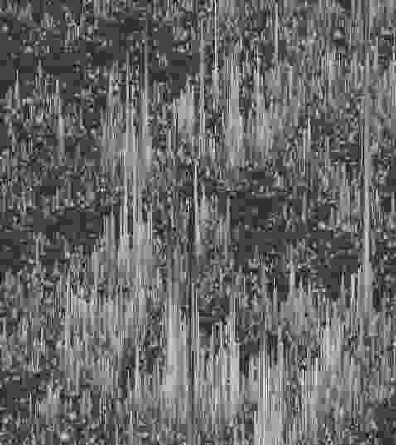
Fig.1: The figure caption.
- Authors: Times New Roman, 14pt
- Affiliations: Times New Roman Italic, 12pt
- Email: Times New Roman, 11pt
- Main text and references: Times New Roman, 12pt
- Figure caption: Times New Roman, 11pt

Please convert this file to PDF before submission. The file name should be {First name}-{Family name} of the author who gives the presentation followed by either “_Talk.pdf” or “_Poster.pdf”, depending on the type of presentation, e.g. Naomichi-Hatano_Talk.pdf or Hideaki-Obuse_Poster.pdf. The email address given after the list of affiliations should be that of the presenter.

For those who have a Google account,
- please submit your abstract through the form here.
For those who do not have any Google account,
- please fill in the form here.
- please send the PDF of your abstract to pos.byd@eng.hokudai.ac.jp by the deadline. The subject of the email should be "Abstract".
For those who cannot access to Google services,
- please download the form through the mirror site (https://ssp-ap.eng.hokudai.ac.jp/pos-byd/abstract_form.xlsx) and fill it in.
- please send the filled form and the PDF of your abstract to pos.byd@eng.hokudai.ac.jp by the deadline. The subject of the email should be "Abstract".

[1] P. Anderson, Phys. Rev. 109, 1492 (1958).

