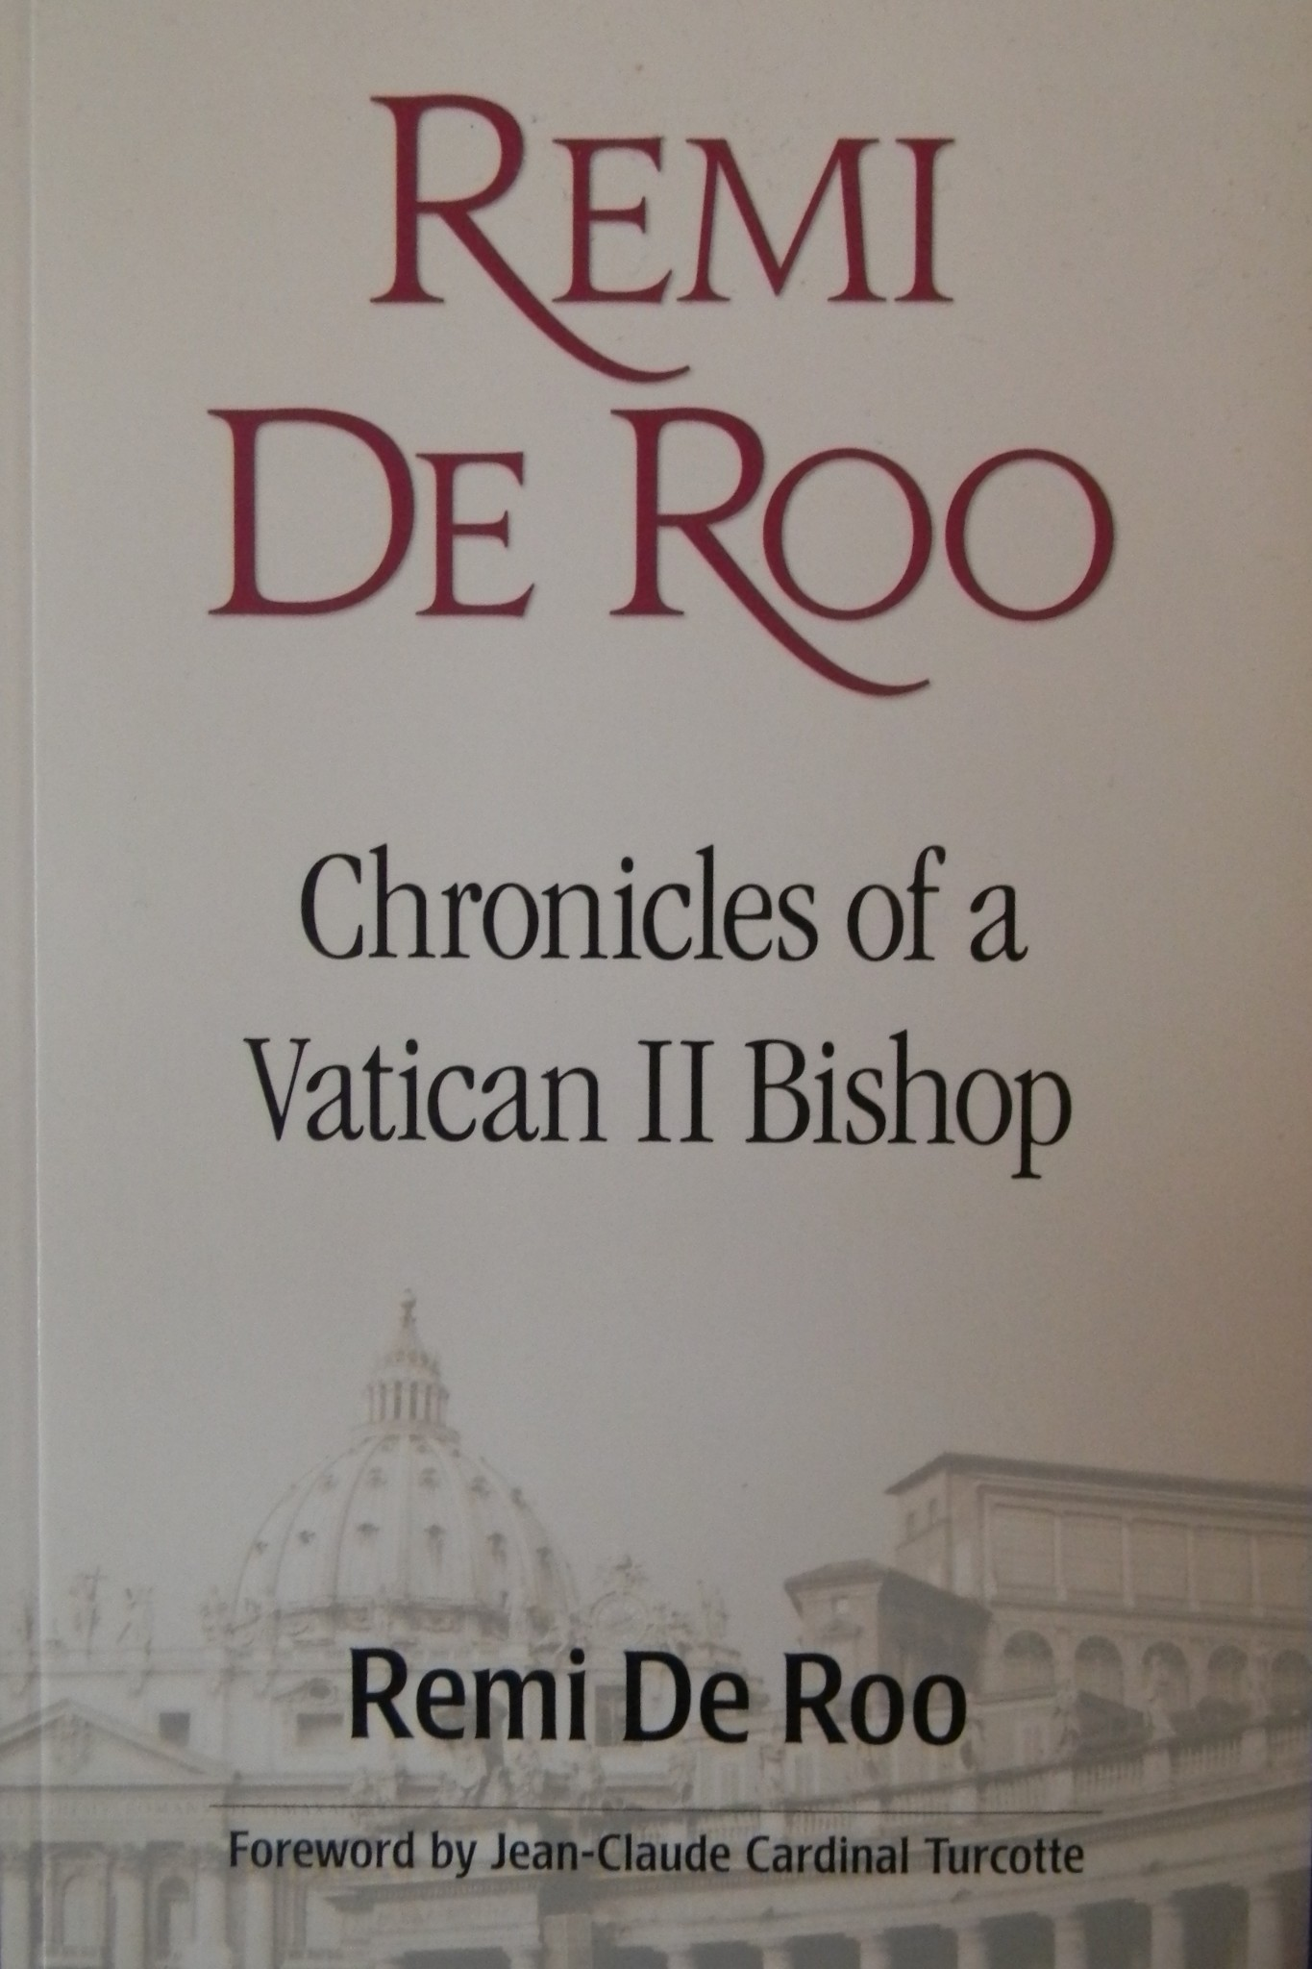

Remi DeRoo

Chronicles of a Vatican II Bishop

Remi De Roo

Foreword by Jean-Claude Cardinal Turcotte

© 2012 Novalis Publishing Inc.

De Roo, Remi. Remi De Roo: chronicles of a Vatican II

bishop / Remi De Roo.

Issued also in an electronic format. ISBN 978-2-89646-471-5

1. De Roo, Remi J. 2. Catholic Church British Columbia - Victoria Bishops Biography. 3. Bishops British Columbia - Victoria- Biography. 1. Title.

BX4705.D436A3 2012 282.092 C2012-903872-5

Catholic Action

Perhaps one of the most significant things to blossom at and after the Vatican Council was what is known as "Catholic Action." Catholic action means people: the outward reach of the Church into the hearts of humanity. It includes social justice and human rights, the developing nations and the marginalized poorest of the world, war and peace, nuclear weapons and the real nature of economics. I had read about this new development while I was studying at the Major Seminary. That was when I first learned the name of the renowned Belgian priest Canon Josef (Joseph) Cardijn. It was my privilege to meet him the following summer at an international convention in Montreal. I introduced myself to him in our common native tongue, Flemish. It was the beginning of a long and rewarding friendship.

...

Catholic Action was first suggested by Pope Pius X as a formula whereby the laity could help the Church in the restoration and promotion of true Christian civilization under the direction of ecclesiastical authority. It was formally authorized or "mandated" by Popes Pius XI and Pius XII, and was described as the collaboration with, or participation in, the apostolate of the hierarchy. It was subject as well to the "mandate" of the local bishop. It developed a variety of forms and spread through many countries. Canon (later Cardinal) Cardijn promoted it very successfully among young workers. He provided it with its now classic formula: observe, judge, act.

This movement was one of several precursors to Vatican II, along with the liturgical renewal, updated religious education, and social reform movements. Gradually, more autonomous forms developed. Many of the Catholic Action groups began to wane when Vatican II proclaimed its teaching about the baptismal priesthood. Lay people became aware that their true calling was based on their baptism and confirmation. Therefore, this calling did not require the intervention of the hierarchy. It was now understood that the baptismal priesthood of the people contained in itself the mandate to proclaim the Gospel and live the Beatitudes. The Spirit imparts divine gifts freely, and believers need not wait to undertake their mission in life.

Later, at Vatican II, Cardinal Cardijn confided to me that he never fully succeeded in getting "those Romans" to grasp the true nature of specialized (meaning the apostolate of like to like) Catholic Action. They failed to grasp how it was directed primarily towards the transformation of society through Gospel values. It was not meant to be oriented towards the strengthening or promotion of Church structures as such. I remember him bemoaning the fact that in the commission in which he participated during the Council, he had found it practically impossible to get the members to understand the true nature of Catholic Action.

SOURCE:

Remi De Roo, Remi De Roo, Chronicles of a Vatican II bishop, (Foreword Cardinal Jean-Claude Turcotte) Novalis, Toronto, 2012, 176p. at p. 72-74.

