Your Digital Footprint

TEACHER KEY
ASSESSMENT

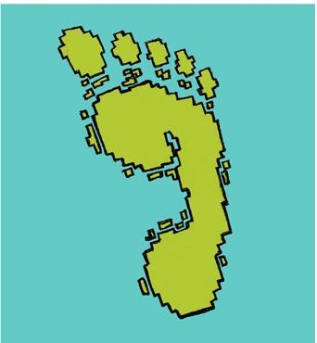
What is a digital footprint?

A track that animals leave behind
  - Shoes that you buy on the Internet
  - The information about you on the Internet
Answer feedback
The correct answer is c. Your digital footprint is the information
about you online, such as a news story with your name in it or something that you write online.

TOP SECRET

- What kind of information is safe to share online?
  - Your birth date
  - Your first name or computer username
  - Your address
Answer feedback
The correct answer is b. It is okay to share your first name or your
username online. But sharing your address or birth date could make your information unsafe because other people might use your information to pretend to be you!

- Which animal below has the digital footprint that leaves him or her most unsafe?
HINT: Think about which animal shares the most private information online.
- Fran the fish b) Betty the Bird c) Tony the Tiger  Hobbies swimming flying going to the 3rd street gym  Address the sea a nest 523 Green Street  Other pet’s name is Frank I love seeds! My real name is Thomas | - Fran the fish  - Betty the Bird  - Tony the Tiger  Answer feedback  The correct answer is c. Tony the Tiger put private information online, like his address, which is not safe. Fran and Betty shared information, but they did not share anything private about themselves.

