**SUMMATIVE TEST NO. 1**

|  |  |  |  |  |
| --- | --- | --- | --- | --- |
| **Objectives** | **CODE** | **Percentage** | **No. of Items** | **Item Placement** |
| Visualizes and describes the different solid figures: cube, prism, pyramid, cylinder, cone, and sphere using various concrete and pictorial models. | . **(M6GE-IIa-27)** | **40%** | **10** | **1-10** |
| Identifies the faces of a solid figure | **(M6GE-IIIb-30)** | **20%** | **5** | **11-15** |
| differentiate expression from equation | **(M6AL-IIId-15)** | **40%** | **10** | **16-25** |
| **Total** |  | **100** | **25** | **1 – 25** |

**GRADE VI – MATH**

**Guro Ako Channel**

**SUMMATIVE TEST NO.1**

**GRADE VI – MATH**

**Guro Ako Channel**

Name :____________________________________________________ Grade and Section:_________

I. A. Choose the solid figure in Column B that is represented by the following objects in column A. Write your answer on a sheet of paper.

A B

_____1. ice cube A. cone

_____2. tissue roll B. cube

_____3. match box C. cylinder

_____4. volleyball D. rectangular prism

_____5. can of sardines E. sphere

_____6. milk box F. square pyramid

_____7. volcano G. triangular prism

_____8. Toblerone H. triangular pyramid

_____9. bus

_____10. roof of a nipa hut

B. Match the solid figures on Column A to its net on Column B.

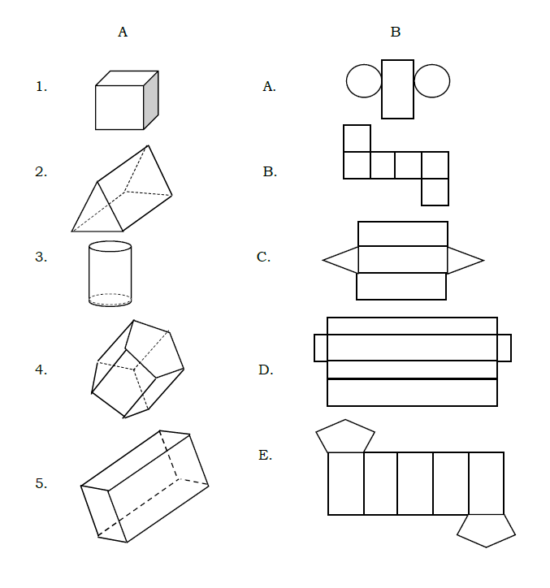

II.Look at the expressions and equations below. Write “ex” if it is an expression and write “eq” if it is an equation.

________A. 9 + b

________B. 15(6 - 2) = 60

________C. (3 x 2) + b

________D. (3 x a x b) = 27

________E. (8 + 3) - 5

________G. (5 x 7) - 13

________H. 6 x 5 = 30

________I. (b x 5) - 10 = 30

________J. 93 - (d x e)

________K. 75 - m = 36

***SUMMATIVE TEST 1 ANSWER KEY:***

II.

A.ex F.ex

B .eq G.eq

C. ex H.eq

D.eq I.ex

E.ex J .eq

I.

1.B 6.D

2.C 7. A

3.D 8.G

4.E 9.D

5.C 10.F/G

1.B

2.C

3.A

4.E

5.D